Thermal Laser Plantar Apparatus

Submitted to:

Dr. Brian Thomson

Senior Design II

Temple University College of Engineering

1947 N 12th St, Philadelphia, PA 19122

December 5th, 2022

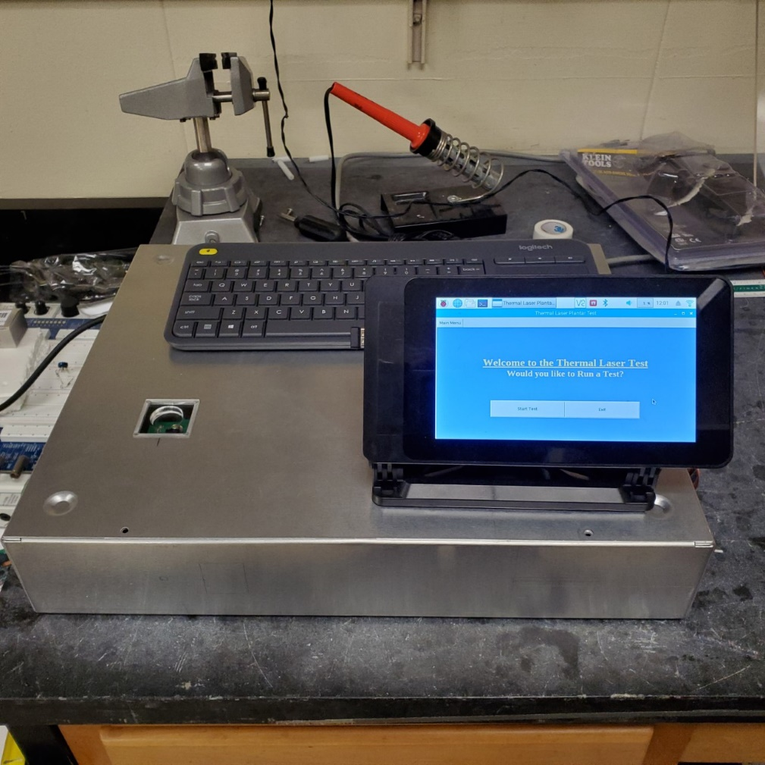

Prepared by: Team 10

Robert Bara, Tyiana Simon, Ezra Galapo, Zari Grandy-Overton

Advisor:

Dr. Michel Lemay

# Abstract

We propose an alternative system to the standardized Hargreaves Test to assess if existing Spinal Cord Injury (SCI) treatments could cause long-term chronic pain as a side-effect. The apparatus assists researchers in observing reflex responses of medium-sized animal groups (cats) with an SCI, by exposing them to existing proteins that assist in locomotor recovery (neurotrophins). A quicker response could prove that the specific protein given increases thermal and mechanical sensitivity to pain (hyperalgesia). This may be a source for chronic pain within individuals that suffer from SCI and will help researchers determine if these specific proteins should continue to treat SCI or conduct treatment with an alternative protein. The system utilizes a thermal laser to stimulate the animal’s back paw reflex. The animal lays oblivious to the system and uses a light-sensitive timer circuit in conjugation with the laser to record, store, and analyze their response times through a Raspberry Pi 3B+. The team utilized previous research to develop experiments for validating each subsystem to validate the functionality before animal testing. The system proved to be successful in obtaining withdrawal times and storing results automatically to an excel database. The system will continue to operate within Dr. Michel Lemay’s research lab at Temple University, which will obtain a larger sample size of felines and use the collected data and analysis to conclude their hypothesis about the effects of neurotrophins.

Key words: Spinal Cord Injury Model, Nociceptor, Neurotrophin, BDNF, NT-3, Hargreaves Test, Plantar Test, Thermal Stimulation, RPI, Acrylic, Qphotonics, Class 2 Laser, Felines

# Exec Summary

The following document proposes an open-source, cost-efficient thermal laser plantar test as an alternative system for measuring nociceptive withdrawal time to the standardized Hargreaves Test as a method for Spinal Cord Injury Modelling. The apparatus will be used to assist researchers in observing if there is a decrease in latency within reflex responses of medium sized animals with a spinal cord injury. Each animal is injected with neurotrophins such as BDNF or NT-3 to observe the effects neurotrophins have on hyperalgesia (an increased sensitivity to pain). If BDNF provokes a faster response than NT-3 then this could prove that while BDNF promotes locomotor recovery, it leads to an increase in sensitivity which may be a source of chronic pain within individuals who suffer from spinal cord injuries. Conclusions from this data could guide medical professionals to stop applying BDNF treatment, and assists in further research corresponding to the United Nations Goals of Sustainable Development Goal 3, to Promote Good Health and Well-Being, as well as Goal 15 to Preserve Life on Land.

The decision to create the apparatus is primarily due to three reasons: thermal stimulation has proven to be the most precise method within stimulating nociceptors, the standardized Hargreaves apparatus is fairly expensive to rent, and the Hargreaves apparatus is limited by modelling for smaller spinal lengths such as rodents, whose results would not reflect well towards modelling humans. The proposed solution uses a thermal laser at $1400nm$ to project through an acrylic plate and stimulate deep neurons within the test animal’s paw and promote a reaction. The test animals within this experiment are medium sized felines induced with a spinal cord injury from the waist down. This means when the laser stimulates their paw, their reflex is still present and will react, however there is no path for the reflex’s signal to travel through the spine to the brain, meaning the cat will not register the feeling of pain. The felines lay upon the top of the system with their back paw overtop of the plate and the operator of the system uses a GUI written on a Raspberry Pi 3B+ which interacts with the photodiode and laser circuit lying under the plate to stimulate the reflex, record the change in time, and automatically compute analysis that is imported/exported to an excel database.

The document explores the background of the system, previous research and studies, the design team’s iterative design process, and testing/validating each portion of the system before initial animal testing. The system proved to be successful with initial animal testing completed and will continue to operate within Dr. Michel Lemay’s research lab at Temple University, which will obtain a larger sample size of felines and use the collected data and analysis to conclude their hypothesis about the effects of neurotrophins.

# Table of Contents

I. Cover Page…………………………………………………………………………………………….1

II. Abstract 2

III. Exec Summary 3

IV. Table of Contents 4

V. List of Figures 7

VI. List of Tables 9

VII. List of Equations 9

VIII. Problem Statement 10

**i.** Overall Objectives 10

ii. Historical Perspective 12

iii. Potential Solutions 17

iv. Proposed Solution 20

v. Major Design and Implementation Challenges 22

vi. Implications of project success 22

IX. Functional Requirements 23

X. Design Constraints 24

XI. Design Approach 28

i. System Overview 28

ii. Design Methodology 31

1. Data Analysis 31

iii. Software 32

1. Data Collection 32

*2.* Saving/Exporting Data 36

3. Graphical User Interface 39

iv. Hardware 41

1. The RPi3B+ 41

2. Photodiode 42

3. The Laser 44

4. System Schematic: (Power Supply, Driver, Laser Interaction) 45

v. Mechanical 50

1. The Acrylic Plate 50

2. The Lid 52

vi. Performing an Experiment 53

XII. Evaluation: Test Methods 62

XIII. Test Methods 62

Testing Functional Requirements 62

**T_FR1:** 63

**T_FR2:** 64

**T_FR3:** 65

**T_FR4:** 73

**T_FR5:** 73

Testing Design Constraints 74

**T_DC1:** 76

**T_DC2:** 76

**T_DC3:** 77

**T_DC4:** 77

**T_DC5:** 78

**T_DC6:** 79

**T_DC7:** 80

**T_DC8:** 83

**T_DC9:** 83

XIV. Cost 85

Materials List of Items Previously Purchased 86

Bill of Materials for Final Design 88

XV. Schedule 89

XVI. Summary and Conclusions 90

XVII. Appendix 94

i. Hargreaves Test Cost Estimate 94

ii. Thermal Laser System Schematic 95

1. Pre-SD Team Contributions 95

2. SD Team Final Design Schematic 96

3. Implementation of Schematics (System Hardware) 97

iii. Software Source Code 102

1. Animal Class 103

2. Table Class 110

3. Export Class 112

4. GUI Class and Driver 120

XVIII. Reference List 128

# List of Figures

Figure 1. Harvard Apparatus Quote for Hargreaves Test 11

Figure 2 : Hargreaves Test Apparatus 13

Figure 3. General System Schematic of Dr. Lemay's Laser Prototype 16

Figure 4. Raspberry Pi 3B + 17

Figure 5. OFLD-1440mw Laser with Butterfly Diode Connector 18

Figure 6 Basys 3 Artix-7 FPGA Trainer Board 18

Figure 7. Topcat Metrology HotProd 19

Figure 8. Work Breakdown Structure of the System 27

Figure 9. Flowchart of animal.Trial() function 31

Figure 10. Flowchart of animal.timer() function 33

Figure 11. Function for computing Cat's Average Time 33

Figure 12. Example of an Excel Export for Two Cats in Group 2 35

Figure 13. Example Bar Graph Output 35

Figure 14. Control Flow of Program 38

Figure 15. The RPi 3B+ Board 40

Figure 16. RPi board with screen monitor 40

Figure 17. Design of TEC 41

Figure 18. Photodiode symbol 41

Figure 19. Finalized Schematic of Hardware and Mechanical Connections 43

Figure 20. Implementation of the Schematic 44

Figure 21. Photodiode and Laser Mount Implementation 45

Figure 22. Frame 1, Prompt the User to Start or Quit the Program 46

Figure 23. Enter the Animal's Name 47

Figure 24. Enter the Animal's Group Number 47

Figure 25. Control Menu for Testing an Animal 48

Figure 26. Example of Placing a Cat onto the System 49

Figure 27. LED and Safety Switch 49

Figure 28. Error Message, no reaction detected 50

Figure 29. Prompt the User for a Valid Trial 51

Figure 30. Returning to the Control Menu after Valid Trial 51

Figure 31. Measuring the Laser with IR Sensor 55

Figure 32: Examining Footage for Experimental Values 57

Figure 33. Comparing Analysis between Python and Excel 60

Figure 34. Automating Excel with Python in Export Class 61

Figure 35. Exported Results from Excel for Initial Animal Testing 61

Figure 36. Time Out Declaration in animal.timer() 62

Figure 37: 1/8-inch depth acrylic sheet 67

Figure 38: 1/4-inch depth acrylic plate 68

Figure 39. QPHOTONICS data sheet for laser 69

Figure 40. Datasheet showing current specifications 70

Figure 41. Sheet showing different laser wavelengths and the temperature 72

Figure 42. Examining effects of Therapeutic Lasers on Skin 72

Figure 43. Harvard Apparatus Quote for Hargreaves Test 82

Figure 44. General System Schematic of Dr Lemay's Laser Prototype 83

Figure 45. Finalized System Schematic 84

Figure 46. Implementation of Finalized Schematic 85

Figure 47. PhotoDiode Schematic 86

Figure 48. Implementation of the Photodiode Circuit 86

# List of Tables

Table 1. Functional Requirements with associated metrics, target values, and references 21

Table 2. Design Constraints with associated metrics, target values, and references 24

Table 3. Database Table Example 34

Table 4. Go Pro Hero 8 FPS to Sampling Period 56

Table 5: Start/Stop Times determined by Go Pro 57

Table 6: Go Pro Response Times and Percent Differences 58

Table 7. Comparing System Results to Go Pro Results 58

Table 8. Bill of Materials to be Purchased throughout Senior Design II 75

Table 9. Bill of Materials Previously Purchased before Our Team's Contributions 76

Table 10: Specifications of Butterfly Laser Diode Mount 87

Table 11: Butterfly Laser Diode Mount Pin Diagram 87

Table 12: Butterfly Laser Diode Mount Pinout 88

# List of Equations

Equation 1 28

Equation 2 28

Equation 3 28

Equation 4 28

Equation 5 28

Equation 6 28

Equation 7 41

Equation 8 41

Equation 9. Sampling Period 55

Equation 10. Percent Difference 58

Equation 11 59

Equation 12 59

Equation 13 60

# Problem Statement

## Overall Objectives

Individuals who suffer from spinal cord injuries (SCI), often suffer long term chronic pain, sometimes regarded as a “phantom pain”. While existing treatments are available to relieve the patient, medical and biological researchers devote their work to creating spinal cord injury models to study the source of the patient's pain. Conclusions from conducted studies are often studied by other labs and companies to develop better treatments in hopes to cure the patient of their pain.

Dr. Michel Lemay of Temple University is one researcher among others that attempts to find the source of the patient’s pain. Previous research conducted by Dr. Lemay and other scientists has raised the question of whether specific neurotrophins may be the root of the problem. Neurotrophins are proteins that affect neuronal growth and are often used in spinal cord treatment to restore locomotor recovery [1]. Brain-derived neurotrophic factor (BDNF) is one neurotrophin that has been found to help restore locomotor capabilities in animal models of spinal cord injury, however, it is also suspected that it may side effect a heightened sensory response. This long-term effect of heightened sensory response is suspected to cause the “phantom pain” individuals with SCI may develop. One way to test for heightened sensitivity is to stimulate a nociceptor (a reflex) affected by the injury and examine if there is or is a lack of any latency.

Nociceptors are essential sensory neurons that allow organisms to be alerted of potentially damaging stimuli (pain) when exposed to extreme changes in temperature, pressure, and injury-related chemicals to their skin [2]. Triggering nociceptors can be done using a variety of methods, a common heat plantar test known as the Hargreaves Test, is a method of measuring thermal nociception by measuring the paw response time when applying thermal stimulation to animal models of hyperalgesia, which are animal models that experience an increased sensitivity towards feeling pain [3]. Data collected from such tests can serve as the substantial research in developing a Spinal Cord Injury (SCI) model, however studies utilizing the Hargreaves apparatus itself, estimate costs at approximately $\$9,766$ alone, as seen by Dr. Lemay’s quote from Harvard Apparatus,

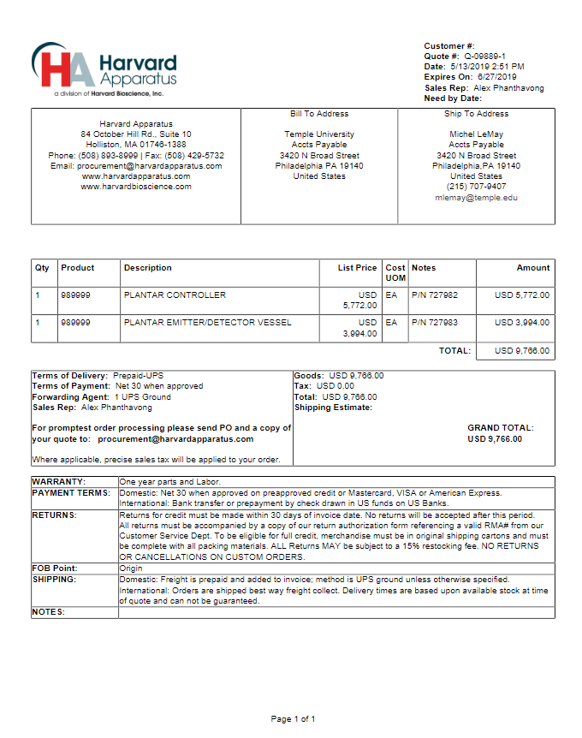

Figure 1. Harvard Apparatus Quote for Hargreaves Test

Source: [4]

Adding additional materials, a typical Hargreaves test can total over $\$10k$ per study. Furthermore, the standardized Hargreaves apparatus is designed specifically for rodents, which results prove to be less reliable when correlating to humans due to spinal length. In other words, if a rat grew an inch of skin, that would be a big deal for the rat, however if a human grew an inch of skin, this is a minimal mutation in terms of the size of the rest of the human spine [5]. Therefore, a more reliable model would be to conduct research on a medium-sized animal or animal with a similar spinal length to humans. Other thermal plantar test studies have gone as far to schedule their research around renting out facilities that house Multiwave Locked System (MLS) lasers instead of attempting to obtain the budget to perform the experiment on their own, where a typical MLS laser can cost over $\$10k$ by itself [6].

Our team introduces an alternative, automated, portable, user-friendly system inspired by systems such as the Hargraeves test at an affordable price. By creating a system that allows medium-sized animals such as cats who suffer from spinal cord injuries from the waist down, Dr. Lemay and his lab can inject various neutrophins into the cat’s rear paw nociceptors and divide each cat into groups determined by classification of neutrophins. One group may not have any neutrophins, while another may be injected with BDNF into the paw, or other neurotrophins such as NT-3, which promote similar locomotor recovery, but is theorized by previous studies to not cause a heightened sensory response. Their team can then use our system to examine differences in the speed of the withdrawal responses/reaction time gathered by thermally stimulating the nociceptor with a laser. This primarily works because you can picture the body as a circuit comprised of sensors such as the reflex which gathers data that is sent up through the spine to the brain, which post processes the data. When a spinal cord injury occurs, the brain and sensors such as the reflex is still present and functioning independently, however the broken link between them no longer allows for the nociceptor to send a signal through the spine to the brain and register the feeling of pain. In other words, the animal will still withdraw their paw and react due to the reflex, but since brain will not register the stimulation as pain the animal will not feel pain nor will it understand this is being. The following figure demonstrates the brain and reflex interaction as a circuit, with the spine acting as a switch.

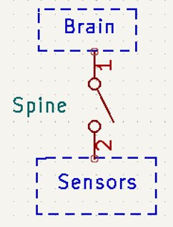

Figure . Brain and Reflex Circuit

The usage of our system will then allow Dr. Lemay and his group to conclude if BDNF heightens sensory response, which may drift research and treatment away from using BDNF to aid those with spinal cord injuries, and further research and develop possible treatments based upon the outcome of studying the long-term effects that nuerotrophins have on individuals with spinal cord injuries.

## Historical Perspective

Nociception is a survival skill for all living organisms, any damage caused to this neurological system could put any creature or person in a potential life-threatening situation, if the neurological reaction is unrecognized [2]. Spinal cord injury (SCI) and associated treatments lead to modifications in the sensation of pain, and those changes are monitored with a number of assays that include the skin nociceptors’ reaction to heat. The Plantar or Babinski reflux area of an organism consists of the area under the sole of the human foot or paw of an animal. Plantar testing can be beneficial to assessing a spinal cord injury model because when pain is stimulated within the plantar, if a detection in abnormal behavior is present then this could mean that the “wrong” receptive field is being triggered, meaning there is a structural abnormality within the corticospinal system upstream, which is responsible for controlling the primary motor activity from the neck to feet. This is also an indicator that an underlying medical condition may be present such as a hemorrhage or brain/spinal tumors [7].

Since the initial 1987 Hargreaves study, the test has continued to be performed in several studies. The test is typically done on rodents to test their thermal pain sensation. Via rodents, the test analyzes the effectiveness of their somatosensory system, specifically focused on sensory stimuli. Pain, touch, pressure, and vibration are crucial factors that are studied to gather valuable information towards repairing this system if it falls victim to injury. Tests are typically ran on rodents to make discoveries in relation to patients who suffer from neural injury, the goal is to observe whether there is an actual defect and if so, find suitable treatments towards neural regeneration [8].

One performance of this test has previously been done by a Europe PMC Funders Group in 2017. This group’s test consisted of both mice and rats; with specific strains of the rodents recommended for the most effective results in data collection (i.e., one kind being more active than another which can affect the accuracy of the test). The setup consisted of a frame glass panel (glass table), a glass animal enclosure, an emitter/detector vessel, and a controller.

It was important that they inhabit the rodents into the testing chamber/ enclosure to ensure that they would remain calm and still during the test. They did this for two days for $30-60$ mins; each day, allowing the rodents to find comfort in the environment; they were also fed and taken care of in the process. The enclosure was constantly disinfected after each use to eliminate outlying factors during data collection. Therefore, when the test was administered, after giving the animals $15-20$ minutes to settle in the enclosure, the emitter/detector was positioned directly under the center of their paws (one rat at a time, whichever paw being tested), and when fully set up, the “start” button on the controller was pushed. Pressing “start” turned on the infrared light and automatically started the timer. The test ended when the rodent reacted and removed its paw from the glass enclosure which then got detected by the vessel, the vessel detection turned off the infrared light and stopped the timer. The test is suggested to be repeated for at least three trials to observe the average reaction time, however the max recommended, if time allows, is five trials to eliminate the highest and lowest reaction time and collect a more accurate average. Five trials is recommended as the max to prevent any harm done to the test subjects. It was noted to beware of actual paw removal due to the heat of the infrared light (involuntarily by the animal), so they paid close attention to the animal as it was tested and saw whether it checked its paw or licked it following the reaction, otherwise the trial was thrown out to avoid voluntary movement and the possibility of faulty data. Their test was restricted to $20$ seconds max testing time if the animal did not react before then. This was protocol for burn injury prevention. There was also a requirement to allow at least five-minute intervals in between testing the same animal. The test ran by this group was straight-forward and allowed them to collect acceptable data amongst a variety of rodents [8].

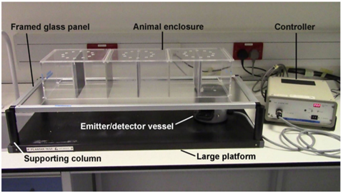

Figure 3 : Hargreaves Test Apparatus

Source: [8]

It is known how Hargreaves works on rodents but a glimpse of how it works on humans and primates was needed to see if it can be safely used on humans. Normally there is quantitative assessment used to test the effect on non-crossing and crossing sensory pathways, but it does not give a good result. Quantitative assessment is not as good to use because it can often lead to inconsistent results, even the machines used to get the results have been known to be unreliable [9]. Finding a way to measure the pain threshold but getting a correct response can be done using a modified Hargreaves. Performing the test, eight primates, fifty-five healthy humans selected, and twelve humans with chronic sensory deficits were chosen. The test continued to stick to general Hargreaves procedure by measuring pain threshold through a plantar surface from heating up the footpad through a glass platform. When testing the primates, they are placed into a chair with their eyes covered. This was done so that the monkeys could not remove their hind paw due to visual stimulation. The results from this test were the ability to realize that the Hargreaves test can be applied safely on larger mammals besides rodents, such as humans, and yield accurate responses.

Keeping the previous studies in mind, developing a prototype to test a spinal cord injury model for larger animals such as felines could utilize various methods to trigger nociception. The Hargreaves test is typically done with a filament (i.e. the heat source could be components such as a lightbulb or vacuum tube, which contains a conductive wire with a high melting point that could act as a valve or diode when heated to incandescence by electric current); however, a major disadvantage of heat generated by a filament is the limited ability to increase cutaneous temperature at a fast rate, which would not allow peripheral and central neuronal responses to be synchronous [10]. Other behavioral nociceptive testing methods include electrical stimuli, which while easily controllable, bypasses the generator compartment of nerve terminals when applied to the peripheral nerve, and therefore loses information regarding the transduction process. Mechanical stimuli such as needles do not only activate nociceptors but activate mechanoreceptors. Additionally, the process takes longer to test compared to other methods. The benefit of using a thermal laser allows for a fast rate of changing cutaneous temperature while activating nociceptors within a few seconds [10]. However, some drawbacks include the lack of a thermal laser system which automatically detects responses, unlike using methods such as utilizing an electric hot plate in conjugation with an automated system or mechanical methods involving flicking the tail of the animal [3]. However, if an automated system is developed, the decision to use an Infrared Laser diode for a modified Hargreaves plantar test would yield the most precise test data over methods such as electric, mechanical, or heat stimulation.

The idea of laser technology was developed by Albert Einstein’s prediction of “Stimulated Emission” in the early $1900s$, which has come to be known as the overview towards the “operation of all lasers” [11]. Stimulated Emission is described as “a sudden burst of coherent light as atoms discharge in a rapid chain reaction” [12]. In studies Einstein found the idea of spontaneous emission that reflects what an “excited atom in isolation” is bound to return, and this scaled all radiative interactions, inclusive of stimulated emission. With more digging he proposed that “as light passes through a substance, it could stimulate the emission of more light” [12]. Stimulated emission eventually grew to be discovered in microwaves by Charles Townes, Nikolay Basov, and Alexander Prokhorov in $1950$ [12]. Charles Townes studied molecular spectroscopy, which focused on the absorption of light by molecules [12]. In his studies he noticed that when microwave wavelength shortened, the light interacted with molecules more strongly. This was in direct relation to stimulated emission and he was motivated to create a device that could produce light at shorter wavelengths [12]. From then the laser was proposed, Gourdon Gould was responsible in $1959$ for this development and expected to represent the stimulated emission capability of amplifying light. The LASER “Light Amplification by Stimulated Emission of Radiation” was then created, expected to be an “optical resonator that can create a narrow beam of coherent light.” Prototypes eventually emerged in the $1960s$; the first by Theodore Maiman which used synthetic Ruby that “emits a deep red light” and it was initially designated for military range fighters. This very laser is still commercially used today for diamond hole drilling. Another was the Carbon Dioxide (CO2) laser created by Kumar Patel that was lower in cost and more efficient [12]. With these starting points the laser industry continued to expand throughout the years into present times where they’re much more affordable and accessible with various uses. Today lasers are used to remove tattoos, correct vision defects with laser eye surgery, cut through materials, scan prices in grocery and department stores, withing electronic devices, in laboratory studies, and much more [12].

There are a total of four different classes of lasers that could be used on an animal, the class of laser that are typically used on animals are “Class 2lasers, which include laser pointers and some therapeutic lasers, produce a beam in a visible spectrum ($400-700$ nanometers)” and “Class 3lasers include the most used therapeutic lasers” [11]. In the senior design project presented we are using a Class 3 laser to test cats as our research animal. It has been proven that laser is safe to use on animals if the settings are adjusted correctly and the duration of the treatment is spread out enough to not cause more injury to the animal [8]. In fact, Class 3 thermal lasers have also been beneficial in treating animals in what is called laser therapy in which, “therapeutic lasers use light waves of a specific wavelength to cause photo biomodulation, or the alteration of cellular and tissue physiology” [13]. One example is a study done on rats dived into two different groups, one receiving laser treatment and one that will not. All rats had a spinal cord injury and was subjected to an Multiwave Locked System (MLS) laser whose “impulse is based on two combined and synchronized emissions: $808 nm$ continuous and $905 nm$ pulsed light” [6]. MLS therapy was used to observe differences between the rat group for locomotion, beam walk, and ladder beam tests. Results yielded significant differences found between the two different rat groups; those that did receive the treatment overall could perform better and have shown that the injury has been healed.

Previous research for a computerized thermal plantar test has already been constructed at Temple University under Dr. Michel Lemay. Originally, Dr. Lemay wanted to utilize the Hargreaves apparatus for developing an SCI model for felines, but as seen within the appendix, the estimated cost of obtaining a Hargreaves apparatus totaled $\$9,766$ alone [4]. With technological advancements we experience every day, the decision to investigate prototyping a cost-efficient thermal stimulation plantar test led to the following system thus far. The general idea is that the power supply delivers power to the driver circuit which acts as a constant current source by sending a signal to drive the laser triggered by a program written in the Raspberry Pi (RPi). The constant current source would be connected to the laser through the butterfly laser diode mount, which also connects the thermoelectric cooler (TEC), designed to prevent the laser’s temperature from overheating. The TEC is also powered by the power supply. The decision to use a thermal laser was concluded because of the accuracy of utilizing thermal stimulation to activate the Plantar reflux when hitting the skin, as well as the idea to program the laser to power on/off automatically based on the animal’s response. QPhotonics’ OFLD-1440-200s laser was selected not only for QPhotonics reputation and cost under $\$1k$, but the specific model was selected primarily based upon the wavelength in which it operates from $1430$ to $1455nm$ at $200mw$ [14]. The range of the wavelength was initially selected due to research by Dr. Plaghki and Dr. Mouraux, study, *How do we selectively activate skin nociceptors with a high power infrared laser? Physiology and biophysics of laser stimulation,* and later verified by following studies. Plaghki and Mouraux’s study consisted of testing a variety of lasers and recording the results of their interactivity with nociceptors. Based upon their results, a wavelength of about $1440nm$ will be most effective for this project with a wavelength coefficient of $0.5nm$ to result in low absorption to the skin and stimulates deep neurons within the skin for a reflex reaction instead of heating up the skin [10]. More on this discussion will be brought up in the design approach and test methods section. The OFLD-1440-200s laser also utilizes its own mount for convenience and provides a powerful heatsink, which so far has made the TEC act only as a backup cooling system. One future area of research for the OFLD laser is if this laser could be upgraded for finer results or downgraded to a cheaper, less powerful laser since the 1440-200s runs at $200mw$ and was never used in Dr. Lemay’s initial tests at maximum power. This is the primary reason why the thermal electric cooler (TEC) circuit was introduced to combat the laser’s capability and prevent thermal runaway. The photodiode circuit is also connected to a Raspberry Pi 3B+ and the general idea for the system would work by placing the test animal’s paw upon the photoresistor, thus covering it. When the laser stimulates the animal’s paw, the animal reflex activates and removes the paw from the photoresistor, which increases the resistance due to more light being detected. Ideally, this sends a signal back to the RPi to stop the laser, and the withdrawal time is collected. Additional block diagrams, pinouts, and schematics of the individual circuit components may be referred to within the appendix.

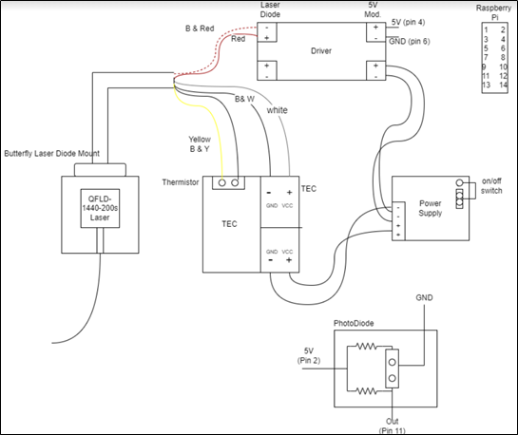

Figure 4. General System Schematic of Dr. Lemay's initial idea for a Laser Prototype

## Potential Solutions

Regarding potential solutions to the problem, we must settle on a solid circuit for recording and exporting information which will be discussed below. Based upon the desired route the team decides, all solutions will need to develop a durable physical apparatus to interact nicely with the animal as well as package the system into a portable-accessible enclosure. Each solution is evaluated based on budget, performance, and system integration with each of the components. All solutions must promote a solution that is cheaper than systems such as the Hargreaves test. The main performance of the system is determined by the requirement that it must obtain the paw withdrawal time of the animal, any additional data such as changes of temperature in the animal’s skin, are nice to include, but the paw withdrawal time is the required data Dr. Lemay is interested in. Validating this data can be done in several ways with the inclusion of additional sensors to the system. Additionally, the team aims to include automated data analysis capabilities for further results and so we can manually test validity besides simply exporting the raw data. Determining the average and standard deviation for individual animals and each group are some methods we intend to include, and we could calculate percent difference of our systems’ analysis versus manual calculations to ensure the analysis is working correctly. While each of the solutions will uphold these criteria, the system can be designed in several ways:

1. Continuing with the already developed system, we could develop an interface to check for the signal coming from the photodiode and upon starting the program it would project the laser into the animal’s paw whilst starting a counter to measure time. We could create an interface that could be connected to the RPi’s General Purpose Input/Output (GPIO) pins for sending signals to power the laser or detect a change in light from the photodiode. The RPi can then be programed to collect data that can be saved and stored in an excel file. Together, we could integrate a GUI or local website that would utilize user-friendliness through a language such as JavaScript or Python. The bulk of this solution would involve writing software to control the system, creating a mount for the laser and photodiode that would fit into the enclosure and amplify the thermal range of the laser into a precise, consistent area of the paw, and finally packaging and wiring the system within the enclosure would take some work.

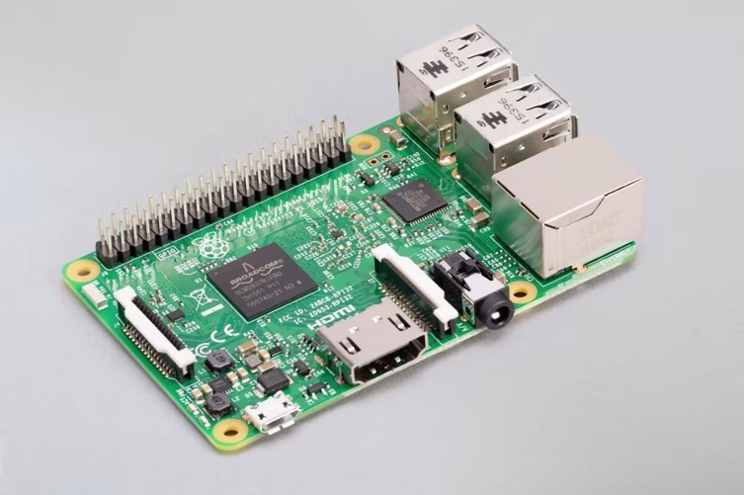

Figure 5. Raspberry Pi 3B +

Source: [18]

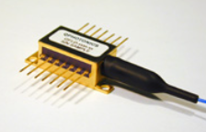

Figure 6. OFLD-1440mw Laser with Butterfly Diode Connector

Source: [9]

1. One possible solution is to focus the system as a hardware descriptive language (HDL) circuit instead of a software based. This would include integrating an FPGA board to control the system instead of a microcontroller. Verilog HDL can then be developed to build a D-flip flop like circuit which would take the photodiode’s state as an input enable signal. This would allow us to start a clock at a precise rate and start the laser circuit when the cat covers the photodiode, upon which the laser starts with the positive clock cycle. If we sample the clock rate at a small enough clock cycle, the cat will remove their paw and immediately at the next clock cycle the laser would stop running. We could then create another module to output the sum of the clock cycles when the laser was running, as well as convert the sum into seconds. Validating this design can be done similarly to the first proposed solution since they both rely on the laser and photodiode configuration. The benefit of using something like an FPGA is that everything would be done explicitly through hardware which can be directly connected to a PC via USB instead of using a microcontroller with its own operating system such as a RPi, which would need either development to publish the data to a host PC using some sort of custom GUI or allow the user to log into a remote desktop. Using an FPGA board or further fabricating a chip to complete the circuit could also utilize more analog components such as buttons or switches to turn on/off the system, for additional user-friendliness. Finally, we could create a program to automate any data retrieved from the system and export it for further analysis to excel using either python or MATLAB.

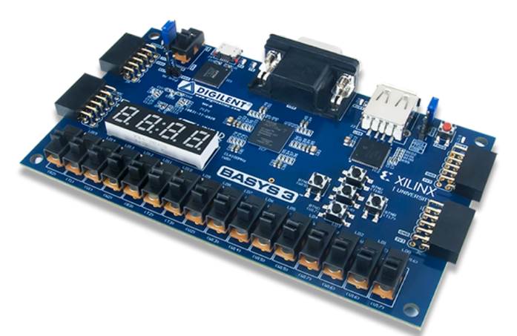

Figure 7 Basys 3 Artix-7 FPGA Trainer Board

Source: [17]

1. Despite Dr. Lemay proceeding to obtain the OFLD laser for the system, another solution he had begun to investigate before purchasing the laser included utilizing the Topcat Metrology’s HotProd, which is a handheld thermal threshold tester that measures the skin’s temperature before and after applying thermal stimulation [15]. The benefit to this solution is that this solution records the change in temperature, yielding that additional data, as well as utilizing its own low-powered batteries, so the power consumption of the laser and determining what amount of power is needed to be delivered to the skin, is no longer an issue. Creating a system around this sensor, however, would still need to use a digital circuit such as low-cost microcontroller or FPGA to create a timer that will start and stop at the correct changes in temperature, and determine when to start/stop the HotProd and using this time to estimate the paw withdrawal time for later analysis. Additionally, like the other proposed solutions, an apparatus will be constructed to house the electronics and promote a user-friendly system for the researcher and test animal.

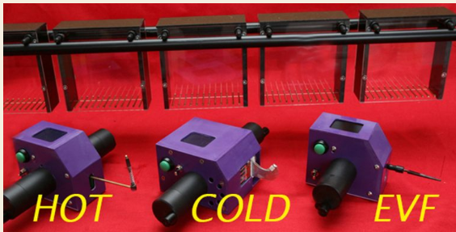

Figure 8. Topcat Metrology HotProd

Source: [12]

## Proposed Solution

After reviewing the potential solutions, our proposed solution is to continue the high-level circuit design originally constructed by Dr. Lemay and his research assistants. The primary reasoning for selecting this solution was based on component integration and budget. At the end of the day, we want to create a solution which will produce the same functionality as the Hargreaves test. One key aspect of the Hargreaves procedure, as previously stated, is to acclimate the test animal in a situation in which they are comfortable and as oblivious as possible to stimulation. Examining the candidate solution involving the HotProd, while the probe would downsize the enclosure to hold other circuits within the system, the probe would not be mounted to anything meaning the person operating the system would have to place the probe in the same area of each cat’s paw for every test, instead of remaining in a fixed location. This would also defeat the purpose of the cat being oblivious to the system and may stress the cat out. Additionally, this will require us to inquire about purchasing the HotProd, which may be out of budget. The Hargreaves test typically acclimates the animal to a new enclosure and allows enough time for the animal to become comfortable. Building an entire housing system for a cat is inefficient when thinking about the size of the animal, furthermore, exposing the cat to an enclosed environment could also take a while and waste potential testing time. When thinking about comfort, most people typically think about lying in bed, therefore, one possibility to make the cat as comfortable as possible is to create a system in which the cat lays down and never sees what exactly is happening. A general idea can be seen in figure 9 we photoshopped,

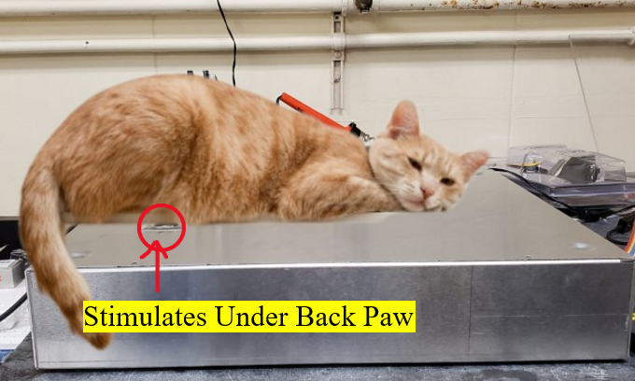

Figure 9. General Diagram for Cat Interaction with System

Using this information, we can abstract the system into block diagram with three subsystems components: software for controllability and analysis (whether it is hardware based or not), physical hardware for stimulating the paw and recording a response, and a mechanical system to mount the hardware in a precise/accurate manner to stimulate the paw,  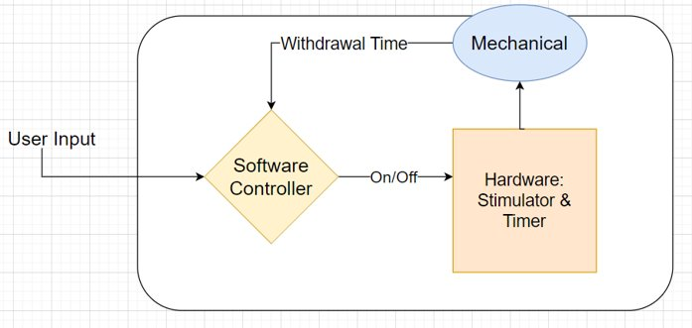

Figure 10. Abstract Block Diagram

Disregarding the HotProd solution, points the team into using a thermal laser for stimulation based on the research presented in the historical perspective and since we could develop a system to mount the laser under the general back paw area when the cat lays ton top of the system without the cat knowing. Reviewing the other two candidate solutions proposes using the laser Dr. Lemay previously purchased as a starting point. The laser operates on Transistor-Transistor Logic through the butterfly diode connector. The Hardware based solution dependent on using an FPGA board or embedded system could interact with this logic, however it would require the team to program the system on a binary level, and possibly manufacture our own chip which could get costly and dependent on supply chain since this is something Temple cannot produce in house. Furthermore, since we want to store data to our PC, if we went a custom hardware route, we would also have to purchase or construct an analog to digital and digital to analog circuits to connect to our computer, as well as develop a way to save the withdrawal time’s signal, based on a clock. This system in general would be much more complicated and time-consuming given the two-semester timeframe for senior design and would still require additional software and hardware wiring to ensure power calculations are compatible with the existing power supply, or if we will need to purchase or develop a new one. Therefore, examining the previously purchased components by Dr. Lemay sees that the laser’s TTL signal can interact with any microcontroller which contains GPIO pins, therefore the RPI 3B+ will do. Looking ahead at user friendliness, the RPI’s Linux-based operating system allows software-based languages to program the system, meaning we could use various python libraries such as *openpyxl* and *tkinter* to store information as a data base and create a simple GUI for user friendliness. Additionally, this solution already has power supplies associated with powering both the laser and RPI, which could work for prototyping, and we could decide later after a working prototype is developed, if this power supply is excessive or not, thus resulting in a potential upgrade, downgrade, or development of our own power supply.

## Major Design and Implementation Challenges

Major Design and Implementation challenges that could impact on the system primarily revolve around sustaining that no harm is done by upholding the Animal Welfare Act. Ideally, a system must be designed to test animals in a way in which they are comfortable and unaware of the thermal stimulation they are being subjected to. One possible challenge may also be the timeframe of validating the system to move to animal testing. Given the preparation behind obtaining a research animal, it is likely that the system will have to be developed and validated without animal testing and any animal testing that occurs on the system may contain a small sample size to properly observe the effects of neurotrophins. Regardless, our system will be developed to allow for ongoing testing expanding past the senior design timeframe and the team’s contributions to properly assess Dr. Lemay’s hypothesis. Additionally, the overall goal is to design a system which will be cheaper than the standardized Hargreaves test, so purchasing materials upon a design iteration must keep this in mind. Furthermore, these challenges will be discussed further in the Functional Requirements and Design Constraints section.

## Implications of project success

By creating a functional prototype, the end goal aims to create a portable, precise, and cost-efficient system which would aid the United Nations Sustainable Development Goal 3, to promote Good Health and Wellbeing [16]. Researchers such as Dr. Lemay or other neurologists can use our system to conduct nociceptive research as a cheaper, automated alternative to the expensive standardized Hargreaves test or other plantar tests. In the case of Dr. Lemay’s research, our system will allow him to study if nuerotrophins such as BDNF or NT-3 lead to an increased sensitivity, which could defer treatments away from using BDNF to help those with spinal cord injuries. Furthermore, studying the effects of nuerotrophins can lead to further research and development in treating chronic pain in spinal cord injury, with the goal to one day eliminate the chronic pain entirely. Additionally, our system will allow researchers to conduct similar studies for biological, neurological, or technological prototyping, where a nociceptor test may be needed. Our system is also modifiable, and the basis could be used and tweaked for a variety of studies whether it is conducted on small, medium, or larger animals. The system may also have an impact on Goal 15, to Preserve Life on Land, since results obtained from using our system may result in new developments for spinal cord injury within the test animals’ species as well [16].

# Functional Requirements

Keeping the background information presented in the problem statement in mind led us to draft functional requirements for our proposed Thermal Laser Plantar Test system. The main Functional Requirements include the following. To create a computerized system to interact with the hardware which will automatically turn the laser on/off based upon the state of the animal’s paw being placed over the photodiode circuit. Furthermore, the withdrawal of the animal’s response time must be recorded and yield a response of less than or equal to $+/-10$ seconds to satisfy the client’s expectations and avoid harm to the animals. The system should be user friendly, in terms of packaging, portability, human and animal interaction with the system, and the goal to develop a Graphical User Interface (GUI) for maximum user friendliness, or at the minimum, a shell script to trigger the necessary python scripts to automate the system. Testing the overall hardware and software should be repeatable within the animal group, yielding results between individual animals and those within the same group to be within less than a $20\%$ difference.

A summary of the current Functional Requirements is displayed in the following table.

Table 1. Functional Requirements with associated metrics, target values, and references

|  |  |  |  |  |
| --- | --- | --- | --- | --- |
| **Priority**  **(negotiable or non-negotiable?** | **Functional Requirement** | **Metric** | **Target Value, Range, or Pass/Fail** | **Justification** |
| Non-negotiable | Ability to capture paw withdrawal reflex data. | Computerized System is implemented and exports raw data to a file for analysis. | Pass/Fail | United Nations Sustainable Development Goals: Good Health and Well Being, Life on Land/Client |
| Non-negotiable | No Paw burn/tissue damage to the animal | Power of laser/Heat Transfer to skin | Pass/Fail | Animal Welfare Act |
| Non-negotiable | Repeatability within an Animal group | Multiple trials and accessible to animals.    Analysis such as Standard deviation, Mean, and Percent Differences will be calculated | Min: Results within less than a $20\%$ difference    Max: Results within a 1 $0\%$ difference | Client |
| Negotiable | Withdrawal time | Test subject/counter | Min: More than a second    Max: Less than $+/-10$ seconds response time | Client |
| Negotiable | User Friendly interface | GUI/Hardware | Min: Shell Scripts for data collection and packaged system with stable wiring    Max: Full GUI interface, cable management, comfortability for both the animal and user. Users' surveys will dictate. | Future Teams, Prototyping, Patenting, etc. |

# Design Constraints

Design constraints to the actual system primarily include the following ethical considerations. To develop a system to safely be used on felines, the system must consider animal welfare for performing the test, as well as safety protocols for the team when developing and testing the apparatus. The Animal Welfare Act (AWA) is the federal law in the US that provides guidelines that regulate the use of animals in research. The act gives a set of standards regarding housing, handling, sanitation, food, water, veterinary care, and protection from weather extremes. The act over the years has been amended a few times to give more protection to animals and greater fines to those who do not follow the amendment. Even though each of the changes are important, the key one that this senior design should focus on is the Improved Standards for Laboratory Animals (ISLAA). In December 1985, the Food Security Act (P.L.99-198) was added to AWA, which includes ISLAA. The amendment was created to help with minimizing the pain and distress of animals that are in a laboratory environment. If there is a researched facility, there must be a veterinarian and an unaffiliated person that must represent the welfare of the animals. If the regulations set forth by AWA are not followed there would be violations up to $\$2,500$ [17]*.* Prior research mentions the Hargreaves test upholding the International Association for the Study of Pain (IASP)guidelines. IASP guidelines for the use of animals in research supports the use of animal testing for the “development of new approaches for the management of pain.” It is understood that the range of testing can be on the spectrum of analyses that observe acute pain as well as the extreme of more complex testing that cause the nervous system to be altered because of tissue injury. With these conditions it is always expected that those who perform experiments on live animals are doing so humanely. The IASP endorses the animal welfare policies and guidelines that are established by many national and regional organizations. The reference in this case would be U.S based policies and guidelines and researchers are expected to abide by them. All publications of work after research findings must be verified by authors in compliance with these guidelines upon submission [18]. There are no local references or recommendations for our specific location of research, therefore the Animal welfare act will be the primary point of reference for our project, but we will keep other references in mind to develop the most humane system.

Regarding the project a few design constraints must be kept in mind by the Animal Welfare Act. The number of trials is important to keep in mind because there should not be any damage to the cats’ paw. There should be at most $5$ trials and a minimum of $3$ trials. There is importance of this because of two reasons the accurate data since the average set of data must be calculated and lowering the damage to the paw. There should be $5$ minutes in between each of the tests for the safety of the animal. The constraint with the animal welfare act is that there is a cut-off point (less than or equal to $20$ $seconds$) where the laser will be cut-off so that there is no potential burn injury to the cats [3].

Before any animal testing occurs, the following safety procedures will be performed.There must be proper signage around the machine to make sure that people present outside of those performing the test are aware of testing. A quick way to turn off the laser in case of an emergency was developed by adding a switch that is attached to the laser that gives the user the ability to turn on and off the laser. Before starting tests, a preliminary test at a lower energy level must be done, where the power of the laser will be stepped up and set to avoid any harm. While assembling the laser it should avoid eye level whether the person is standing or sitting, we must make sure the area is clear around the table, and there cannot be any reflective material near the laser. This differs however from our acrylic plate since that aspect of the project is to amplify the thermal range of the laser to a greater surface area of the animal paw. Personal Protective Equipment (PPE) should be labeled and stored in front of the lab. There needs to be a pair of proper safety glasses for everyone near the laser with the correct optical density and wavelength. Only use material that will not produce harmful chemicals when the laser is applied to it, and the laser should be covered while not in use or once it is finished. In addition to other safety concerns there needs to be a plate that will be applied to the laser so that the laser diode is focused and not dispersed throughout the machine [19]. Any testing with the laser will be performed on us because human skin is less resistant than that of cat. If the laser performs without costing considerable damage to our fingers, then it is known that the cat can handle the power of the laser.

Additionally, the project aims to create a cheaper system than the Hargreaves Test, meaning the finalized product must be less than $\$10k$, and our contributions to the existing prototype must be within budget of $\$1000$ granted to the four-person senior design team. Making a test that is less than $\$1000$ gives the possibility of creating an affordable alternative option when wanting to do testing like the Hargraves Test. Regarding the microcontroller one constraint is the option to continue development with a Raspberry Pi 3B+ or move to another microcontroller such as upgrading to a Jetson Nano which may have better performance due to the GPU, or downgrade to a cheaper microcontroller such as the Raspberry Pi Zero, depending on complicated the hardware and software interfaces may need be. The option to change microcontrollers is ultimately determined by the interaction with the rest of the system, such as compatible python libraries to handle data collection/exportation while using the RPI’s GPIO pins, as well as cost, and performance with the rest of the system. Furthermore, initial testing done by Dr. Lemay found that the photodiode component’s durability has been flimsy in testing. To help with this, an acrylic plate is created to create a shield over the photodiode and the laser. The acrylic plate hinders any damage that may be done to the laser and diode because the cats' paw will directly be on the acrylic versus on the photodiode. Additionally, the acrylic plate’s interaction with the laser is a method to increase the thermal range once the animal is touching the plate, by letting the laser refract through the plate itself. The laser also renders an operating current of at least $1.01A$ received by the datasheet for OFBGLD-1460-350. Getting the create setting for the current is important for the wavelengths to hit the pain receptors beneath the skin without heating up the skin. Determining the correct power for safely testing on humans and animals will be determined by setting the trim potentiometer on the laser, adjusting the height of the acrylic plate, and testing the interaction between these components and the photodiode’s readings. Any upgrades to these components may result in additional hardware upgrades/downgrades to overall circuit, which may impact the budget of the project, as well accessibility. The final project design should be a non-engineer user-friendly, packaged-portable system with secure wiring and a testing apparatus that interacts nicely with the animals, so they are not uncomfortable or afraid of testing.

A summary of the current Design Constraints is displayed in the following table.

Table 2. Design Constraints with associated metrics, target values, and references

|  |  |  |  |  |
| --- | --- | --- | --- | --- |
| **Priority (negotiable or non-negotiable?)** | **Design Constraint** | **Metric** | **Target Value, Range, or Pass/Fail** | **Justification** |
| Non-Negotiable | Minimum number of trials performed per day. | Laser Power to Footpad/Tissue Recovery | Min: ≥ $3$ Trials per animal paw per day    Max: ≤ $5$ Trials per animal paw per day | Hargraves Test/ Animal Welfare Act |
| Non-Negotiable | Budget/Cost efficiency. | Cost | Less than $\$10k$ (More cost efficient than Hargreaves system) | Client/SD |
| Non-Negotiable | Animal Welfare | Animal’s interaction with System/Animal Health | Pass/Fail | Animal Welfare act |
| Non-Negotiable | Precise data collection-time resolution, and ability to validate the data. | Response time.    Dependent on laser, photodiode, acrylic plate, and software interaction to collect data. | Collect and validate data collection to ensure the system is determining valid readings at a rate of milliseconds. | Client |
| Non-Negotiable | How to increase the thermal range once the animal is touching the plate. | Distance of the acrylic plate to laser. Setting current/power of laser. | Pass/Fail | Performance of System |
| Non-Negotiable | How to increase the power that goes through the laser | Setting current of the Laser Diode | Min: ≥ $0.5A$ Max: ≤ $1.0A$ This is trial and error | Performance of system/Animal Welfare Act |
| Negotiable | Laser upgrade/downgrade | Examining the power of the laser to paw, after all other system components are set. | Min: Through trial and error we experimentally develop a safe range for humans and animals.  Max: Use an IR Power meter to measure the power of the laser onto the acrylic plate and develop a safe range for humans and animals. | Performance of System/Budget |
| Negotiable | Photodiode replacement | Interaction with $5V$ RPI | Min: Continue using the same photodiode    Max: Replace with better suited photodiode | Performance of system |
| Negotiable | Microcontroller replacement | Cost and Efficiency | Min: Continue using the RPI    Max: Upgrade or downgrade microcontroller to establish the best performance of the system | Performance of system |

# Design Approach

## System Overview

To perform an iterative design process for our system, an initial work breakdown structure was drafted to break the design up into various areas and phases. Based upon our proposed solution stated within the problem statement section, continuing the prototype developed by Dr. Lemay and his previous research students was seen as the most effective method to complete our design. From a cost standpoint, the current system introduced the idea of using a laser for stimulating the footpad, and the addition of selecting an RPi3B allows for easy object orientated programming to be interfaced with the laser by utilizing the GPIO pins. Upon review, aiming to finish the system using these building blocks and upgrading/downgrading as necessary drifts the project away from having to scope out components for the system from scratch. Attempting to integrate these components into a functioning system thus focuses the project towards data analysis and user/animal friendliness.

The design process can really be broken down into 3 aspects, software, hardware, and testing. Hardware consists of electrical and mechanical circuits such as the power supply, driver for the laser circuit, photodiode circuit, RPi3, laser, and acrylic plate for animal to place its paw on during testing. The Software design explores the interfacing between the photodiode and laser circuit so a valid test can be performed. From that, the rest of the software design includes data collection/analysis, and creating an easily understood, user-friendly GUI for the person running the experiment. Keeping in mind the overall idea of the cat laying upon our system, the following block diagram was developed to expand upon,

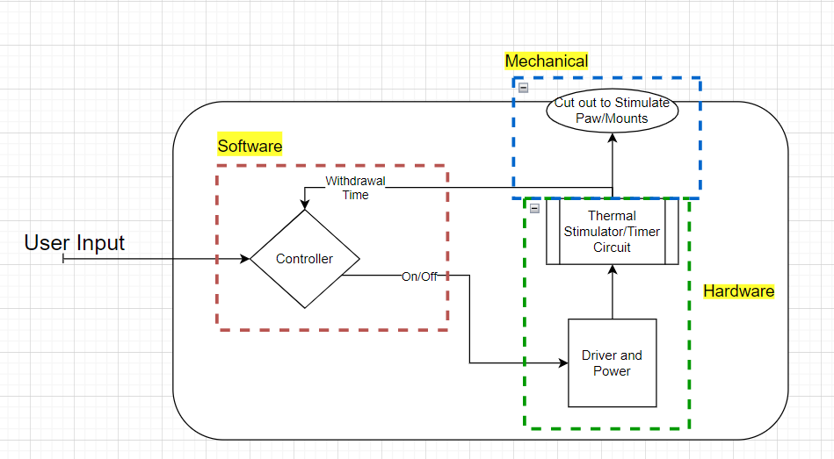

Figure 11. Block Diagram of the System

The final portion of the design process is testing. The testing aspect is for the team to understand what is working within the project and what is not working within the project, this way the team can go back and iterate upon what we know and do not know yet. This will also allow the group to add any additional sensors or rethink the proposed methodology of the system. By testing each aspect of the system, then once a functional prototype is established, then as long as the system upholds the animal welfare act, and has been tested safely, then the initial animal testing can be performed, and the performance of the system can be evaluated, so the team can determine if we need to go back and redesign any aspect of the system. The process for testing each component will be explored within the Test Methods section. The work breakdown structure is shown below, with the rest of the design approach section discussing further about each subtask.

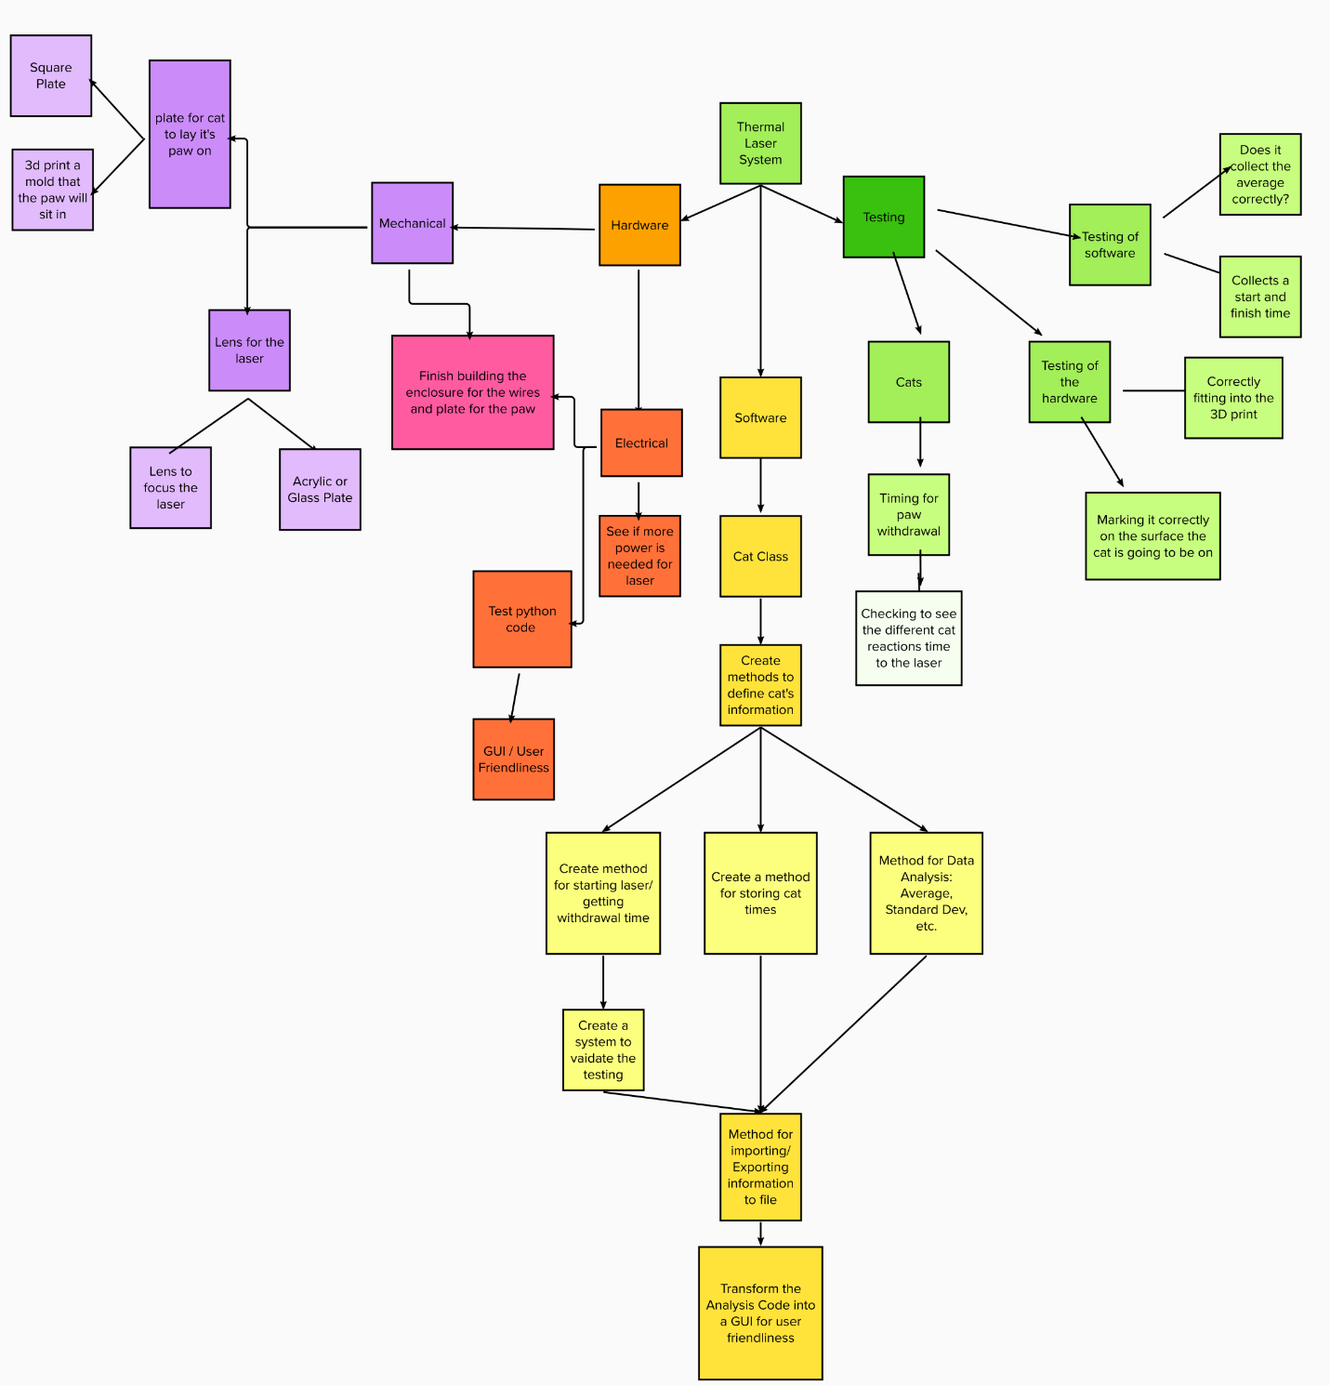

Figure 12. Work Breakdown Structure of the System

## Design Methodology

### Data Analysis

The analysis performed upon exporting the cat’s trials is done by utilizing functions from python3’s statistic’s library.

Equation 1

|  |  |  |
| --- | --- | --- |
|  | $$statistic.mean(data)$$ | (1) |

Python’s mean function simply works by returning the sum of the data passed in divided by the number of data points. Data passed into the function can be a sequence or iterated upon [20].

Equation 2

|  |  |  |
| --- | --- | --- |
|  | $$statistics.pstdev(data,mu=none)$$ | (2) |

Equation 3

|  |  |  |
| --- | --- | --- |
|  | $$statistics.pvariance(data,mu=none)$$ | (3) |

The statistics library also contains functions for finding the standard deviation and variance of the data passed in. The functions take in data which is stored of a data type that can be iterated upon non-empty sequence of numbers. This means the exact population of the data is known, so the data can be accurately analyzed instead of using an estimate by Bessel’s correction. These functions can be used because they are applied to the animal’s data after all the trials are collected for the day, meaning the data set for the animal is complete. The optional argument *mu* refers to the mean of the data. If the second argument is missing when called, the functions automatically call the *mean()* function to calculate the average [20]. Since these functions are based upon the population, their libraries are the official python implementation of their mathematical formulas below:

Equation 4

|  |  |  |
| --- | --- | --- |
|  | $$μ=\frac{\sum_{i=1}^{N}{X}}{N}$$ | (4) |

Equation 5

|  |  |  |
| --- | --- | --- |
|  | $$σ^{2}=\frac{\sum_{i=1}^{N}{{(X-μ)}^{2}}}{N}$$ | (5) |

Equation 6

|  |  |  |
| --- | --- | --- |
|  | $$σ=\sqrt{σ^{2}}$$ | (6) |

Where $σ^{2}$ is the variance and $σ$ is the standard deviation, $X$ defines the current trial time, $μ$ is the average of the trials, and *N* defines the number of trials that have occurred. Analyzing the animal’s withdrawal time differences using these methods allows the user performing the experiment to know how dispersed the data is in relation to the average, and how far the difference in withdrawal times are from each other with regards to all the trials for one animal, or within a group of animals [21].

## Software

The process of creating software for the system to utilize for performing a test can be thought of as three separate phases:

1. Data Collection
2. Analyzing and Exporting Data
3. Graphical User Interface

The idea of breaking the programming down into three phases allows us to focus on the minimal functional requirements, which is to create a system that will run a trial for the animal and calculate their withdrawal time, simply by creating a program to run within the terminal. Upon the completion of phase 1, the second phase will focus on transferring data from the program to output files for further storing and analysis. With Phases 1 and 2 complete, everything that the system needs to properly run will be complete for testing, the final phase is simply to take the results of phases 1 and 2 and create a GUI for user-friendliness. By breaking up the design into these phases, the idea is that once a phase is complete, we should not have to edit any of the programming we have done so far, but simply pass information from one class to another, without breaking the system.

The system’s software can be downloaded directly from the project’s GitHub repository, by navigating to <https://github.com/Rbara00/ThermalLaserSD> and either manually downloading the files, or by opening a terminal and navigating to the desired directory and running the git clone command as follows:

>>git clone <https://github.com/Rbara00/ThermalLaserSD.git>

The requirements for the project are found in the file titled “requirements.txt”, which can be installed in a variety of ways, such as using the terminal command:

>>pip install -r requirements.txt

Furthermore, any updates that are made to the repository can be downloaded using the commands:

>>git pull

or

>>git fetch

All software can be found within the appendix of this document, as this section will discuss the logic behind syntax. Upon reading the following subsections, the python script shown in the appendix contains comments throughout each class file to properly annotate the implementation.

### Data Collection

The first phase of the software design consists of creating a valid method of data collection to turn on/off the laser and collect the cat’s withdrawal time. A timer program was originally established by a previous Graduate student working within Dr Lemay’s research lab. Upon review of the student’s program, the timer algorithm served as a basis within our software design by transforming the program into a function that was further tweaked a refined. The function itself belongs to a custom class that will create a data structure for the test animal which will hold objects to collect their data, and determine the animal’s average time, standard deviation, and variance between trials.

Keeping this in mind, a breakdown of the *animal_class.py* class file starts with the constructor. This class was completed during the first half of Senior Design I.

#### Animal Constructor

The constructor simply allows for a variable of type animal to be created where the name and group number of the test animal will be passed in and assigned as objects to the animal created. The constructor also creates a list to store all of the withdrawal times for each trial to be performed, as well as initializing variables for the animal’s average, standard deviation, and variance to be $0$.

#### Running a Trial

Now that an animal has been established, the class can call other functions of the animal class to gather data for the current animal being tested on. The function *animal.Trial()* is developed as shown in the flowchart below. The program enters the function and will call the timer function, which will start/stop the system and gather the withdrawal time. Once the withdrawal time is returned to *animal.Trial()* function, the user will be allowed to determine if this was a valid trial. This functionality is designed incase anything visually goes wrong during a test. If the user determines the trial is valid then the withdrawal time is saved as a trial by calling the *animal.insert()* function, and functions to calculate the average, standard deviation, and mean are called if there are at least $2$ trials completed. The *animal.Trial()* function then returns back to the driver program that called the function.

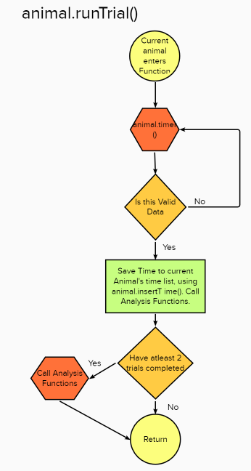

Figure 13. Flowchart of animal.Trial() function

#### The Timer Function

The *animal.timer()* function runs as follows, the program enters the function and initializes the RPI’s GPIO pins. The program then checks if the animal’s paw is initially placed based upon the state of the photodiode. Once the paw is initially placed and the photodiode is covered, a signal is sent from the photodiode into the RPI through GPIO pin 11, which processes the state change and sends a Transistor-Transistor Logic (TTL) signal to the laser. The TTL signal operates between $1.5V-5V=1$ or GPIO.high to turn on the laser, and between $0V-0.7V=0$ or GPIO.low to turn off the laser [22]. The function sends out a signal through GPIO pin 13 to turn on the laser, as well as turn on a mounted LED on the side of the system in GPIO pin 15 which allows the user to see when the laser turns on or off. The initial time is also recorded here once the laser turns on. Upon the animal’s paw removal from the laser, the state of the photodiode changes, which sends a signal to shut off the laser and record the stop time. The time difference is then calculated to be returned to the *animal.Trial()* function, and the GPIO’s signal states are cleaned up.

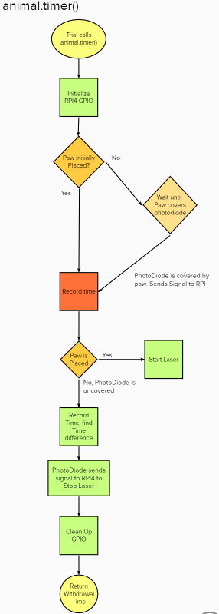

Figure 14. Flowchart of animal.timer() function

#### Remaining animal_class.py functions

The remaining functions written within the animal class are simply written to be utilized for analyzing and exporting the data collected. These functions allow other classes to get the animal’s specific trial time, name, date, number of trials, as well as print all the animal’s information to the terminal for debugging purposes. These functions are simply written as getter functions since their information is stored as objects local to the current animal. The current animal’s average, standard deviation, and variance are calculated by functions to the animal class that call respective functions from the Python’s statistic library on the animal’s withdrawal times, as seen in the figure below, where the sample is the selected cat’s list of response times and the cat’s average is assigned the output of python’s mean function which computes equation 4 defined above in the Data Collection section.

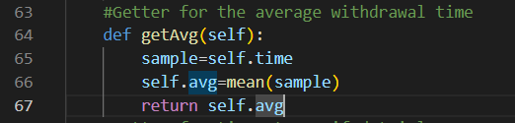

Figure 15. Function for computing Cat's Average Time

### Saving/Exporting Data

Originally, we sought to save each cat in a single python list and iterate through the list whenever we wanted to compare or find individual or group analysis, however this algorithm proves to have a terrible complexity defined by $O(n)$ as the worst case scenario, meaning that the program would have a target cat name or group it would be looking for, and have to traverse through the master list until it found this cat, then upon finding the cat, it would have to traverse through the individual cat’s list [23].

#### Storing Data Within a Table

After exploring various algorithms in ECE3822 Engineering Computation II, a better solution we moved to which was the model the database similarly to a hash table which would have a complexity of $O(1)$ [23]. This phase of the software was mostly completed during the second half of Senior Design I, with adjustments made throughout Senior Design II. This is done by creating an array of python lists to create a table. Illustrated below is a general idea of how the tables class works. Since each cat is prompted for a group number and name, the search index for the cat would be based upon group number, in which the program will then iterate through the row of that table to find the selected cat by name. Once the cat is found, then access to that particular cat’s data and analysis can be accessed, since it is an attribute to that cat’s object.

Table 3. Database Table Example

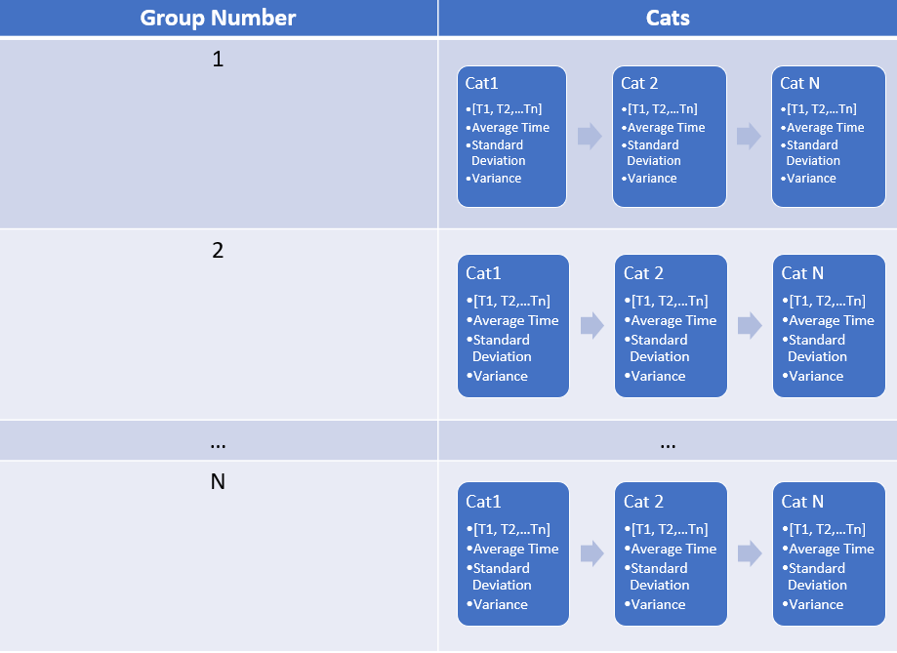

This process continues may continue for as many groups and cats as there are found within the table, or for a maximum of $2^{63}$ number of groups and cats per every time the python program is ran. This is because it is the maximum number of items the $64bit$ RPI3 can hold in a python3 list [20].

#### Exporting Data to Excel from Table and Performing Group Analysis

Furthermore, using this setup also allows exporting the data to excel very easily using *openpyxl* within the *export.py* class. The process for exporting goes by prompting the user upon exiting the program for a filename. If the filename does not exist, *openpyxl* creates an excel file, which then traverses the table to find the maximum group number and an excel sheet for each group. A function is then used to format each column and then the program simply copies each Cat and their data to excel. Initially functions for group analysis were written using python’s statistic functions, however the switch to excel was used for group analysis for finer precision and optimization. This switch will further be discussed in the test methods section, specifically test method T_FR3, when testing repeatability, this algorithm was discovered and changed to better performance. Upon exporting all cats within a group, the python program then automates excel using strings in conjunction with *openpyxl*, meaning for example, we could tell a particular cell to contain the value “=AVERAGE(G2:G4)” and excel would convert this string into the computing the excel function and return the average of the values from G2 to G4 into that particular cell. Using this idea, all group analysis can be computed and a typical excel sheet output looks as follows,

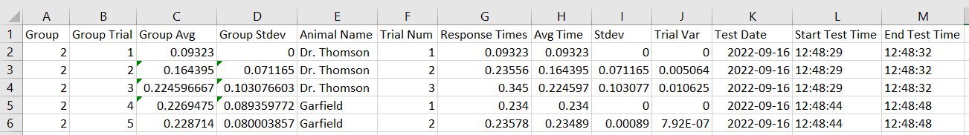

Figure . Example of an Excel Export for Two Cats in Group 2

Upon completing the export and analysis for each group, a bar graph is then automatically generated and added into a new sheet named “Results”. The bar graph is found by using python to iterate through excel and find the maximum number of rows that contain data. Using this, the program knows what index to check to find the last values exported for group average and standard deviation. The following is an example graph generated using data within groups $1$, $2$, and $4$,

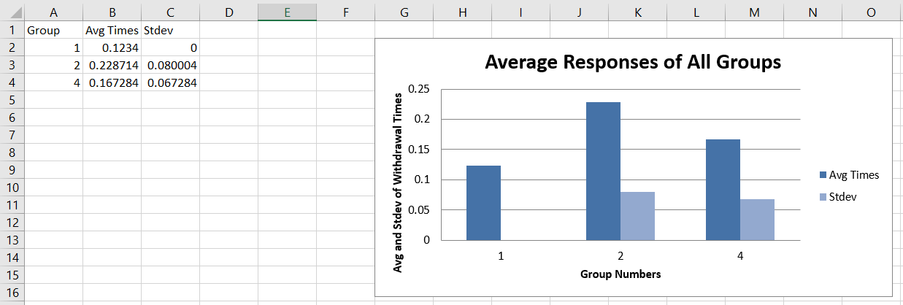

Figure . Example Bar Graph Output

#### Importing Data from Previous Tests

Exporting data from the hash table to excel and automating excel to perform group analysis allows the python script to destroy the hash table upon exiting each program. If the user wanted to continue using the same data, then upon the next test, when the python script asks for an excel filename, the user would simply overwrite the previously saved excel file. The *export.py* class then checks for the maximum number of groups again, and creates any new sheets needed. The program then exports all new data to their respective groups, deletes the sheet titled “Results” which contains the bar graph, and recomputes the group analysis. After the group analysis is completed, the program simply recalls the function to create a new sheet titled “Results” and creates the bar graph as normal.

Additionally, the user can remove previously saved trial data from the excel file or add further analysis as long as any new information added to the spread sheet is not written in a cell that exceeds the maximum number of rows, which may confuse the program when searching for the group analysis to graph.

### Graphical User Interface

Determining a method for which the GUI will be implemented is largely based upon two criteria:

1. Compatibility with various Operating Systems
2. Accessibility of individual libraries

By utilizing a GUI method that is cross compatible with various operating systems, this will allow the team to develop the GUI by simply amending the function to collect data, to manually insert data, thus creating a development workflow that is nondependent on the current operating system. That is to say, the team and user could migrate the software to different raspberry pi’s by simply editing a couple of lines to the source code, or develop the GUI externally from the RPI, such as developing on their home Windows PC. The second criteria for selection of the tools the team uses to develop the GUI, is based upon the functions written within each library. Similar to phase 2 for exporting, most of the GUI can be created by prompting the user to make decisions through a display which they are allowed to click and type information to, rather than type decisions through a terminal prompt.

Towards Science published an article from a development standpoint that acts as an introduction to the various libraries that are out there. The article lists potential pros and cons a developer may face and links the reader to the official documentation of each library, as well as including a YouTube tutorial to get started working with the library [24]. This article was used by the team to understand what candidate options are available for developing the GUI, options that were regarded as cross-platform are currently being analyzed further to understand which library will best fit the second criteria for the project.

#### Tkinter

Ultimately, the *Tkinter* library that comes packaged with Python3 was selected for its simplicity and accessibility, since it is a common library compatible amongst all platforms that can run Python3 and could be further developed post project. This phase of software development was written during the first half of Senior Design II.

Since all data collection, analysis, and exportation was previously implemented up until this point, the only real design work was to convert these functions into a format acceptable for *Tkinter*. To establish maximum user friendliness, the decision direction of the GUI aimed to go for a simple sleek design that will fit on the external monitor’s resolution or larger external monitors.

#### Structure of the Program

The following figure describes the structure of the previously written driver function to execute the terminal version of the program. The program can be broken down into two major sections:

1. Starting the Program and creating an Animal

2. Testing an Animal

With each decision initially as a terminal prompt. The first section’s major prompts are to begin a test and ask the user for a name and group number, while the second section’s major decisions are to prompt to run a trial, keep the acquired data, keep testing the same animal, test a new animal, or exit the program, which then activates the export class,

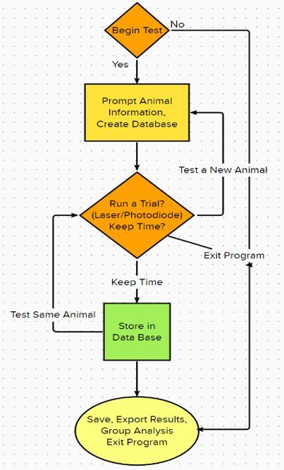

Figure . Control Flow of Program

Keeping this in mind, and for simplicity’s sake, we took advantage of *tkinter*’s frame capabilities to create two frames, one for prompting the user to begin the test and ask for the animal’s name and group number, while the other controls testing the animal and saving the results. From this, we can eliminate the need to type by implementing *tkinter*’s buttons to activate the simple “yes” or “no” decisions as displayed from above and use *tkinter*’s message boxes to create simple popups for the user to enter information such as the name and number of the animal. Using the message boxes will allow eliminating the need for implementing text capabilities within the GUI’s frame or eliminate the need to create any further frames.

##### Callback Functions

To convert these functions to execute in the same flow, some of the previously defined animal class functions had to be converted from operating using while loops to callback functions. This means that the GUI’s frames are always running from a higher level and await a software interrupt triggered by the end user. These software interrupts in our case are implemented by the buttons attached to each frame, where each button is a function that will either run until another software interrupt is triggered, calls another function, or is specified to return back to the main GUI frame.

The structure of the callback function is actually the reason a physical LED was installed into the side of the system to signify when the laser is on because the timer function that turns on the laser and obtains a withdrawal time, occurs within a callback function. The timer function itself operates as a while loop waiting for signals from the RPi’s GPIO pins and yielded software bugs when attempting to update the GUI’s label in time to signify when the laser is on or off. Instead, the LED was connected to another GPIO pin which outputs a high or low signal whenever the laser is on or off.

From this the GUI was created and the structure of the GUI will be discussed in the “Performing an Experiment” section.

## Hardware

The following sections will go into further information about electrical parts that interact to implement our system. It is worth noting that, originally Dr. Lemay had purchased an additional Thermal Electric Cooler (TEC) circuit prevent thermal runaway if the laser were to overheat, however, the laser’s mount came with a heat sink that has been effective in keeping the system stable, so we made the decision to remove the cooler from the final design.

### The RPi3B+

As stated previously, the microcontroller selected for this system is a Raspberry Pi (RPI) 3B+ to communicate between the computer and laser design. The microcontroller is described as, “an inexpensive, credit care sized computer that can be interconnected with a computer monitor, a standard keyboard and a mouse” [25]. Figure 6 shows the RPi that is being used in our design. The microcontroller contains key components such as, General Purpose Input/Output pins (GPIO), USB ports, a gigabit ethernet used to connect the PCS and servers to local networks, a choice of different RAM, a processor and USB-C port. The RPi 3B+ holds $1GB$ of ram and $64GB$ of memory [25]. The interaction and role of the RPi was discussed previously in software section.

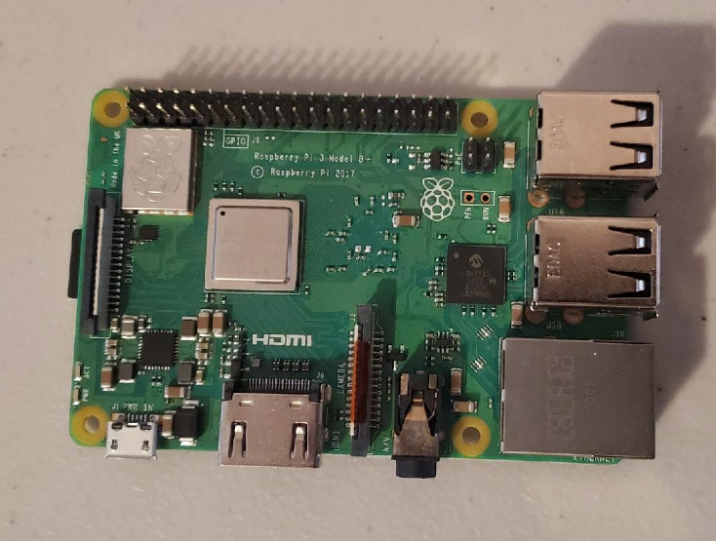

Figure 19. The RPi 3B+ Board

The system also includes monitor for the RPI which came with a $5V, 2.5A$ power supply to power both the screen and RPI from a wall outlet.

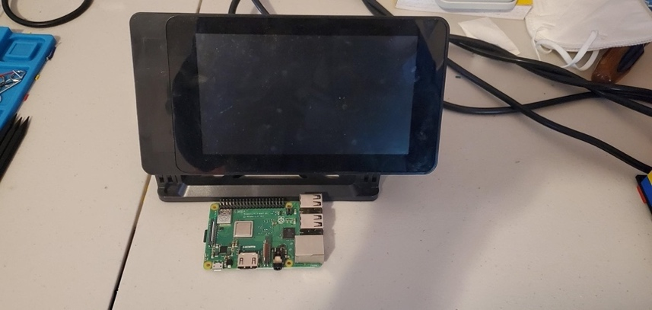

Figure 20. RPi board with screen monitor

### Photodiode

One of the important parts of the design is the photodiode that is used alongside the laser. A photodiode also known as a photodetector, photo sensor, or light detector converts light energy into electrical energy. Electrical energy could be either voltage or current into the circuit [26]. Our design uses a photodiode to detect when the cat is covering the acrylic plate, meaning its paw is over the laser and ready for stimulation.

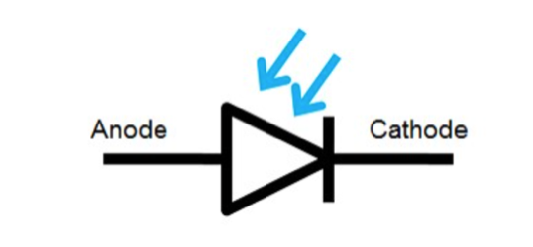

Figure 21. Photodiode symbol

The specific photodiode we use within the is also connected to a built in photoreceiver which acts similarly to a transistor and detects a response from the photodiode and amplifies the signal. The photoreceiver is denoted within the schematic as a Bipolar Junction Transistor (BJT) symbol. The photoreceiver is connected to $5VDC$ voltage source and resistor biased using a voltage divider method to output $4.82VDC$ to emitter leg and amplify the photodiodes voltage signal from microvolts into volts which RPI can understand.

Equation

|  |  |  |
| --- | --- | --- |
|  |  | (7) |

The photodiode and photoreceiver in real life are designed together as one key component which can be seen in the following picture next to the laser mount. More information about the signal sent by the photodiode was previously discussed in the software section.

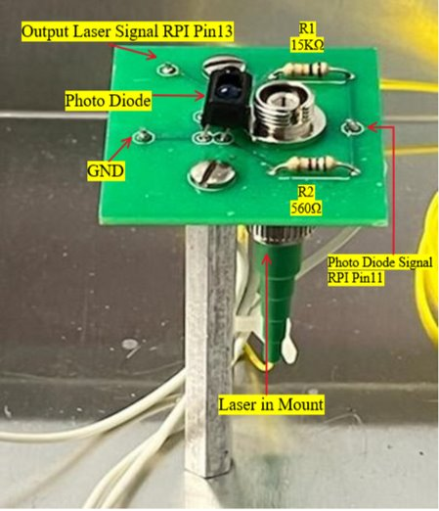

Figure 22. PhotoDiode and Laser Mount circuit

### The Laser

The laser that is being used in the project is an Optical Feedback Laser Diode (OFBGLD) 1460-360. The laser was purchased from QPhotonics. This laser operates by acting like an on and off switch for the diode. When it comes to the output signal it is wired through a specialized connector which is great because it makes connecting and programming the laser to the Raspberry Pi very easy. There was a Fiber Coupled Laser Diode OFLD-1400-200S used in the beginning however after noticing there was not enough current being pushed through an upgrade was done. The upgraded laser was needed for the current, the power being pushed through, and the wavelength. The OFLD-1400-200S laser had an operating current of $678 mA$, which is shown in figure 23.

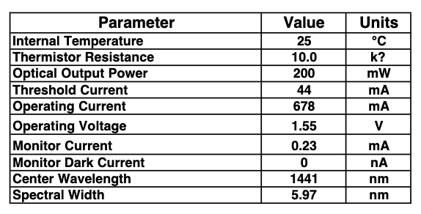

Figure 23. Datasheet for Fiber Coupled Laser Diode

*Source: [9]*

After testing the system on us it was noticed that it does not have a reaction time within the ten seconds that was needed. This is due to the maximum current felt through the acrylic plate to stimulate a reaction. The OFBGLD laser has an operating current of $1014 mA$ nearly doubled that of the OFLD laser which is shown figure 24 that is the datasheet for the optical feedback laser diode.

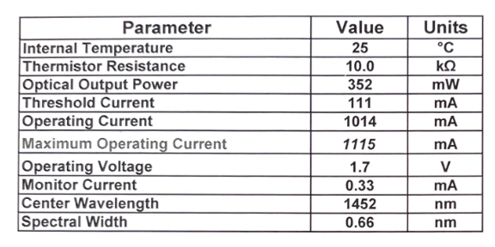

Figure 24. Datasheet for Optical Feedback Laser Diode

*Source:* [14]

Additionally, the QFLD-1400-200S fiber exposed laser had a beam that was too divergent which made the power not be as strong since it was losing power. The OFBGLD-1460-350 laser how ever has a connector that will make sure all the power is exited through the narrow beam. The last reason it was updated was because of the wavelength. It was shown in a 2003 study it shows that thermal wavelengths at 1400 nm does not heat up the skin but goes through the skin and stimulates deep neurons beneath the initial layer of skin which will activate pain receptors [10]. Figure 25 shows what the layers of the skin are, and the goal is to go through the skin into the epidermis which has the pain receptors inside it. The pain receptors stimulate the nerve within the dermis.

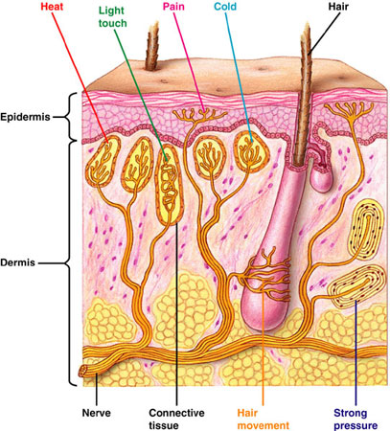

Figure 25. The layers of the human skin

*Source:* [27]

### System Schematic: (Power Supply, Driver, Laser Interaction)

Expanding upon the previous block diagram which will be shown again below,

 The following schematic uses the key components described within the design approach section to dictate the overall final design. The actual interaction between the hardware, software, and mechanical subsections will be discussed within the performing a trial section.

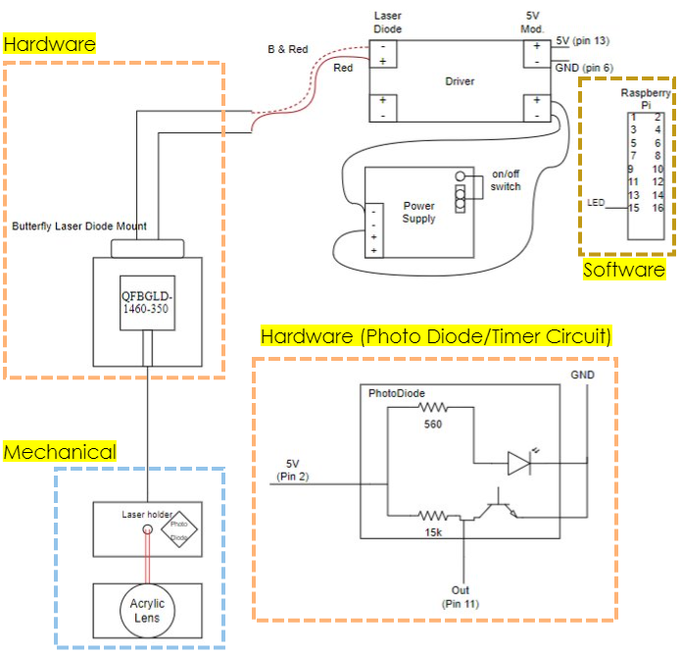

Figure 26. Final System Schematic

The DC power supply circuit steps takes in $120VAC$ wall power from a 3prong cord and converts the voltage down to $12VDC$. The power supply circuit connects the $12VDC$ as an input to the laser driver circuit [28].

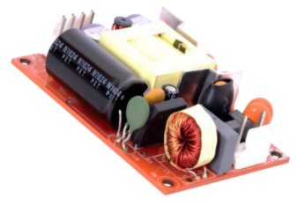

Figure 27. ABC41-1T12L Power Supply

*Source:* [28]

The laser driver utilizes Transistor-Transistor Logic (TTL) to power the laser on/off by connecting the TTL pins to the Butterfly Laser Diode Mount. This means the laser will be off when a voltage between $0-0.4VDC$ is delivered and will activate on between $2.4VDC to VCC$. Voltages in between in the on/off range depend on the device. In our case as stated in the laser subsection, a voltage of $1.7VDC$ will conduct the laser to turn on. Additionally, a trim potentiometer is located on the driver circuit to control the laser’s current as a DC current source. The Laser driver circuit is shown in more detail below.

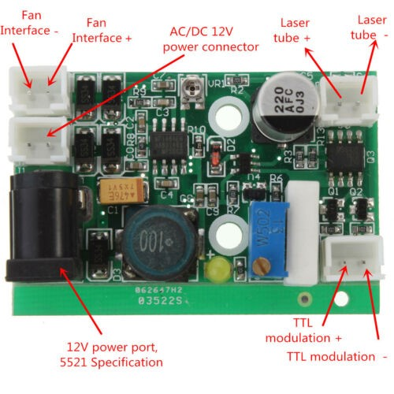

Figure 28. Laser Driver Circuit

The Butterfly Diode Connector is shown below with the following pinout taken from the datasheet,

Table 4. Butterfly Diode Connector Pinout

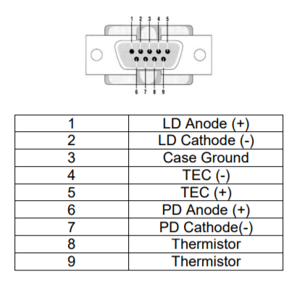

A switch is connected to the connector to allow the user to arm or disarm the laser for safety. An implementation of the system shows the previously described connections, which can be compared to the previously shown schematic,

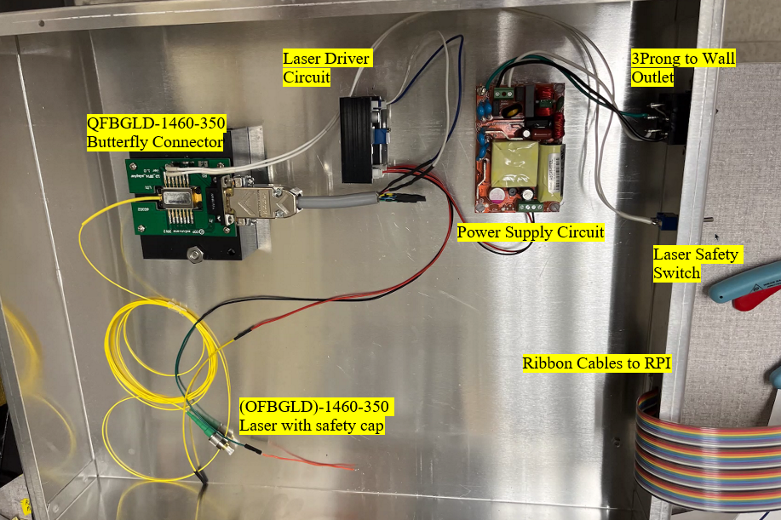

Figure 29. Implementation of the Schematic

As mentioned previously, the laser is finally mounted next to the photodiode circuit as shown again,



Figure 30. Photodiode and Laser Mount Implementation

## Mechanical

### The Acrylic Plate

The idea of using an acrylic plate came after initial testing of the laser during SD I, without any amplification of thermal range. Initial results proved the laser could trigger and capture a reflex, but only when your finger is placed exactly on top of the laser, therefore this will not produce repeatable results. This will be discussed further in the test methods section. To amend this, an initial design was to have a laser end cap that would increase the diameter of the thermal laser. The idea was scraped due to how expensive commercial options were that would match the dimensions of the end of our laser. Furthermore, the design constraint of aiming to stimulate the same exact portion of the paw each test came into question, which would affect repeatability and would not be solved by using an end cap. This led the team towards the idea of manufacturing a transparent plate to guide the paw over the laser so the test could be repeated. The choice of acrylic was used due to the process of cutting glass versus acrylic.

The next issue that had to be addressed was what thickness the acrylic should be to make sure that the paw would be able to be stimulated by the laser. The initial thickness that was used was a $\frac{1}{8}$ inch acrylic sheet. Using SolidWorks, the model was created to have a lip that would sit on top of the top plate. There was a $5mm$ lip that the router cut out of a larger piece of acrylic. After the outline of the acrylic piece was made, the piece was then put into the CNC mill which had to be programmed. The result is below.

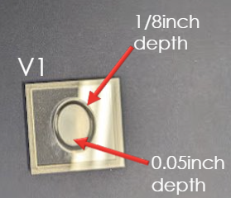

Figure 31 :Version 1: 1/8-inch Acrylic Plate

The acrylic piece was tested, and the paw was unable to fit into the designated oval, so the design was modified. The depth was also not correct and the finger that was tested was not stimulated enough by the laser, so the acrylic sheet needed to be enhanced to a thicker piece. The acrylic sheet that was used after was the $\frac{1}{4}$ inch.

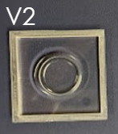

Figure 32. Version 2: 1/4th inch Acrylic Plate

Once the design was modified and updated the router was used again to make more acrylic pieces. The code for the CNC needed to be modified as well and then placed into the CNC. After the mill was finished the bottom of the acrylic was opaque and the laser was not able to penetrate the surface. An acrylic cleaner was used to create a transparent face for the surface, which then allowed for greater penetration. While version 2 proved to be effective, the only issue was that the diameter of the circle to guide the cat’s paw was deemed too small, therefore a final version of the acrylic plate was created to increase the circle’s diameter, based after measuring the paw of an actual cat,

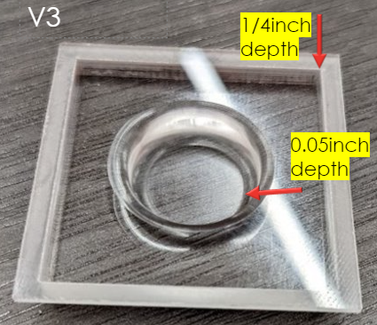

Figure 33 : Final Version: 1/4-inch acrylic piece

### The Lid

After the acrylic plate was worked out, the lid needed to be routed out and screwed into the baseplate. Using SolidWorks, a model was created to cut out a piece of aluminum for the acrylic piece. Due to the part already made, there was a trial and error between the distances of the acrylic plate and the laser from the placement of the screws in the top plate. After multiple iterations, one of the issues that occurred was the router’s laser is not exact. In order to fix this problem, another piece of wood was used to create a new origin. After that was fixed and the displacement of the acrylic plate and the laser were centered the final plate was able to be aligned with the screws.

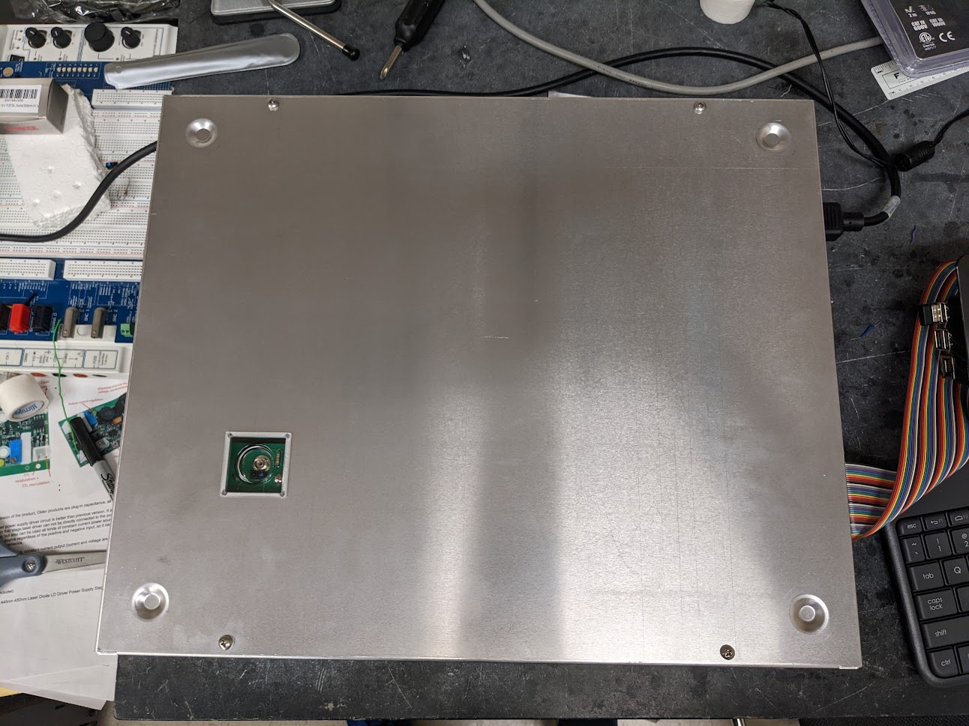

Figure 34: The laser centered, and the screws screwed in

## Performing an Experiment

Upon the completion of the software, hardware, and mechanical design, this subsection will discuss the overall schematic and walk a user through using the system for the first time.

Attached is a picture of the finalized system set up and ready to run a trial. The following subsection will discuss the process for a first-time user using the finalized system.

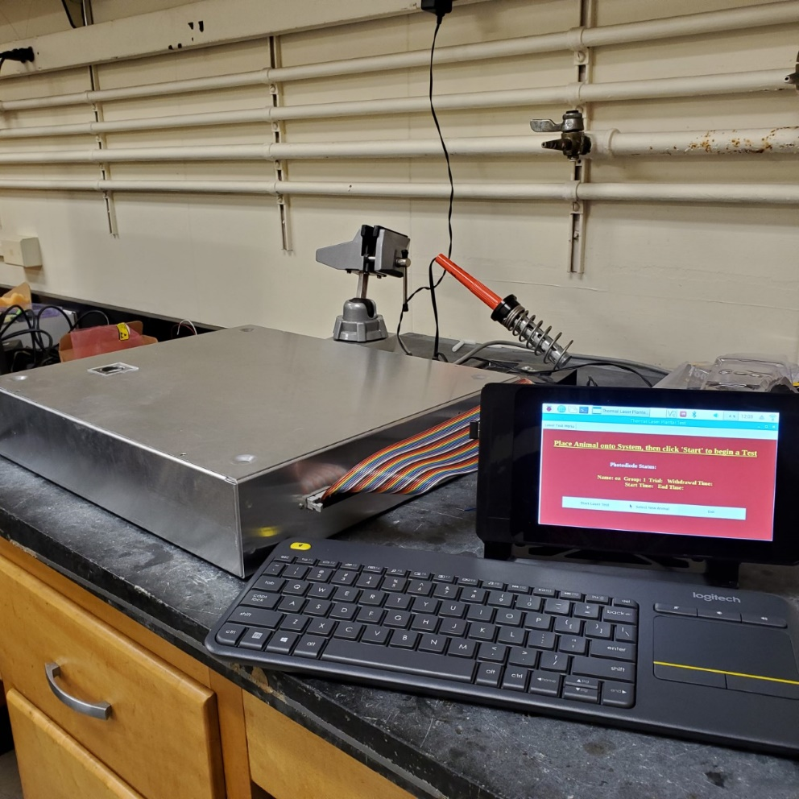

Figure 35. Picture of the Finalized System Ready for a Test

First, connect the three-prong power which powers the laser circuit, as well as the power supply for the RPI and screen, into an outlet. Push in the power button on the RPI supply to turn on the RPI and screen. Using the keyboard with trackpad, navigate to the “Thermal Laser Plantar Test” shortcut on the RPI’s desktop, or use the file explorer or terminal to execute *laser_test_GUI.py*, which will then execute the software algorithm, as reminded below,

​ 

Figure 36. Software Control Flow

The first frame of the GUI is established to prompt the user if they would like to begin the test,

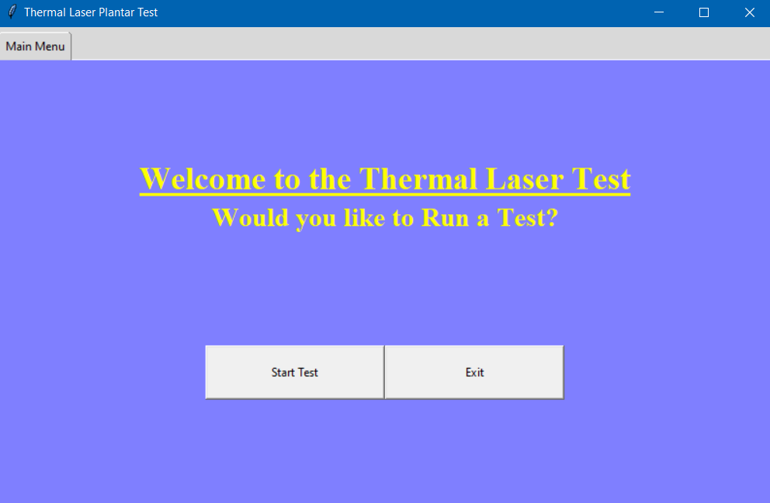

Figure 37. Frame 1, Prompt the User to Start or Quit the Program

Upon selecting “Start Test”, the callback function for that button calls a message box to prompt the animal’s name and group number, which then is fed to the animal classes’ constructor,

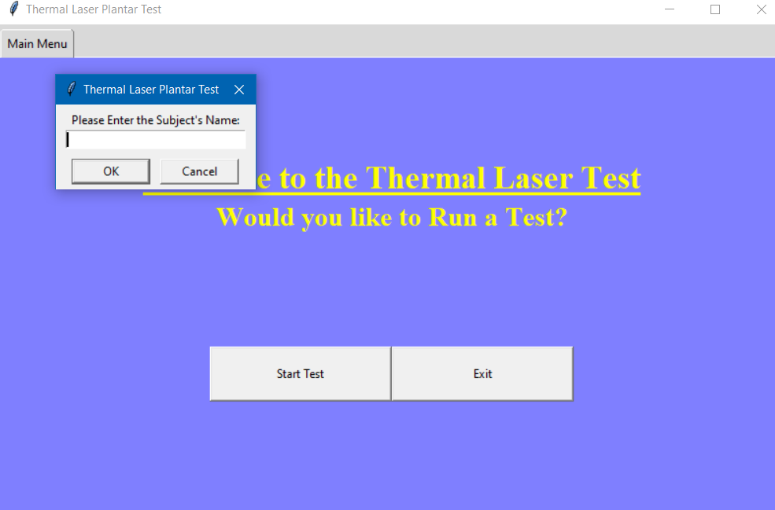

Figure 38. Enter the Animal's Name

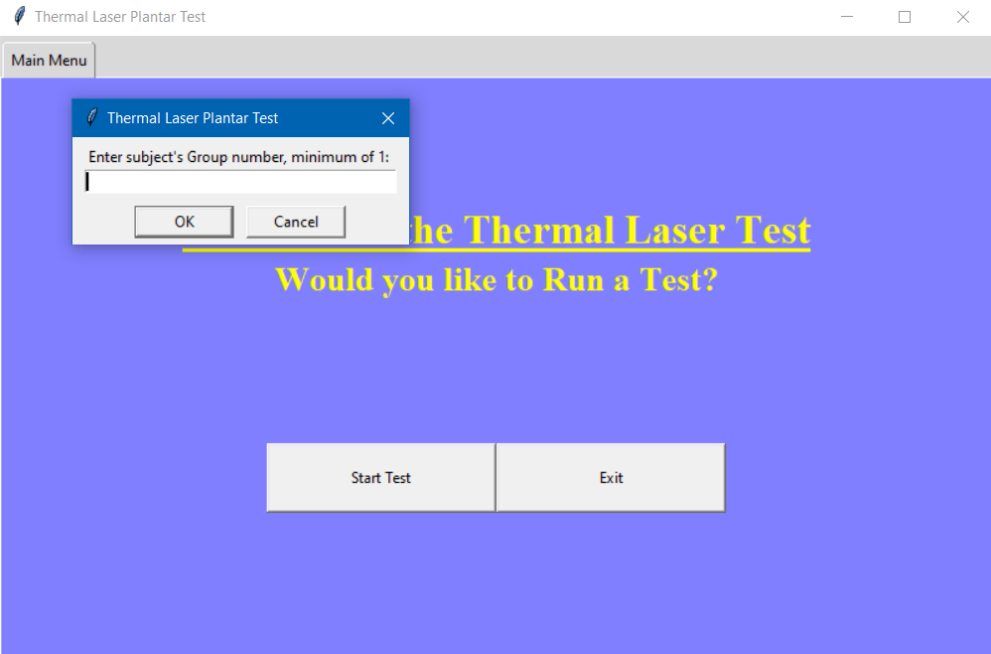

Figure 39. Enter the Animal's Group Number

This navigates the user to a second control frame which displays the current animal’s name, group number, current trial number, current withdrawal time data, starting time of the experiment, and end time of the experiment. At this point, the GUI prompts the user to execute a callback function to either run a trial by selecting the “Start Laser Test” button, test a new animal by selecting the “Select New Animal” which repeats the message boxes shown in the previous two figures, or exit the program.

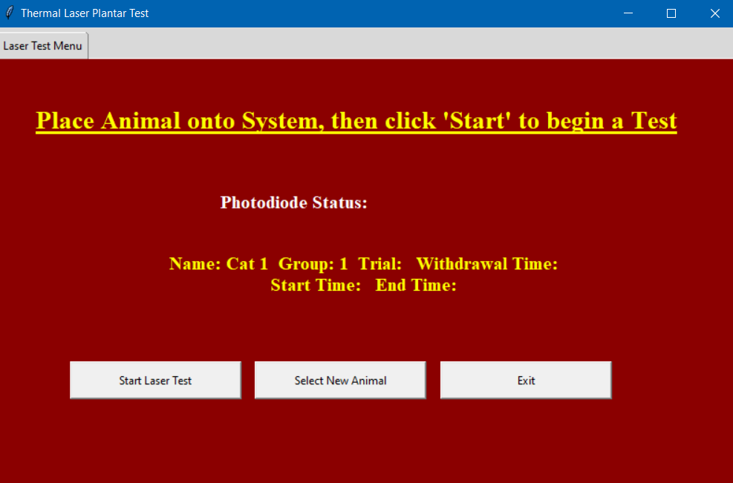

Figure 40. Control Menu for Testing an Animal

At this point, the user should place the animal on top of the system if they have not already, with the back paw placed over the acrylic plate of the system, covering the photodiode. Refer to the diagram in which we photoshopped a cat and annotated the system,

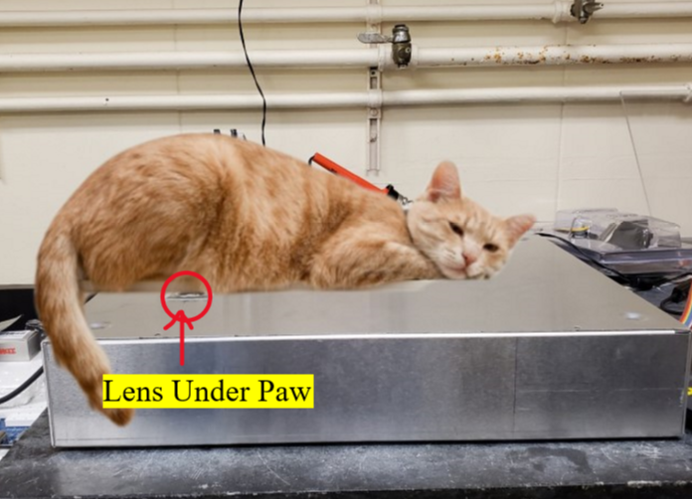

Figure 41. Example of Placing a Cat onto the System

Next the flip safety switch next to the LED into the up position, which arms the laser, ready to be controlled by the RPI.

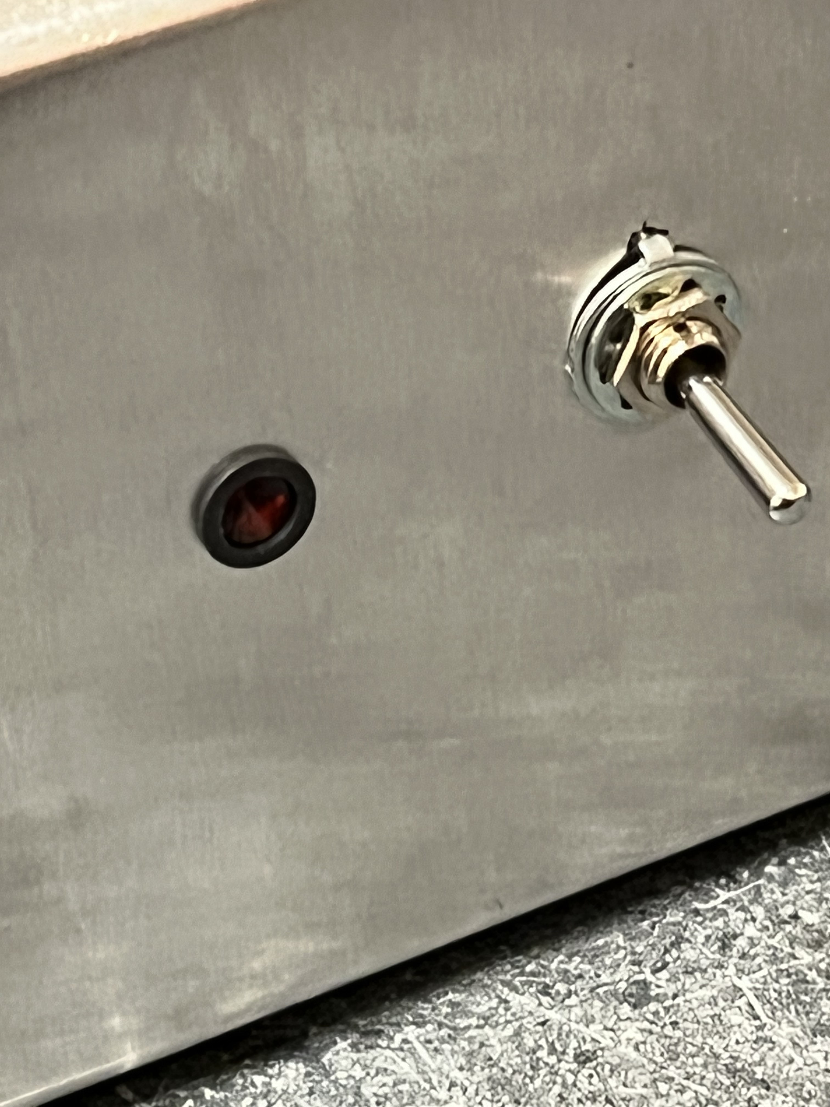

Figure 42. LED and Safety Switch

The system is now ready to run a trial. Click the “Start Laser Test” button on the GUI’s control menu and observe the LED on the side of the system to light up, indicating the laser is turned on when the photodiode detects darkness due to the animal’s paw covering the photodiode over the acrylic plate.

The previously described software algorithm, hardware and mechanical design, then interacts to perform the following 5-step process. First the photodiode gets covered by the cat’s paw, which the Raspberry Pi reads as a signal. The RPi then sends a signal out through the laser driver to turn on the laser. The laser shoots up towards the acrylic plate and the RPI uses Python’s time library to take an initial timestamp.​ Once the cat’s reflex is activated, it removes its paw​ which exposes the photodiode to light and takes a final timestamp for that trial. Immediately following the timestamp photodiode sends a signal to the Raspberry Pi, which then sends a signal out to the laser driver to turn off the laser. ​Finally, the Raspberry Pi calculates the change in time and delivers this information back to the user. The user then decides using the software to either perform another trial, test a new cat, or save and export the results.



Figure 43. System Schematic

If there is no reaction within $10$ seconds, the system will execute an error box indicating a “timeout”, which will shut off the laser and return to the control menu,

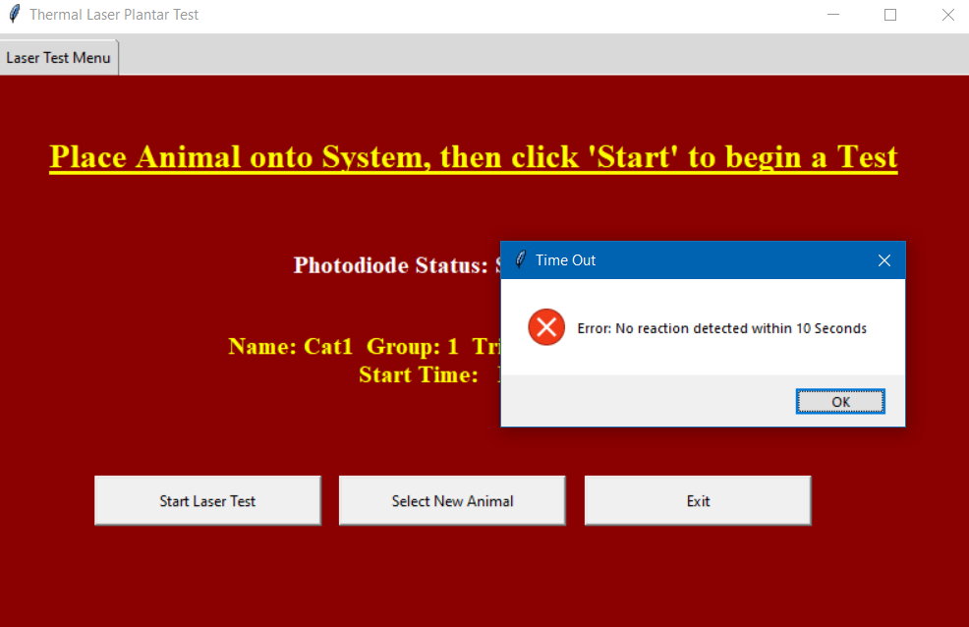

Figure 44. Error Message, no reaction detected

If there is a reaction, the user will be prompted by a message box to keep the trial.

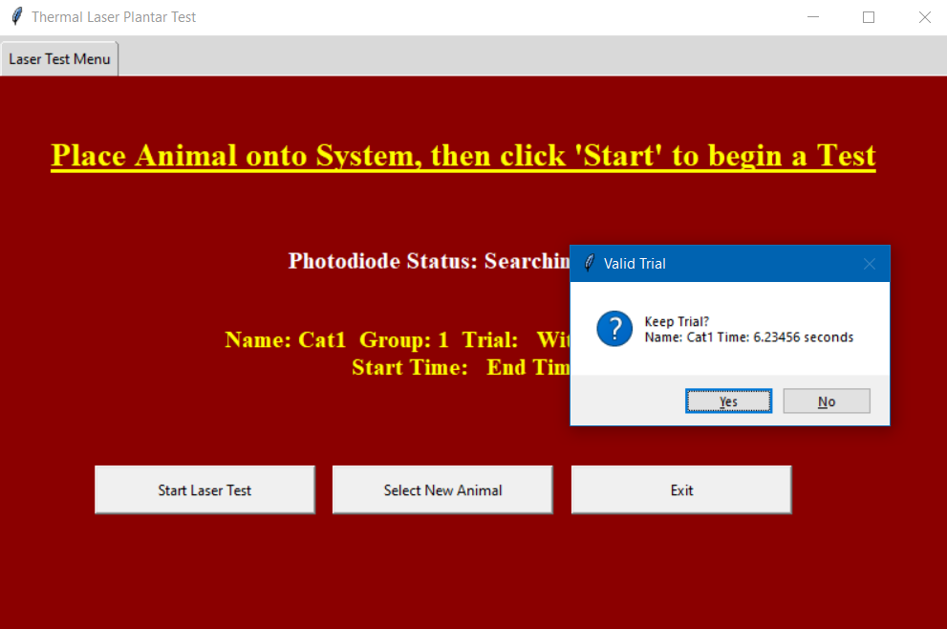

Figure 45. Prompt the User for a Valid Trial

If the user keeps trial, the withdrawal time will be displayed on the GUI, as seen by the example and program returns to the control menu. At this point the user may repeat testing the same animal, test a new animal, or quit the program.

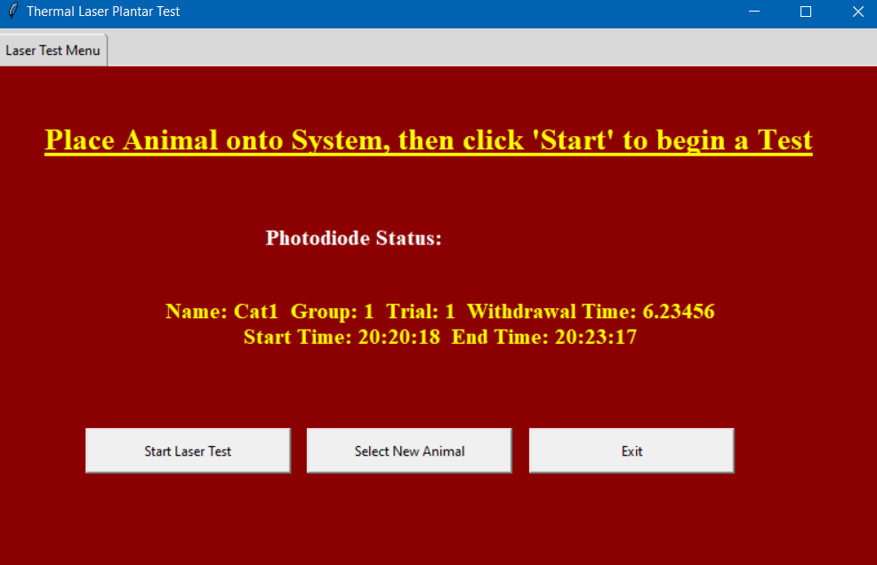

Figure 46. Returning to the Control Menu after Valid Trial

Upon exiting the program, the user may quit without saving by selecting the “x” at the upper right of the GUI window, or they may save the results by selecting the “Exit” button which prompts the file explorer and asks the user to enter a filename. This can be a new filename or overwrite a previous file to append new data to an older result. At this point the user may then navigate where they saved the file to view the output, as described earlier in the software section of the design approach. Upon shutting down the system the user should flip the laser’s safety switch into the down position, shut down the RPI through the desktop, and then flip the laser’s power button off, as well as the RPI’s power supply button.

# Evaluation: Test Methods

## Test Methods

### Testing Functional Requirements

A reminder of the current Functional Requirements and Design Constraints are summarized by the following tables.

**\*T_FR: Test Functional Requirement Method**

**Table 1: Functional Requirements with associated metrics, target values, and references\***

|  |  |  |  |  |  |
| --- | --- | --- | --- | --- | --- |
| **Code** | **Priority (negotiable or non-negotiable?** | **Functional Requirement** | **Metric** | **Target Value, Range, or Pass/Fail** | **Justification** |
| **T_FR1** | Non-negotiable | Ability to capture paw withdrawal reflex data. | Computerized System is implemented and exports raw data to a file for analysis. | Pass/Fail | United Nations Sustainable Development Goals: Good Health and Well Being, Life on Land/Client |
| **T_FR2** | Non-negotiable | No Paw/tissue damage to the animal | Power of laser transfer to skin | Pass/Fail | Animal Welfare Act |
| **T_FR3** | Non-negotiable | Repeatability within an Animal group | Multiple trials and accessible to animals.    Analysis such as Standard deviation, Mean, and Percent Differences will be calculated | Min: Results within less than a $20\%$ difference    Max: Results within a $10\%$ difference | Client |
| **T_FR4** | Negotiable | Withdrawal time | Test subject/counter | Min: More than a second    Max: Less than $+/-10$ seconds response time | Client |
| **T_FR5** | Negotiable | User Friendly interface | GUI/Hardware | Min: Shell Scripts for data collection and packaged system with stable wiring    Max: Full GUI interface, cable management, comfortability for both the animal and user. Users' surveys will dictate. | Future Teams, Prototyping, Patenting, etc. |

Referencing the Functional Requirements table above, the following section discusses each experiment and results or literature review to test each functional requirement for the system.

### **T_FR1:**

Creating a functioning computerized system to capture paw reflex data and export the results within the RPI3, is a requirement of the entire system. Therefore, each component/sub system will be tested accordingly on their own, as stated in the other test methods. Once validation of each part of the system is completed, then we will run a series of trials both on ourselves as well as research cats and further review the data collected to ensure that all aspects of the system is properly functioning, and the power of the laser will not provide damage to the cat paw. We also have recorded a video of our system conducting a typical trial on ourselves and report the data collected. The following link is the team’s final presentation, which shows the video of testing ourselves at 18:10

<https://youtu.be/Gu6zqBxIRyg>

The following raw data is the outcome of the test where each team member was tested twice.

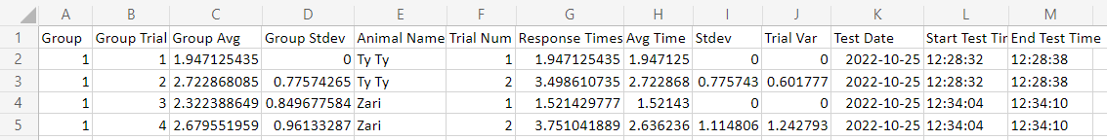

Figure . Group 1 Results

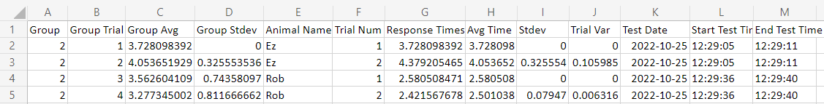

Figure 48. Group 2 Results

We then examine the bar graph which compares group 1 and group 2’s results. We show these results to prove that we have satisfied this functional requirement, we have explained what the results would mean previously and the validity of results delivered by our system will be further discussed in later test methods.

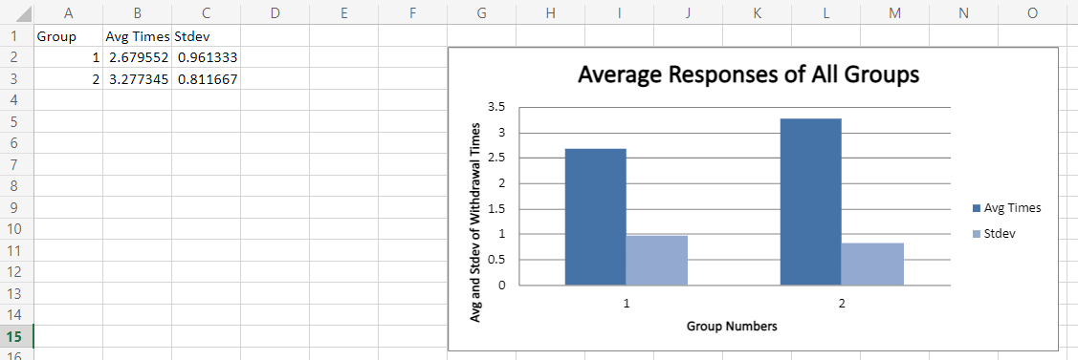

Figure 49. Group 1 vs Group 2 Results

### **T_FR2:**

One of the biggest functional requirements for our project is to make sure the cat is not burned or harmed when the paw is interacting with the laser. Added to the Animal Welfare Act in 1984, the Improved Standards for Laboratory Animals Act was passed by the 98th congress which states that there needs to be standards put in place to make sure that any animal that is subjected to experimental procedures should be in as minimal pain and distress as possible. In the Hargreaves test the guidelines for the experiments of the animals follow the International Association for the Study of Pain. The IASP includes the policies of the AWA. However, due to the test being in the USA the primary use is the Animal Welfare Act. To truly get into discussion of how we assess our laser will not provide any damage to the paw/tissue, therefore we will break down evaluating each component of the laser. Refer to Design Constraints $6-7$ for more information about how the power to the animal’s paw is tested.

### **T_FR3:**

Discovering the repeatability in an animal group would consist of using multiple research cats and dividing them into three groups. Each group will be given a different neurotrophin, and each cat will be tested individually. From a timeline perspective, we performed initial animal testing in late September and have used the initial data to modify and refine the system. However, the next set of animal testing is not to be performed until late November and given the timeline of Senior Design II and quantity of animals that will be tested at that time, it does not seem likely that we will have enough data to conclude animal repeatability for each group with a large enough sample size.

Since our project is focused directly on creating a system for Dr. Lemay and his team to use for further research, our concern is less about the specific repeatability and conclusions drawn from Dr. Lemay’s future animal testing, but rather determining general repeatability in results, regardless of the test subject. We can test that our system performs repeatable results by breaking down this requirement into testing two aspects of the system:

1. The precision and accuracy of the laser and photodiode,
2. The precision and accuracy of the analysis.

By validating the laser and analysis, we can deliver the wanted analysis for Dr. Lemay’s study to conclude if neurotrophins such as BDNF increase thermal sensitivity through calculating the mean, standard deviation, and variance of each individual animal and their groups, but also use this data to validate the precision and accuracy of our system’s analysis, which will allow us to examine repeatability in our tests amongst ourselves and theoretically validate animal testing repeatability within future testing. The following subsections describe the experiments performed and their results to test both components.

#### Testing Laser and Photodiode Precision/Accuracy

To test the laser and photodiode’s precision and accuracy, we decided to use a Go Pro Hero 8 to visually examine the start and stop time of the laser and compare the results captured by our system. We used a Go Pro Hero 8 that was borrowed from Dr. Bai’s lab and recorded $5$ trials with the camera set to film $1080p$ at $30$ frames per second (FPS). Using an Infrared (IR) sensor paper, photodiode was covered to trigger starting the laser and the camera was placed on top of the system with the sensor angled slightly so the camera could visually capture the light of the laser hitting the sensor,

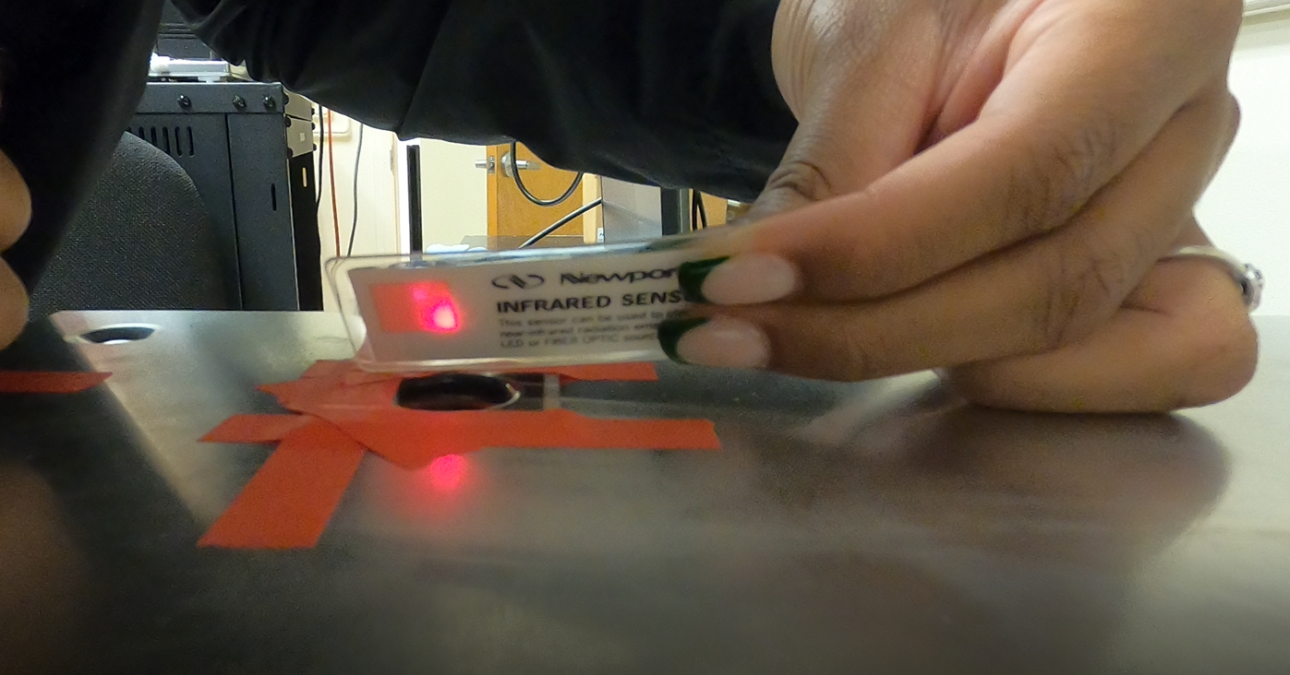

Figure 50. Measuring the Laser with IR Sensor

Once the laser was on, we decided to wait for various periods of time to model a variety of possible withdrawal times, before removing the sensor/exposing the photodiode to the light, which then turns off the laser and records the stop time.

Since the camera records at $30FPS$, and video is simply the process of playing still images (frames) in series, then we can examine the start and stop times visually by examining the frame at which the laser turns on, and the frame at which the laser turns off, and calculate the difference in time to be compared to the response time determined by the photodiode. One method of doing this is to write a script to export each frame from the .MP4 video file and then sort through until the start and stop frames are determined, however, that would also require the frames to be exported at the exact sample rate the video was recorded at, and to title each frame based upon the respective timestamp it occurs in the video. This method would require some work and ultimately will results in hundreds to thousands of frames depending on the size of the .MP4 video file, which seemed to be an extremely inefficient and storage heavy test method without creating some sort of script to iterate through all the exported frames and only detect and locate the frames where the laser turns on/off.

Instead, we determined the responses detected from the Go Pro Hero 8, as follows. Since the camera recorded at $30FPS$, then we can find out when the frames change by determining the Sampling Period as,

Equation . Sampling Period

|  |  |  |
| --- | --- | --- |
|  | $$T=\frac{1}{Fs}=\frac{1}{30FPS}=0.030303 second$$ | (9) |

Meaning the footage is only going to show you the same still frame until another $0.030303$ seconds have passed. Using this we can create a scale to see when each frame occurs in one second until we reach $30/30$ or $1$ full second.

Table 5. Go Pro Hero 8 FPS to Sampling Period

|  |  |  |
| --- | --- | --- |
| **Frame Number** | **Fraction of a Second** | **Seconds** |
| 1 | $$1/{30}$$ | 0.03030303 |
| 2 | $$2/{30}$$ | 0.060606061 |
| 3 | $$3/{30}$$ | 0.090909091 |
| 4 | $$4/{30}$$ | 0.121212121 |
| 5 | $$5/{30}$$ | 0.151515152 |
| 6 | $$6/{30}$$ | 0.181818182 |
| 7 | $$7/{30}$$ | 0.212121212 |
| 8 | $$8/{30}$$ | 0.242424242 |
| 9 | $$9/{30}$$ | 0.272727273 |
| 10 | $${10}/{30}$$ | 0.303030303 |
| 11 | $${11}/{30}$$ | 0.333333333 |
| 12 | $${12}/{30}$$ | 0.363636364 |
| 13 | $${13}/{30}$$ | 0.393939394 |
| 14 | $${14}/{30}$$ | 0.424242424 |
| 15 | $${15}/{30}$$ | 0.454545455 |
| 16 | $${16}/{30}$$ | 0.484848485 |
| 17 | $${17}/{30}$$ | 0.515151515 |
| 18 | $${18}/{30}$$ | 0.545454545 |
| 19 | $${19}/{30}$$ | 0.575757576 |
| 20 | $${20}/{30}$$ | 0.606060606 |
| 21 | $${21}/{30}$$ | 0.636363636 |
| 22 | $${22}/{30}$$ | 0.666666667 |
| 23 | $${23}/{30}$$ | 0.696969697 |
| 24 | $${24}/{30}$$ | 0.727272727 |
| 25 | $${25}/{30}$$ | 0.757575758 |
| 26 | $${26}/{30}$$ | 0.787878788 |
| 27 | $${27}/{30}$$ | 0.818181818 |
| 28 | $${28}/{30}$$ | 0.848484848 |
| 29 | $${29}/{30}$$ | 0.878787879 |
| 30 | $${30}/{30}$$ | 0.909090909 |

Importing the footage into a video player/editor such as media classic player, the playback speed was slowed the playback to play at $0.25x$ speed, which allowed each second to last $0.25$ times slower, or $\frac{1}{0.25}=4$, meaning every second’s frames are stretched across a viewing period of $4$ seconds. By watching the footage and skipping to the periods within the video where the laser turns on and off, the start and stop times can be ballparked by pausing and unpausing the video and examining the timer’s playback counter in milliseconds,

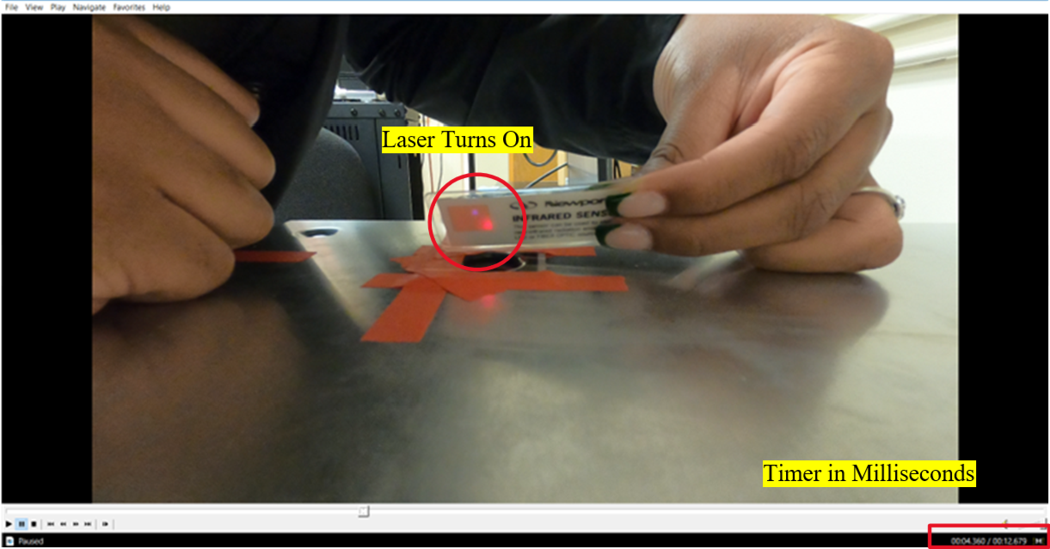

Figure 51: Examining Footage for Experimental Values

This allowed us to gather "experimental" values for the $5$ trials which is then cross examined by rounding down to the nearest theoretical frame that is supposed to occur, thus yielding "theoretical" values as shown by the following table. For example, in Trial $1$, it was visually seen at $16.453$ seconds that the frame changed where the laser appears on. According to the previous table, the nearest frame that this could have occurred at is at $0.424242$, which is the 14th frame that appears during that second, therefore, the frame in which the laser turns on occurs at $16.424242$ seconds. The same process is done for when the laser turns off.

Table 6: Start/Stop Times determined by Go Pro

|  |  |  |  |  |
| --- | --- | --- | --- | --- |
| **Trial** | **Experimental Start Time** | **Theoretical Start Time** | **Experimental End Time** | **Theoretical End Time** |
| $$1$$ | $$16.453$$ | $$16.424242$$ | $$17.258$$ | $$17.242424$$ |
| $$2$$ | $$4.358$$ | $$4.333333$$ | $$8.165$$ | $$8.151515$$ |
| $$3$$ | $$3.075$$ | $$3.060606$$ | $$5.421$$ | $$5.424242$$ |
| $$4$$ | $$4.625$$ | $$4.606061$$ | $$6.143$$ | $$6.121212$$ |
| $$5$$ | $$5.23$$ | $$5.212121$$ | $$6.593$$ | $$6.575758$$ |

Using this collected data, the change in time can be calculated for both the theoretical and experimental timestamps, and the percent difference between the experimental and theoretical timestamps is observed by the following table,

Table 7: Go Pro Response Times and Percent Differences

|  |  |  |  |
| --- | --- | --- | --- |
| **Trial Number** | **Experimental Time(T2-T1)** | **Theoretical Time (T2-T1)** | **Percent Difference** |
| $$1$$ | $$0.805$$ | $$0.818182$$ | $$1.624217124$$ |
| $$2$$ | $$3.807$$ | $$3.818182$$ | $$0.29329136$$ |
| $$3$$ | $$2.346$$ | $$2.363636$$ | $$0.748932614$$ |
| $$4$$ | $$1.518$$ | $$1.515151$$ | $$0.187857446$$ |
| $$5$$ | $$1.363$$ | $$1.363637$$ | $$0.046724225$$ |

Where percent difference is calculated as,

Equation 9. Percent Difference

|  |  |  |
| --- | --- | --- |
|  |  | (10) |

With $V1$ =Experimental Time and $V2$ =Theoretical Time.

Therefore, the camera now has two relatively close withdrawal times. Comparing both of these times with the time capture by the photodiode was done by taking the percent difference between the experimental go pro values and the photodiode values, as well as the theoretical go pro values with the photodiode values. This is shown in the table below,

Table 8. Comparing System Results to Go Pro Results

|  |  |  |  |
| --- | --- | --- | --- |
| **Trial** | **Photodiode Times** | **Theoretical Percent Diff** | **Experimental Percent Diff** |
| **1** | 0.804466248 | 1.690539156 | 0.066326585 |
| **2** | 3.782261133 | 0.94523086 | 0.651944018 |
| **3** | 2.361724615 | 0.080899011 | 0.668034615 |
| **4** | 1.499226332 | 1.056580928 | 1.244432199 |
| **5** | 1.338901043 | 1.830572344 | 1.783851934 |
| **Average Percent Difference** |  | 1.12076446 | 0.88291787 |

Calculating the average of the experimental and theoretical percent differences, shows our laser’s interaction with the photodiode captures valid withdrawal times within a range of $0.88\%-1.12\%$. Needless to say, our laser is effective for our system since it surpasses by our repeatability range of $10\%-20\%$.

#### Testing Analysis Precision/Accuracy

As stated earlier within the design approach, the system’s Python script computes mean, standard deviation, and variance for each individual animal’s withdrawal times, to examine animal repeatability and changes in responses based on the respective neurotrophin given to the animal group. Since we know the number of animals that will be tested on, as well as the number of trials, then we will always know the exact population for each experiment meaning there is no need to compute Bessel’s correction when computing analysis and we can utilize python’s population functions. As a reminder python’s functions for mean, standard deviation, and trial variance from the statistics library, implement the following equations,

*Equation 1 $statistics.mean(data)$*

|  |  |  |
| --- | --- | --- |
|  | $$μ=\frac{\sum_{i=1}^{N}{X}}{N}$$ | (4) |

*Equation 2 $statistics.pstdev(data,mu=none)$*

|  |  |  |
| --- | --- | --- |
|  | $$σ^{2}=\frac{\sum_{i=1}^{N}{{(X-μ)}^{2}}}{N}$$ | (5) |

*Equation 3 $statistics.pvariance\left(data,mu=none\right)$*

|  |  |  |
| --- | --- | --- |
|  | $$σ=\sqrt{σ^{2}}$$ | (6) |

Where in our system, $μ$ =Mean of Trials, $X$ =Current Trial Time, $N$ =Number of Trials (population) $σ^{2}=$ ​Standard Deviation between Trials, $σ$ =Variance between Trials​ [20].

Since we are exporting all results to a spreadsheet in excel, lets can compare these functions to excel’ s statistic population functions as follows,

Equation 10 $AVERAGE(Num1:NumN)$

|  |  |  |
| --- | --- | --- |
|  | $$μ=\frac{\sum_{i=1}^{N}{X}}{N}$$ | (11) |

Equation 11 $STDEV.P(Num1:NumN)$

|  |  |  |
| --- | --- | --- |
|  | $$σ^{2}=\sqrt{\frac{\sum{{(x-x)}^{2}}}{N}}$$ | (12) |

Equation 12 $VAR.P(Num1:NumN)$

|  |  |  |
| --- | --- | --- |
|  | $$σ=\frac{\sum{{(x-x)}^{2}}}{N}$$ | (13) |

Where in our system, $μ$ =Mean of Trials, $X$ =Current Trial Time, $N$ =Max Number of Trials (population) $σ^{2}=$ ​Standard Deviation between Trials, $σ$ =Variance between Trials [29].

While both programs calculate the mean, standard deviation, and variance, we can see that python versus excel’s formula differs slightly per algorithm. Creating a mock test by manually entering withdrawal time data for two example cats with three trials each, we exported results to excel and examined the typical output generated for two cats with results in the same group. Using excel’s formulas, we recalculated each average, standard deviation, and variance between each trial. Finally, the percent difference is calculated the same way as used to validate the laser and photodiode’s response time in the previous subsection, except this test shows $V1$ =Python’s Calculated Value and $V2$ =Excel’s Calculated Value.

Furthermore, calculating the results by hand using a standard calculator will achieve the same results at a less efficient rate. Examining the results between python and excel, we can see that regardless of the algorithm, we achieve nearly the same answer with a difference of less than $1\%$, shown in columns $K:M$, rows $10:13$,

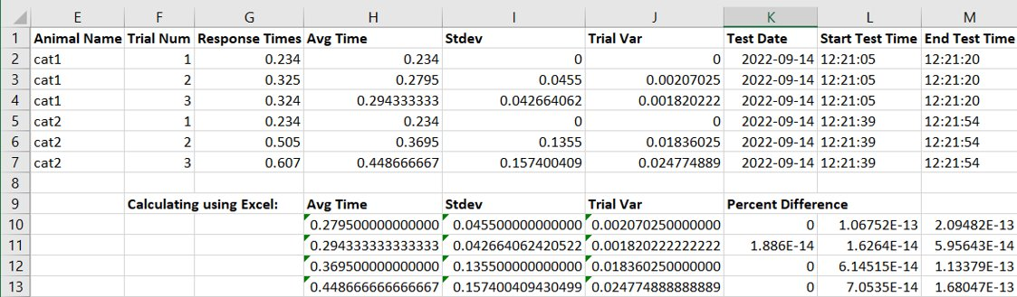

Figure 52. Comparing Analysis between Python and Excel

Since we see that excel’s functions compute with a finer decimal precision. This gave us the opportunity to optimize the system further by reworking our python algorithm to compute all analysis between groups to be automated using excel rather than python. This will allow the end user to examine results with finer precision, and it allows the python program to run faster since we bypass having to read through all data within the hash table database and using the statistics functions to compute results functions after every trial, and instead we now compute all group analysis after testing is performed and while we export results to excel by letting python export strings to call excel’s functions after exporting each animal’s results. For example, calling excel’s mean function is done by exporting a string to a cell with the by entering as a value as stated in line $100$ of the *exportGUI.py* class,

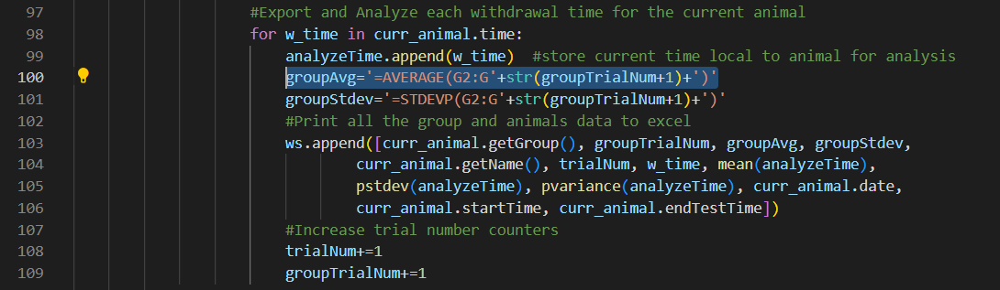

Figure 53. Automating Excel with Python in Export Class

Ultimately, both the hardware and software validation prove that we have less than $10\%$ difference in results, which was our minimum targeted range, thus meaning we have surpassed our expectations and the system records data precisely and accurately, meaning any results should be repeatable.

#### Repeatability in One Animal, from Initial Animal Testing

We can also draw the conclusion that the system is working relatively well based with some repeatability within an individual cat’s paw. This conclusion is based on the initial animal test conducted October 4th, 2022, where a cat without any neurotrophins, had her rear right paw tested for the first $5$ trials, followed by a short break, and the testing her left rear paw for $5$ trials. As we can see from the withdrawal times in column “G”, the cat’s responses yield within $+1.72±0.25$ seconds from the right paw, and $+5.36±0.69$ seconds from the left paw. Variance between the left and right paws may be natural and is something the Team and Dr. Lemay is further researching from previous studies such as the Hargreaves Test. Furthermore, these results led the Team to revise the positioning of the acrylic plate and laser within the enclosure of the system. The exported results are shown in the figure below,

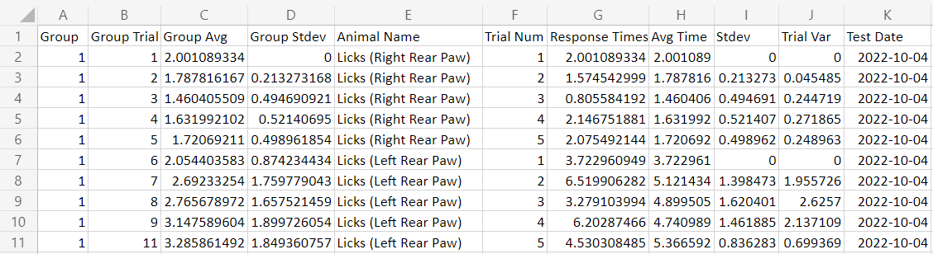

Figure 54. Exported Results from Excel for Initial Animal Testing

### **T_FR4:**

This functional requirement is negotiable since the withdraw time between the laser touching the animal’s paw to the reaction time that the animal has is dependent on the animal and the power of the system and accuracy of the laser stimulating the cat’s paw. Due to not wanting to harm the animal, the laser’s power should be just enough to not harm the animal but trigger a response out of them. Additionally, to avoid any possible violation of the AWA or IACUC, we have decided to model our safety parameters off the original Hargreaves test which calls for an emergency cutoff if there is a lack of response within $20$ seconds of the laser turning on [3]. Since our initial animal tests, seen in the Figure $5$ of the previous section, we’ve seen that our system typically provokes a reaction within $5$ seconds, so we have decided to further shut off the laser and return if there is a lack of response within $10$ seconds of the laser turning on. Furthermore, the python script simply defines the length until timeout as a variable that can easily be modified in the future by opening *animal_classGUI.py* and changing the variable “time_out” located in the *timer()* function in line $152$,



Figure 55. Time Out Declaration in animal.timer()

### **T_FR5:**

This functional requirement is entirely suited for establishing user friendliness for the user. The requirement is negotiable, so at a minimum the python program is compliable and runs within the terminal on the RPI3 and collects data properly, then the minimum target is achieved. The maximum targeted version of the program will contain reliable, easy hardware that interacts nicely with the animal, and allows users to operate the system using a Graphical User Interface (GUI) to collects, stores, and exports data collected by the laser and photodiode circuit. To test user friendliness, we asked Dr. Lemay and his lab assistant to fill out a google forum while they performed animal testing. Feedback from the users was considered to further refine the system. The results of the survey are shown in the following table, where we used a scale of $1$ to $5$, from worst to best:

|  |  |  |  |
| --- | --- | --- | --- |
| **Question Number** | **Question** | **Response 1** | **Response 2** |
| $$1$$ | Is the system easy to power on and start up? | $$5$$ | $$5$$ |
| $$2$$ | GUI is easy to start up | $$5$$ | $$5$$ |
| $$3$$ | GUI User Friendliness? | $$5$$ | $$5$$ |
| $$4$$ | Is the system easy to work with animals? | $$4$$ | $$3$$ |
| $$5$$ | Exporting Results User Friendliness? | $$5$$ | $$5$$ |
| $$6$$ | System is portable and easy to setup | $$5$$ | $$3$$ |
| $$7$$ | Do you have any questions, comments, concerns about the system, specifically the functionality of the laser and photodiode circuit? | Cat positioning seems to affect reaction times. Issues to be resolved by the Lemay team, and is likely related to sensory feedback and the nervous system. | N/A |
| $$8$$ | Do you have any further feedback for the system or ideas of aspects that should be changed/done differently to maximize user and animal friendliness? | As an add-on feature, some way to hold the cat in a semi-vertical position | The mold on which the cats paw is supposed to lay does not fit the shape of the paw. Toes were not accounted for in the mold and as a result the paw easily slides out place before the laser stim. |

Using this initial feedback, the Team continued to modify and revise the system though responses to question 8 would have to be a future addition to the system due to time constraints. Furthermore, while testing the accuracy of the laser which is discussed in T_FR3: Testing Laser and Photodiode Precision/Accuracy, the Team decided to mount an LED to the side of the system which will turn on to indicate when the laser is on and turn off when the laser turns off. This was decided since updating the label to indicate the laser is on within the GUI has proven to be buggy since it requires the label to refresh the GUI’s window, in the middle of subfunction within a callback function. The structure of the GUI is further explained later in the Design Approach section of the document.

Additionally, during Senior Design II Poster Day, we aim to bring the system to the display and will create an informed consent forum that would allow individuals judging our poster/project the opportunity to test their own reflexes stimulated by the system and fill out a feedback forum for user-friendliness. Spectators of the demonstration will also be asked to fill out a form regarding their thoughts on user-friendliness.

### Testing Design Constraints

A summary of the current design constraints are summarized by the following table.

**\*T_DC: Test Design Constraint Method**

**Table 2: Design Constraints with associated metrics, target values, and references\***

|  |  |  |  |  |  |
| --- | --- | --- | --- | --- | --- |
| **Code** | **Priority (negotiable or non-negotiable?)** | **Design Constraint** | **Metric** | **Target Value, Range, or Pass/Fail** | **Justification** |
| **T_DC1** | Non-Negotiable | Minimum number of trials performed per day. | Laser to Footpad/Tissue Recovery | Min: ≥ $3$ Trials per animal per day    Max: ≤ $5$ Trials per animal per day | Hargreaves Test/ Animal Welfare Act / Client |
| **T_DC2** | Non-Negotiable | Budget/Cost efficiency. | Cost | Less than $10k (More cost efficient than Hargreaves system) | Client/SD |
| **T_DC3** | Non-Negotiable | Animal Welfare | Animal’s interaction with System/Animal Health | Pass/Fail | Animal Welfare act |
| **T_DC4** | Non-Negotiable | Precise data collection-time resolution, and ability to validate the data. | Response time.    Dependent on laser, photodiode, acrylic plate, and software interaction to collect data. | Collect and validate data collection to ensure the system is determining valid readings at a rate of milliseconds. | Client |
| **T_DC5** | Non-Negotiable | How to increase the thermal range once the animal is touching the plate. | Distance of the acrylic plate to laser. Setting current/power of laser. | Pass/Fail | Performance of System |
| **T_DC6** | Non-Negotiable | How to increase the power that goes through the laser | Setting current of the Laser Diode | Min: ≥ $0.8A$   Max: ≤ $1.115A$   This is trial and error | Performance of system/Animal Welfare Act |
| **T_DC7** | Negotiable | Laser upgrade/downgrade | Examining the power of the laser to paw, after all other system components are set. | Min: Through trial and error we experimentally develop a safe range for humans and animals.  Max: Use an IR Power meter to measure the power of the laser onto the acrylic plate and develop a safe range for humans and animals. | Performance of System/Budget |
| **T_DC8** | Negotiable | Photodiode replacement | Interaction with 5V RPI | Min: Continue using the same photodiode    Max: Replace with better suited photodiode | Performance of system |
| **T_DC9** | Negotiable | Microcontroller replacement | Cost and Efficiency | Min: Continue using the RPI    Max: Upgrade or downgrade microcontroller to establish the best performance of the system | Performance of system |

Room

### **T_DC1:**

Keeping in mind the Animal Welfare Act, a balance is needed between animal testing and data collection. Based on a study conducting a Hargreaves test completed by the Europe PMC Funders Group, they performed a minimum of three trials per test subject with the recommendation of five [30]. This is a minimum requirement as odd numbers of trials contribute to proper data assessment of accuracy and provide minimum data to “obtain an average reaction time.” With that insight we subjected our testing to a minimum of three trials and a max of five per paw. This helps us maintain data and stay within the safety guidelines of the Animal Welfare Act as our goal is to perform the test without harming our test animals. When talking with our client, Dr. Lemay, also shared that he would like a minimum of three trials and at most five because that is what he is comfortable with doing. As mentioned in T_FR4 there are additional measures in place to uphold our end of harm prevention, the laser is set to shut off after 10 seconds if no reaction is had from the test animals. This implements safety features to avoid possible scarring and/or tissue damage that could happen within testing the animal’s paw. Additionally, more information regarding additional safety measures will be discussed in design constraints $6-7$.

### **T_DC2:**

Our overall budget for the system being created is expected to stay under the estimated cost to rent a Hargreaves Test which sits at $\$9,766$, not including the purchasing of additional materials to modify the system for cats, which would approximate to about $\$10k$ [4]. Currently we have spent around $\$1,700$, with $\$1,500$ spent by Dr. Lemay prior to our team taking on the system in Senior Design, while we have only spent an additional $\$200$ on materials and are still provided with extra funding from our coordinator Dr. Lemay if it becomes necessary and needed. More information about the cost of our system is described in the budget section of the document.

### **T_DC3:**

We manage to abide by the animal welfare act, since the prototype has already achieved approval from Temple IACUC through Dr. Lemay. During animal trials, they will only be handled by Dr. Lemay and his approved lab assistants. Our job will simply ensure that the cat will be able to sit comfortably on our system, where the laser will only impact a rear paw that suffers from spinal cord injury. By designing our system to uphold the other design constraints and fulfil the functional requirements, we have designed a safe system with emergency shutoffs, added an LED light to let us know when the laser is on or off, and set the laser to stimulate the paw’s nociceptors without causing damage to paw itself. As a reminder, the cat does not feel pain triggered by the laser, since the signal triggered by stimulating the nociceptor cannot travel up a broken spine and deliver to the brain which would process the feeling of pain. Instead, the reflex is triggered, without the cat noticing.

### **T_DC4:**

Testing the constraint of ensuring a valid response time is based on three factors of the system:

1. The Laser and Photodiode acting as a timer
2. The Software’s Interaction with the Hardware
3. The Mechanical projection of the Laser through the Acrylic

Refer to the narrative of T_FR3 for the experiments to validate sections 1 and 2.

This timer constraint will also determine T_DC7. See T_DC6 for information regarding the photodiode’s interaction.

The acrylic plate acts as a separator between the laser and the paw and will be tested to make sure that the thermal area of the laser is increased to a repeatable range and transferred through the acrylic plate to reach the cat. Since the state of the photodiode is dependent on light, the acrylic plate must be designed using a transparent material. Raw materials such as clear glass and frosted glass were tested by placing them upon the laser and feeling if the laser projected through the glass. Clear glass worked, however frosted glass did not. Ultimately, despite the glass yielding promising results, the concern over the glass shattering upon routing, led us to experiment with other materials, specifically acrylic which we decided to use. More information about testing the design iterations of the acrylic plate is discussed in T_DC5.

Additionally, interaction between all components was shown to yield initial animal testing results in T_FR3’s narrative, and the final test for this constraint would be to simply gather more animal test data since we have validated each component individually to gather precise data. Ultimately, that is dependent on Dr. Lemay’s access to research cats, with a second animal test to be conducted in November, however, this may still be too small of a sample size to properly assess the entire system.

### **T_DC5:**

#### Testing the Design Iterations of the Acrylic Plate

Initially when testing the laser, there was no separator between our fingertip and the laser, and because of that, the laser kept getting damaged. The laser would also interact with the tester’s skin due to not being able to have an exact distance away from the laser. The laser would then also get in contact with the tester’s skin and contain oil and skin cells on the laser prohibiting it from getting accurate results. The use of an acrylic plate is used to create more consistent test results as well as creating a barrier between the animal and the laser. This protects the photodiode, laser, and the animal. The first iteration of the acrylic plate was a $\frac{1}{8}$ inch acrylic sheet, however once the piece was made, the depth was not close enough to have any effect on the laser since the finger had no response to the laser stimulation.

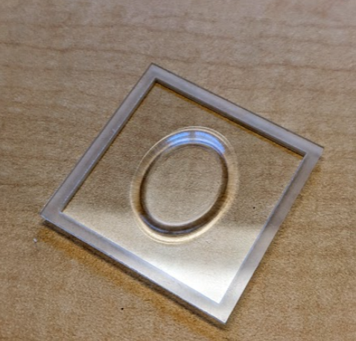

$$0.05 inch depth$$

$$\frac{1}{8} in depth$$

Figure 56: 1/8-inch depth acrylic sheet

The second iteration was using a $\frac{1}{4}$ inch acrylic sheet with keeping the distance between the bottom of the acrylic piece and the groove at the same $0.05 inch$.

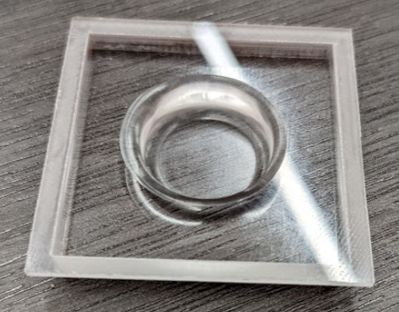

$$0.05 inch depth$$

$$\frac{1}{4} in depth$$

Figure 57: Version 3, 1/4-inch depth Acrylic Plate with larger diameter for foot pad

The acrylic plate was tested for thermal projection by holding the plate over the laser and using our finger to feel if the plate was clear enough to stimulate a reaction from the laser. Furthermore, to increase the emissivity of the laser through the acrylic, a polish is used to decrease opacity. Upon settling on an acrylic plate, the distance that the plate is mounted from the laser still needed to be determined. This process was also done in parallel with T_DC6 which goes into more detail about setting the current of the laser, while the acrylic plate was held, before the mounting process was finalized.

#### Packaging the System for Cat Interaction

Finally, the machine shop’s router was used to cut the mounting hole for acrylic plate out of the aluminum lid that the cat would lay upon. This was done by taking measurements to program the router, using calipers, and measuring the position of the mounted acrylic plate inside the system. After many iterations of trial and error, the correct placement of the lid was perfected, as seen in the final pictures of our system.



### **T_DC6:**

For this constraint design it focuses on how to increase the power that goes through the laser. After the acrylic plate was mounted and finalized as stated in T_DC5. From the datasheet, the laser conducts like a diode at a set threshold operating voltage of $1.7VDC$, therefore, to set power the current driving the laser should be determined for an operational range. This was done by measuring the current of the laser diode experimentally using a current clamp. The minimum value was determined experimentally by adjusting the laser’s trim pot up every $50mA$ and examining the effects the laser to plate interaction had on stimulating a reaction from our finger. The maximum value was retrieved by the parameters provided by the datasheet where the operating current from QPhotonics experiments measured to $1.014A$ and the maximum operating current is $1.115A$. Setting the current is important for the performance of the system because it helps get accurate data of the cats' withdrawal time. The laser stimulates the nerves within the cats’ paw with wavelength provided by the current. From our experiments, we found that we begin to feel the stimulation of the laser around $0.8A$, but this was too weak to provoke a reaction unless if we began to press down onto the. For the sake of the cat’s interaction, we would need to find a reasonable value that would provoke a reaction when the cat simply lays its paw onto the plate. At approximately $1.0A$, we found to be nearing the measured operating current and stimulating our fingers with little effort, in which would correspond to a power rating between $350mW$ to $400mW$ based on the laser’s data sheet. Thus, we concluded a range of $0.8A$ to $1.115A$ should be considered when calibrating the system, with an operational current around $1.0A$.

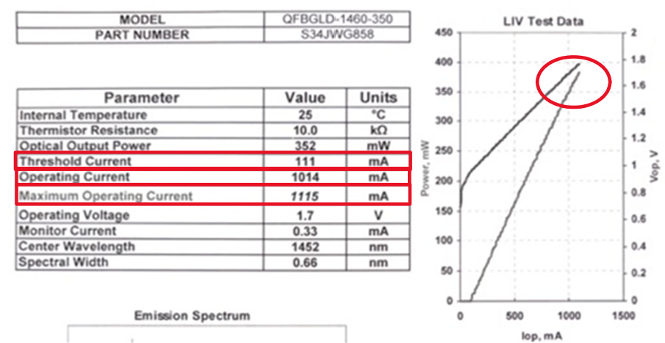

Figure 59. Datasheet showing current specifications

*Source:* [31]

### **T_DC7:**

#### Initial Upgrade and Evaluation

The laser upgrade/downgrade overall affects performance of system and the budget. This is a continuation of T_DC6 with if the power is not enough then the laser would have to be changed to have a top performance. We upgraded our laser from the QPhotonics QFLD-1440-200S to the QPhotonics QFBGLD-1460-350 laser between SDI and SDII. This was because the newer laser opts for the same parameters such as wavelength, but a larger maximum operational current so we would have a larger room to work with when validating the plate. This was primarily due to initial reactions when we tested our system at the end of SDI before implementing the plate when noticing that the QFLD-1440-200s laser was only felt when the maximum current of $670mA$ was set and our finger was directly placed onto the laser. Upon hovering our finger above the laser, little to no reaction was felt, which was a concern for us when determining how we would further increase thermal range with the plate. Therefore, we upgraded to the QFBGLD-1460-350 laser which had a maximum current of $1014mA$ as stated in our experiment described in T-DC6. Upon more hopeful reactions from the new laser without the plate, we decided to continue moving forward with the design and would reevaluate upgrading the laser after the acrylic plate portion of the system was completed, and before moving to animal testing. Furthermore, the heatsink that came with the laser proved to be effective in limiting any possibilities of thermal runaway at our laser’s current and voltage settings, therefore the TEC was deprecated from our project.

#### Safety Evaluation of Current Laser

A key part of the project is to make it an affordable system that many can use. Laser upgrade/downgrade would further determine the budget of system, and furthermore, the decision to upgrade or downgrade the laser would also be upon determining if the laser is safe for humans and animals, after the system is completed and evaluated by the previous design constraints. The minimum action that needs to be looked at is through developing a safe range of laser power for humans and animals. The maximum action is using an IR power meter to measure the power of the laser onto the plate and develop a safe range for humans and animals, however due to cost and time constraints of the project, we decided to assess the constraint based on what we know about the laser.

Based upon the previous assessments, our voltage and current are now set at values to provoke a precise and accurate reaction from our laser. Examining the effects, the laser has on our skin through trial and error, we conclude that no damage to our skin is evident when testing our fingertips. Additionally, to uphold the AWA and ICAUC guidelines, we implemented the RPI to shut down the system down if there is a lack of response within $10seconds$ as mentioned in T_FR4. Therefore, the only possible parameter left to consider when evaluating safety and performance would be to examine the wavelength of the laser. The decision for using a laser with a wavelength around $1400nm$ was discussed previously in the problem statement and design approach, and concluded from research such as Frahm’s 2020 study, to be a good wavelength. To clarify, the laser does not stimulate a reaction by heating up the skin, instead the wavelength activates deep layers of the skin where thermal pain receptors, such as c-fiber or delta are located, this stimulation is what provokes the nociceptors to provoke a reaction [32]. Furthermore, if a concern about the temperature of the laser somehow burning the cat’s paw, then we can search for a correlation between the wavelength of the laser and temperature. Since the laser does not dissipate heat, this is impossible to test using a simple thermometer with our system, however conclusions can be drawn about the laser’s output temperature range based on the following research. A 2014 study by Tae-Hoon Kim and his colleagues, set out to create a model of how wavelength corresponds to temperature, and the effects on skin. They concluded when sending the laser as a pulse signal to the skin, that darker skin provokes a higher temperature than lighter skin. They also conclude that as wavelength increases, the corresponding temperature range decreases [30]. This is summarized by the following figure, in which shows an increase until temperature begins to settle by the third pulse number,

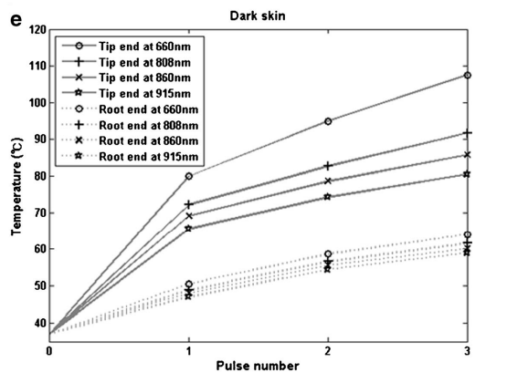

Figure 60. Sheet showing different laser wavelengths and the temperature

*Source:* [30]

Despite Kim’s study maxing out at $915nm$, we can draw the conclusion that our laser’s wavelength of $1452nm$ would output a lower temperature. This can also be backed by examining experimental results from a study in $2011$ by Jon Joensen which examined the effects of therapeutic lasers operating between $810nm$ to $904nm$ at $60mW$ on humans of various age and skin appearances. Stimulating their fingertips, the effects on darker skin only yielded an average increase of $6°C$ from the baseline initial temperature of $30.7 °C$, after a maximum of $12J$ was projected into the group’s skin [33]. This is summarized by the following graph,

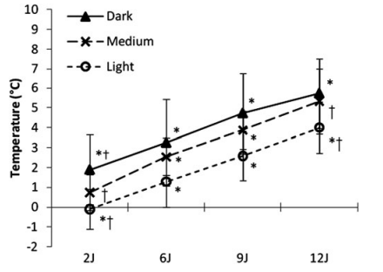

Figure 61. Examining effects of Therapeutic Lasers on Skin

*Source:* [33]

Given that Dr. Lemay’s research lab uses Tabby Cat’s, these cats have darker skin on their paws, and even if the team did switch to a breed with lighter skin, the effects of temperature would be decreased. Furthermore, we can conclude that any increase in temperature would be minimal and most likely within a range between $40°C$ to $55°C$, which would match the original Hargreaves temperature parameters of $45°C$ to $52°C$, as well as later studies which have used and modified the system, as discussed in the problem statement’s historical perspective section [3]. Although the initial Hargreaves test does not explicitly state why the temperature range is selected when using their specific filament, their system is regarded as the standard for thermal plantar testing and obeys AWA and ICAUC guidelines, with a shutoff switch after $20 seconds$ [3]. Therefore, modelling our conclusions off their range between this is enough to determine that at our laser’s set voltage, current, wavelength, and shutoff switch after $10 seconds$ of inactivity, our system will be safe for human and animal testing. The only decision to further reevaluate the system would be if animal testing does not provide any reasonable results, which based on the initial results discussed in T_FR3, this is not the case.

### **T_DC8:**

Initial testing of the laser and photodiode interaction without the acrylic plate proved to be harmful to the photodiode. While we were able to obtain withdrawal times with the interaction of the laser, the laser’s stimulation proved to be too precise as stated prior in T_DC5, furthermore as we tested the system with our fingers, our fingertips seemed to directly hit the photodiode upon activating our reflexes. At the time, the photodiode was commercial grade photodiode component we were using which became flimsy from our reactions, thus degrading the durability of the photodiode. We upgraded to a military graded version with physically has a stronger durability and prevent further damage to the photodiode by implementing the acrylic plate to indirectly capture withdrawal times. More about the plate and photodiode interaction was discussed in the T_DC5, as well as the design approach section. In terms of testing how accurate the photodiode’s readings are, this was conducted in our experiment discussed to measure repeatability, refer to T_FR3 for further information about the experiment and results.

### **T_DC9:**

Determining if a microcontroller replacement is necessary is determined by both cost and efficiency of the RPI within the system. Realistically, any microcontroller that contains General Purpose Input/Output (GPIO) pins to take in the signal from the photodiode circuit and send out a signal to the laser would prove to be effective in this system. Since Dr. Lemay and the team would like a user-friendly system with a GUI, a microcontroller that has a GPU for graphic capabilities is needed, meaning microcontrollers such as an Arduino cannot be used. This left us with determining if the RPI3B+ was a good enough microcontroller or if we should migrate to something such as a Jetson Nano. Looking ahead at programming the GUI, libraries such as *openpyxl* was researched proved to be the easiest solution in terms of conceptualization and syntax to work with when programming the system [34]. This combined with the fact that the RPI3B+ was purchased previously to the team’s contributions to the project, led us to work within the constraints of the RPI3B+. While the GUI written would work on any RPI, upgrading or downgrading the microcontroller would cost additional money, that the Team felt was not worth purchasing.

The only true design constraint faced when using the RPI is the fact that Temple University’s Wi-Fi blacklists the use of RPI’s as a security threat. Our project does not technically require any Wi-Fi since results can simply be moved on/off the system using a flash drive. Furthermore, our system includes a portable screen and portable keyboard with trackpad so there is no need to implement a remote desktop onto the microcontroller for user-interaction, although remote desktops such as VNC Viewer, No Machine were installed while developing on other Wi-Fi networks, as enabling SSH capabilities. There is a work around for connecting the RPI to *tusecurewireless,* however it would require either editing the network settings of the RPI to hash a user’s login which is ineffective since Temple requires students and faculty to constantly change their password, or the other work around would be to set up WPA2 enterprise, however this proved to be difficult for the team and would require further assistance from Temple’s IT department. If the RPI truly needed to be connected to the internet for a software update or GitHub repository update, then the user can simply create a hotspot onto their phone and then connect the RPI to the hotspot.

# Cost

Since our system builds off a prototype previously purchased through Dr. Lemay’s research, there are a few materials needed to make the system move smoothly. The first being a keyboard with a track pad for user friendliness. Artificial silicon skin was bought to test the power of the laser before using it on the test subjects, however proved to be unusable, however since bought it with our budget money, we decided to keep it within the bill of materials. The $1/8th$ acrylic sheet was bought to be cut down into the plate for the laser to be able to shoot through and stimulate a response from the test subjects. Lastly, the Klein Current Clamp is going to make measuring the current of the laser easier without the need of rewiring.

Table 9. Bill of Materials to be Purchased throughout Senior Design II

|  |  |  |  |  |
| --- | --- | --- | --- | --- |
|  | | | | |
| Name of Part | Qty | Cost | Total Cost | Website/Distribution |
| Keyboard with track pad | 1 | $26.99 | $26.99+tax | <https://www.amazon.com/Logitech-Wireless-Keyboard-Touchpad-PC-connected/dp/B014EUQOGK/ref=sxin_15?asc_contentid=amzn1.osa.1213c232-4911-4c93-a5a9-080c7940f1b5.ATVPDKIKX0DER.en_US&asc_contenttype=article&ascsubtag=amzn1.osa.1213c232-4911-4c93-a5a9-080c7940f1b5.ATVPDKIKX0DER.en_US&content-id=amzn1.sym.7f00b8f5-a224-428c-9d73-1105a21b80ef%3Aamzn1.sym.7f00b8f5-a224-428c-9d73-1105a21b80ef&creativeASIN=B014EUQOGK&cv_ct_cx=keyboard%2Btrackpad&cv_ct_id=amzn1.osa.1213c232-4911-4c93-a5a9-080c7940f1b5.ATVPDKIKX0DER.en_US&cv_ct_pg=search&cv_ct_we=asin&cv_ct_wn=osp-single-source-pecos-desktop&gclid=CjwKCAjw3qGYBhBSEiwAcnTRLnXc6uJjaIeGkQvdtQ3XS5BNzeqhMhX5ThM5zuZjK-66kENfH3qQRRoCEx0QAvD_BwE&hvadid=616931742700&hvdev=c&hvlocphy=9007310&hvnetw=g&hvqmt=e&hvrand=7497026125204293939&hvtargid=kwd-10903103680&hydadcr=24657_13611735&keywords=keyboard%2Btrackpad&linkCode=oas&pd_rd_i=B014EUQOGK&pd_rd_r=0a924056-199b-40b9-8095-8f4987a8a3ed&pd_rd_w=4yMZO&pd_rd_wg=iYgZU&pf_rd_p=7f00b8f5-a224-428c-9d73-1105a21b80ef&pf_rd_r=2S0CQREARM4G6NPRCYAY&qid=1661529509&sr=1-1-c26ac7f6-b43f-4741-a772-17cad7536576&tag=gadgetreview-tca-20&th=1> |
| Artificial silicon skin | 1 pack of 10 | $12.99 | $32.98+shipping | <https://www.amazon.com/Practice-10Pieces-Silicone-Beginner-Experienced/dp/B09CMGL1D1/ref=sr_1_8?crid=HS0OW0S8XHCJ&keywords=silicone+skin+tattooing&qid=1661530901&sprefix=silicon+skin+tattooin%2Caps%2C68&sr=8-8> |
| 1/8th Acrylic sheet | 1 | $11.22 | $51.20+ shipping | <https://www.mcmaster.com/8536K134/> |
| Klein Current Clamp | 1 | $142.94 | $194.14+ shipping | <https://www.amazon.com/Klein-Tools-Auto-Ranging-Impedance-Measures/dp/B08MG3FWMV/ref=sr_1_32?crid=3GRUQUF9Q4GEL&keywords=klein+current+clamp&qid=1661530471&sprefix=klien+current+clamp%2Caps%2C85&sr=8-32> |

## Materials List of Items Previously Purchased

The following Bill of Materials table demonstrates the total cost for components purchased that were purchased for the system prototype before our team took over the project. Combining both list of materials, we see that the overall cost was spent on the project yields at approximately $\$2.543k$ spent by Dr. Lemay and $\$195$ spent by our team’s budget, to yield about $\$2,737.17$ spent total.

Table 10. Bill of Materials Previously Purchased before Our Team's Contributions

|  |  |  |  |
| --- | --- | --- | --- |
| **BILL OF MATERIALS Pre-SD Team** | | | |
| Name of Part | Cost | Total Cost | Website/Distribution |
| 12V TTL 1W 2W 3W 445nm 450nm Laser Diode LD Driver Power Supply Stage Light lighting lamp 200mW-3W 405/445/450/520nm | $30+tax | $30+tax | <https://www.amazon.com/Violet-Step-down-Constant-Current-Circuit/dp/B06WRMZJCN> |
| Optlasers TEC-20A-30V | $40+tax | $70+tax | <https://www.ebay.com/itm/234734077294?chn=ps&mkevt=1&mkcid=28&srsltid=AR5OiO3mq3NeZu5Yzj30MCAgD6wShL4J_1ApiaiYw8Jn0hI3wW4WWs4fI4g> |
| LM14S2 14-PIN BUTTERFLY DIODE MOUNTS | $384.89+tax | $454.89+tax | <https://www.thorlabs.com/newgrouppage9.cfm?objectgroup_ID=1558> |
| Power Supply Circuit | $11+tax | $465.89+tax | <https://www.belfuse.com/product-detail/power-solutions-ac-dc-open-frame-abc-series-abc41?navCategory=ABC%20Series> |
| Raspberry Pi 3B+ | $27+tax | $492.89+tax | <https://www.raspberrypi.com/products/> |
| QFLD Laser | $990+tax | $1,482.89+tax | <http://www.qphotonics.com/Single-mode-fiber-coupled-laser-diode-200mW-1440nm.html> |
| QFBGLD Laser | $990+tax | $2,472.89+tax | <http://www.qphotonics.com/Single-mode-fiber-coupled-laser-diode-200mW-1440nm.html> |
| Photodiode | $14.28+tax | $2,487.17+tax | <https://www.digikey.com/en/products/detail/genicom-co.,-ltd./GUVA-T31GD/10474890> |
| Photodiode PCB | $5+tax | $2,492.17+tax | Custom PCB designed in Eagle, ordered manufactured by out of house PCB company. |
| Enclosure | $50 | Approx.  $2,542.17+tax |  |

## Bill of Materials for Final Design

Disregarding materials bought such as the artificial skin, TEC Cooler, and original laser however significantly reduces our cost, meaning our finalized system costs approximately $\$1,693.32$ USD to be manufactured.

|  |  |  |  |
| --- | --- | --- | --- |
| **BILL OF MATERIALS SDII Team Final Design** | | | |
| Name of Part | Cost | Total Cost | Website/Distribution |
| 12V TTL 1W 2W 3W 445nm 450nm Laser Diode LD Driver Power Supply Stage Light lighting lamp 200mW-3W 405/445/450/520nm | $30+tax | $30+tax | <https://www.amazon.com/Violet-Step-down-Constant-Current-Circuit/dp/B06WRMZJCN> |
| LM14S2 14-PIN BUTTERFLY DIODE MOUNTS | $384.89+tax | $414.89+tax | <https://www.thorlabs.com/newgrouppage9.cfm?objectgroup_ID=1558> |
| Power Supply Circuit | $11+tax | $425.89+tax | <https://www.belfuse.com/product-detail/power-solutions-ac-dc-open-frame-abc-series-abc41?navCategory=ABC%20Series> |
| Raspberry Pi 3B+ | $27+tax | $452.89+tax | <https://www.raspberrypi.com/products/> |
| QFBGLD Laser | $990+tax | $1,442.89+tax | <http://www.qphotonics.com/Single-mode-fiber-coupled-laser-diode-200mW-1440nm.html> |
| Photodiode | $14.28+tax | $1,457.17+tax | <https://www.digikey.com/en/products/detail/genicom-co.,-ltd./GUVA-T31GD/10474890> |
| Photodiode PCB | $5+tax | $1,462.17+tax | Custom PCB designed in Eagle, ordered manufactured by out of house PCB company. |
| Keyboard with track pad | $26.99 | $1489.16+tax | <https://www.amazon.com/Logitech-Wireless-Keyboard-Touchpad-PC-connected/dp/B014EUQOGK/ref=sxin_15?asc_contentid=amzn1.osa.1213c232-4911-4c93-a5a9-080c7940f1b5.ATVPDKIKX0DER.en_US&asc_contenttype=article&ascsubtag=amzn1.osa.1213c232-4911-4c93-a5a9-080c7940f1b5.ATVPDKIKX0DER.en_US&content-id=amzn1.sym.7f00b8f5-a224-428c-9d73-1105a21b80ef%3Aamzn1.sym.7f00b8f5-a224-428c-9d73-1105a21b80ef&creativeASIN=B014EUQOGK&cv_ct_cx=keyboard%2Btrackpad&cv_ct_id=amzn1.osa.1213c232-4911-4c93-a5a9-080c7940f1b5.ATVPDKIKX0DER.en_US&cv_ct_pg=search&cv_ct_we=asin&cv_ct_wn=osp-single-source-pecos-desktop&gclid=CjwKCAjw3qGYBhBSEiwAcnTRLnXc6uJjaIeGkQvdtQ3XS5BNzeqhMhX5ThM5zuZjK-66kENfH3qQRRoCEx0QAvD_BwE&hvadid=616931742700&hvdev=c&hvlocphy=9007310&hvnetw=g&hvqmt=e&hvrand=7497026125204293939&hvtargid=kwd-10903103680&hydadcr=24657_13611735&keywords=keyboard%2Btrackpad&linkCode=oas&pd_rd_i=B014EUQOGK&pd_rd_r=0a924056-199b-40b9-8095-8f4987a8a3ed&pd_rd_w=4yMZO&pd_rd_wg=iYgZU&pf_rd_p=7f00b8f5-a224-428c-9d73-1105a21b80ef&pf_rd_r=2S0CQREARM4G6NPRCYAY&qid=1661529509&sr=1-1-c26ac7f6-b43f-4741-a772-17cad7536576&tag=gadgetreview-tca-20&th=1> |
| 1/8th Acrylic sheet | $11.22 | $1,500.38+tax | <https://www.mcmaster.com/8536K134/> |
| Klein Current Clamp | $142.94 | $1,643.32+tax | <https://www.amazon.com/Klein-Tools-Auto-Ranging-Impedance-Measures/dp/B08MG3FWMV/ref=sr_1_32?crid=3GRUQUF9Q4GEL&keywords=klein+current+clamp&qid=1661530471&sprefix=klien+current+clamp%2Caps%2C85&sr=8-32> |
| Enclosure | $50 | Approx.  $1,693.32+tax |  |

# Schedule

Here we broke up our tasks for this project into four sections using excel in conjugation with excels calendar features. Within each section are the goals that were set to achieve an operating system. Additionally, we managed to stay on track by having weekly meetings in which we divide these higher-level tasks into weekly subtasks.

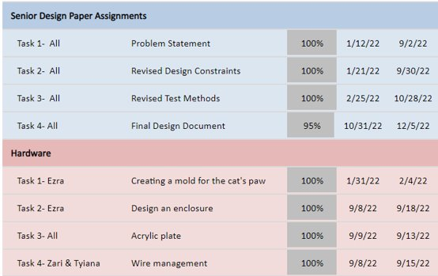

Figure 62. Schedule for Paper Assignments and Hardware

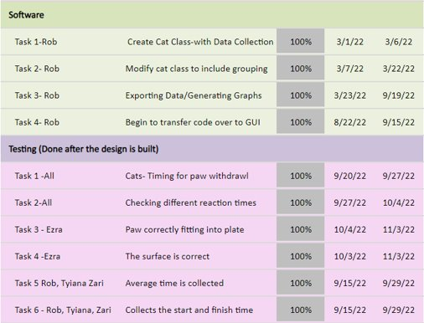

Figure 63. Scheduling for Software and overall Testing

# Summary and Conclusions

Based on the test results, initial cat testing, and cost, our team managed to create a cost-efficient thermal laser plantar test that can obtain precise reactions within $+/-10$ seconds which can be stored to a database with automatically generated analysis for individual and group results. The proposed solution runs off wall power utilizing two power supplies, one for the laser and one for the microcontroller. The overall cost of the system proved to be 6 times cheaper than the standard apparatus for thermal plantar testing. By utilizing our system Dr. Lemay and his team will be able to continue testing more cats over time and analyze results to conclude their hypothesis regarding if BDNF leads to an increase in thermal and mechanical sensitivity to pain (hyperalgesia), which may be a source of chronic pain within spinal cord injuries. Concluding the effects of BDNF may advocate the Lemay lab to present their findings and guide fellow medical professionals away from treating patients with BDNF and to instead promote other nuerotrophins which the lab will also examine. This corresponds in aiding the United Nations Goals of Sustainability goals to promote Good Health and Well Being by aiding medical professionals in developing better treatment for spinal cord injuries, as well as promoting life on land, since all findings within the cat test subjects can also aid veterinarians in treating domestic and wildlife animals that suffer from spinal cord injuries [16].

From a design perspective, the project allowed the team to work in a field in which none of the students have ever worked in. By researching and coordinating with the Lemay lab, the team learned background biological knowledge about spinal cord injuries and previous treatment which allowed the team to get a grasp of the problem the Lemay lab faced. This allowed the team to gain substantial systems engineering knowledge by examining commercial solutions and break down the key components of these systems to draft a better proposed solution. By breaking down the proposed solution into subsystems with interaction, the team drafted a list of functional requirements and design constraints in which the design approach of the system would have to obey and overcome. The team created a work breakdown structure and divided the workload up amongst each other which allowed for new skills to be achieved such as CNC routing for the mechanical aspect, hardware design and cable management for electrical engineers who previously lacked this expertise, as well as software design to create a Graphical User Interface (GUI) which promotes user-friendliness. The design process became an iterative process over the course of two semesters and saw the team optimizing the solution upon each iteration. The team then worked together to create a three-phase test plan by:

1. Testing each Component/Subsystem
2. Testing Interaction between Subsystems
3. Testing the System as a whole

Each individual test method was designed to fit in one of these categories and validate the design approach by succeeding the functional requirements and design constraints. Finally, the system was given to the Lemay lab to gain feedback and improve upon the design. Additionally, the team also brought their design to SDII poster day, in which real-time demonstrations were shown off similarly to a technology expo. This was an important experience because it allowed the team to simulate working within a real-world environment where new skills will be developed over time based on experience and client expectations to further optimize and achieve the best possible solution.

In terms of future work for the system, another team could continue to optimize several areas such as the GUI, which could be modified to provide real-time analysis, as well as the ability to remove previously stored data from the overall database, rather than performing this manually in excel, however implementing this could take up more CPU time due to searching through the database. The ability to also store data to the same animal that was previously tested could also be implemented, meaning that results could be sorted and analyzed by group and individual cat name, instead of simply group and test date. This could be beneficial when examining results for one cat regardless of the test date. In terms hardware or mechanical interaction, one suggestion that came from the Lemay lab survey which was discussed within the test methods section brought up the idea of testing a cat in an upward sitting position instead of laying down. Our team proposes that another team could design a mechanical frame which is clamped to the apparatus and will hold a comfortable sling for the cat to be placed in and hovered over the acrylic plate. This design would be similar to a sling for a baby, as shown in the stock photo below,

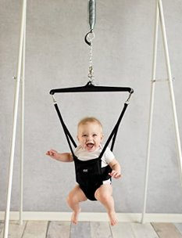

Figure 64. Example for Sling attachment to the system

# Appendix

## Hargreaves Test Cost Estimate

The Hargreaves Test has been known to be a costly procedure that produces precise, accurate results. When initially developing research for a Spinal Cord Injury model in felines, Dr. Michel Lemay contacted Harvard Apparatus to purchase a Hargreaves Test apparatus. The following is a quote from Harvard Apparatus containing the total estimated to be $\$9,766.00$ [4].



Figure 65. Harvard Apparatus Quote for Hargreaves Test

*Source:* [4]

## Thermal Laser System Schematic

### Pre-SD Team Contributions

Schematics of the work done so far to the prototyped system before our team took over the project were proposed as follows. The overall system flows, starting with the power supply, which delivers power to the driver circuit acting as a constant current source by sending a signal to drive the laser triggered by a program written in the Raspberry Pi (RPi). The constant current source is connected to the laser through the butterfly laser diode mount, which also connects the thermoelectric cooler (TEC), designed to prevent the laser’s temperature from overheating. The TEC is also powered by the power supply. The OFLD-1440-200s laser also utilizes a powerful heatsink, which so far has made the TEC act only as a backup cooling system. The photodiode circuit is also connected to the RPi and works by placing the test animal’s paw upon the photoresistor. When the laser stimulates the animal’s paw reflex, the animal removes the paw from the photoresistor, which increases the resistance due to more light being detected. This sends a signal back to the RPi to stop the laser.

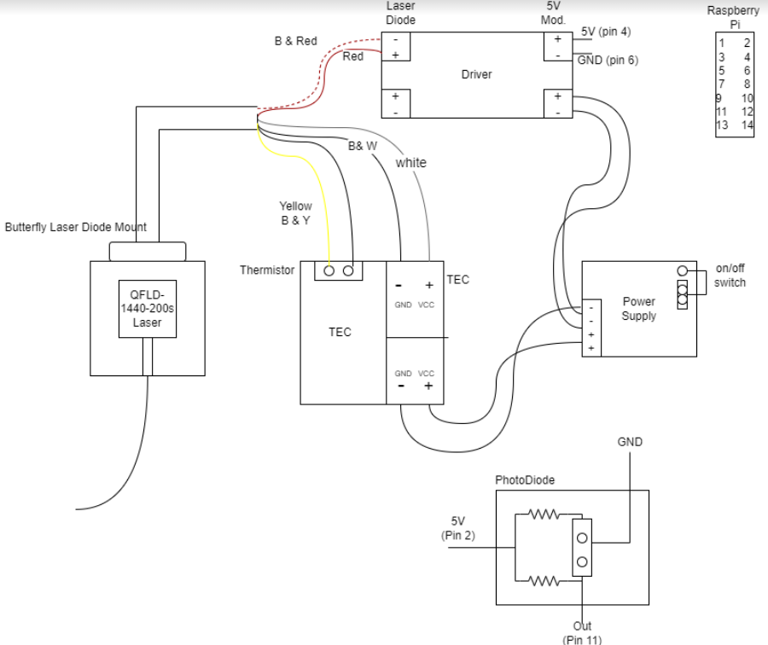

Figure 66. General System Schematic of Dr Lemay's Laser Prototype

### SD Team Final Design Schematic

As stated however, once the team took over, the addition of the acrylic plate was introduced, along with an LED to indicate when the system’s laser is on. The laser itself was also upgraded to the QFBGLD-1460-350 Qphotonics laser, and the TEC circuit was deprecated from the system since the laser’s heatsink handled any concerns for overheating and preventing thermal runaway.



Figure 67. Finalized System Schematic

### Implementation of Schematics (System Hardware)

Implementation of the schematic inside the enclosure of the system is as follows,



Figure 68. Implementation of Finalized Schematic

A deeper in-depth schematic of the PhotoDiode circuit functions as follows, utilizing a voltage divider to set the bias of the PhotoDiode, with respective input and output signals.

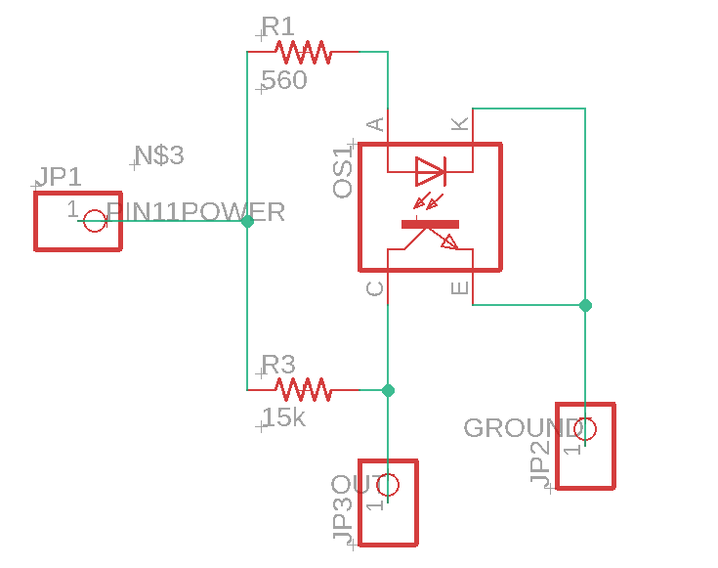

Figure 69. PhotoDiode Schematic

Implementation of the photodiode schematic is shown by the following PCB,



Figure 70. Implementation of the Photodiode Circuit

The laser driver’s datasheet yields the following pin outs for connecting the driver to a circuit.



Figure 71. Laser Driver Pinout

Technical details regarding the Butterfly Laser Diode mount include the following specifications and pinout diagrams.

Table : Specifications of Butterfly Laser Diode Mount

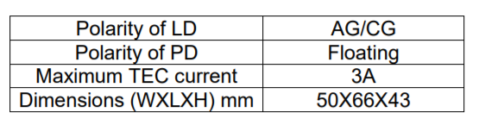

Table 12: Butterfly Laser Diode Mount Pin Diagram



Table 13: Butterfly Laser Diode Mount Pinout

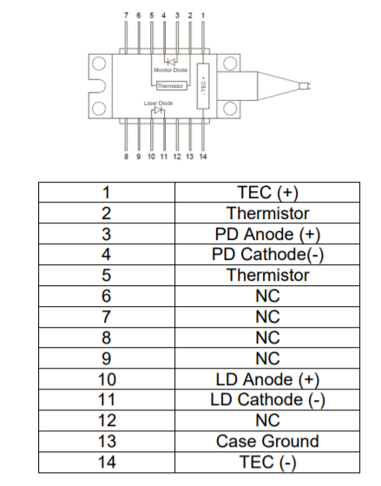

## Software Source Code

Software for the system can also be found upon the git hub repo,

<https://github.com/Rbara00/ThermalLaserSD>

Where the team’s final presentation is also linked for further information and video demonstration of the system in action at 18:10,

<https://youtu.be/Gu6zqBxIRyg>

### Animal Class

###########################################

##

## Animal Class for thermal laser

## SD Team 10: Robert Bara, Zari Grandy, Ezra Galapo, Tyiana Smith

##

## Author: Robert Bara

## Date: 11/9/2022

## Version: 3.0

##

## Description:

## This python file contains the class functions to create an animal data type, obtain data, and analyze the

## data for the thermal laser plantar test on test animals.

##

## Usage:

## This program is invoked by laser_test_GUI.py

##

########################################

############ Includes ##################

from datetime import date

from os import stat

from re import S

from sre_constants import MAXGROUPS # Import date class from datetime module

from statistics import pstdev, pvariance, mean # Import statistics to utilize mean, standard deviation, and variance calculations

import RPi.GPIO as GPIO # Import General-Purpose In/Out for RPI4 to control laser and photodiode

from time import time

from tkinter import*

from tkinter import messagebox

############ animal Class #################

class animal:

##############################

#Constructor for animal

##############################

def __init__(self,name,group):

self.name=name #animal is named from user input

self.time=[] #create a list of all the animal's withdrawal times

self.date = date.today() #stores the corresponding test date

self.startTime=0 #stores the timestamp when testing is starting for cat

self.endTestTime=0 #stores the timestamp when testing is over for the cat

self.group=group #stores the cat's group number

self.avg=0 #Initialize the average to be 0

self.standardDev=0 #Initialize the standard deviation to be 0

self.trialVariance=0 #Initialize the variance to be 0

self.numOfTrials=0 #Counter for how many trials were performed for animal

return

##########################################

# Class Functions:

##########################################

#Getter for the animal's name

def getName(self):

return self.name

#Getter for the test date corresponding to the animal

def getDate(self):

return self.date

#Getter for the animal's group number

def getGroup(self):

return self.group

#Getter for the animal's number of trials completed

def getNumOfTrials(self):

return self.numOfTrials

#Getter for the average withdrawal time

def getAvg(self):

sample=self.time

self.avg=mean(sample)

return self.avg

#Getter for time at specifed trial

def getTimeAt(self,index):

return self.time[index]

#Getter for the Standard Deviation of the animal's response times

def getStdev(self):

sample=self.time

self.standardDev=pstdev(sample)

return self.standardDev

#Getter for the Variance of the animal's response times

def getVar(self):

sample=self.time

self.trialVariance=pvariance(sample)

return self.trialVariance

###################################################################################

# Functions for turning on laser system and inserting withdrawal time into database

###################################################################################

#Method for inserting a new withdrawl time into the list

def insertTime(self,new_time):

self.time.append(new_time)

self.numOfTrials+=1

return

#Trial function with prompt from GUI

def trial_gui(self,placed_label):

############################################################################

#Setup GPIO Board for RPI

GPIO.setmode(GPIO.BOARD)

GPIO.setup(13,GPIO.OUT) #output for laser

GPIO.setup(15,GPIO.OUT) #output for LED

GPIO.output(13,GPIO.LOW) #initialize laser off

GPIO.output(15,GPIO.LOW) #initialize LED off

############################################################################

#Run a trial and insert withdrawal time into a list for exporting

t_1=self.timer(placed_label)

############################################################################

#Clear the GPIO Pins, overide laser to be off

GPIO.setmode(GPIO.BOARD)

GPIO.setup(13,GPIO.OUT) #output for laser

GPIO.setup(15,GPIO.OUT) #output for LED

GPIO.output(13,GPIO.LOW) #initialize laser off

GPIO.output(15,GPIO.LOW) #initialize LED off

############################################################################

t_1=float(t_1) #Ensure the time is a valid time with decimals

#Check if the laser timed out

if (t_1==-10):

messagebox.showerror("Time Out","Error: No reaction detected within 10 Seconds")

valid_trial=False

#Was the trial valid enough for the user?

elif (t_1!=10):

valid_trial=messagebox.askyesno("Valid Trial","Keep Trial?\nName: " + self.name +" Time: "+str(t_1)+" seconds")

#If trial is discarded, return back to the test menu

if valid_trial==False:

placed_label.config(text="Photodiode Status:")

return

if valid_trial==True:

#When a valid trial is ran,

self.insertTime(t_1) #place withdrawal time into list

if self.numOfTrials>1:

#Update the analysis

self.avg=self.getAvg()

self.standardDev=self.getStdev()

self.trialVariance=self.getVar()

else:

#If there is only 1 trial, dont update analysis

self.avg=self.getTimeAt(0) #Average is the only valid trial

self.standardDev=0

self.trialVariance=0

placed_label.config(text="Photodiode Status:")

return

#Method for recording withdrawal time with laser

def timer(self,placed_label):

GPIO.setmode(GPIO.BOARD)

GPIO.setup(11,GPIO.IN) #PhotoDiode Signal Pin

GPIO.setup(13,GPIO.OUT) #Output to the Laser

GPIO.setup(15,GPIO.OUT) #Output to the LED

GPIO.output(13,GPIO.LOW) #Initialize Laser to off

GPIO.output(15,GPIO.LOW) #Initialize LED to off

#Set up label, initialize photodiode reading to off, set timeout to be 10seconds

placed_label.config(text="Photodiode Status: Searching for Paw")

first_placed=False

time_out=10

#--------------------------------------------------------------

#t_1=input("") #REMOVE THIS LINE IN FUTURE THIS IS JUST FOR PROGRAMMING AT HOME

#return t_1

#--------------------------------------------------------------

#Check if the photo diode is not covered, when it is covered, turn on the laser

while first_placed is False:

GPIO.output(13,GPIO.LOW)

if GPIO.input(11)==0:

first_placed=True

GPIO.output(13,GPIO.HIGH) #Turn on the Laser

GPIO.output(15,GPIO.HIGH) #Turn on the LED

break

#Get initial start time, update label

t_0=time()

placed_label.config(text="Photodiode Status: Paw Placed Laser On")

#Check if the paw is removed and the photo diode becomes uncovered, if so turn off the laser

#If nothing happens within 10 seconds, turn off the laser and break from the loop

while (True):

#Priority logic, exit if exceeds 10sec

if(time()>t_0+time_out):

t_1=-10

GPIO.output(13,GPIO.LOW) #Turn off the laser

GPIO.output(15,GPIO.LOW) #Turn off the LED

break

#Check if the paw is removed

if GPIO.input(11)==0:

placed=True

else:

placed=False

GPIO.output(13,0) #turn off the laser

GPIO.output(15,0) #turn off the LED

#If the paw was placed and removed from laser, record change in time

if first_placed is True and placed is False:

t_1=time()-t_0

GPIO.output(13,GPIO.LOW) #Turn off the laser

GPIO.output(15,GPIO.LOW) #Turn off the LED

break

#Update label

placed_label.config(text="Photodiode Status: Paw Placed Laser Off")

#Turn off laser and LED before exiting function and returning withdrawal time

GPIO.output(13,GPIO.LOW)

GPIO.output(15,GPIO.LOW)

GPIO.cleanup()

return t_1

### Table Class

###########################################

##

## Tables Class for thermal laser

## SD Team 10: Robert Bara, Zari Grandy, Ezra Galapo, Tyiana Smith

##

## Author: Robert Bara

## Date: 4/5/2022

## Version: 1.1

##

## Description:

## This python file contains a class to construct a table which will hold store

## an animal into a list avaliable at the given index which is based upon a group,

## graphically the table can be drawn as:

## [column index][list of cats]

## group0 : cat1,cat2,cat3

## group1 : cat1,cat2,cat3

## ...

## groupN : N cats

## Usage:

## This program is invoked by test_class and utilizes inputs from the animal_class

##

########################################

#############################################################

# Table Class

#############################################################

class resultTb:

#constructor for a table of lists which hold a test animal as an element

def __init__(self, size=100):

self.size=size #dynamically allocated memory for the size of the table

self.arr=[[] for i in range (self.size)] #Creating the table as an array of lists

self.filled=0 #Keeps track of how man animals are "filled" in the table

return

#Takes an animal and inserts it into the results table based upon their group number

def insert(self,curr_animal):

group=curr_animal.getGroup()

self.arr[group].append(curr_animal)

self.filled+=1

return

#Prints all animals results within the passed in group number, in order of when they were stored into group

def printIndex(self,group):

#in the table at row with index corresponding to the group number, iterate across the list of animals

for i in range(len(self.arr[group])):

print(self.arr[group][i].printTime()) #Print the current counter's animal results

return

#print all results stored within the table in order of groups

def printAll(self):

for i in range(self.size):

self.printIndex(i)

return

### Export Class

###########################################

##

## Animal Class for thermal laser

## SD Team 10: Robert Bara, Zari Grandy, Ezra Galapo, Tyiana Smith

##

## Author: Robert Bara

## Date: 9/6/2022

## Version: 2.0

##

## Description:

## This python file is responsible for taking data from the laser test and exporting it to excel. Additionally,

## the results automatically generate a bar graph comparing the group averages and standard deviation

##

## Usage:

## This program is invoked by test_class.py

##

########################################

# Imports

from tkinter import filedialog

import os

from statistics import pstdev, pvariance, mean # Import statistics to utilize mean, standard deviation, and variance calculations

import openpyxl # Import for exporting the animal's results to spreadsheets

import openpyxl.chart

#####################################################

# Functions for exporting results to spreadsheet

#####################################################

class export:

#This function creates a spreadsheet based on the workbook name and labels the proper columns for the animal's data

def exportSetup(self,workbookName):

#Create a work book

wb1=openpyxl.Workbook()

#prompt for an output file name

wb1.save(os.path.join(os.path.dirname(os.path.abspath(__file__)),workbookName))

#close the workbook

wb1.close

return wb1 #return the workbook so we can read/write to it with the other export functions

#Prompts the user to load/save an excel file

def load(self):

filename = filedialog.asksaveasfilename(initialdir=os.path.join(os.path.dirname(os.path.abspath(__file__))),

defaultextension='.xlsx',

filetypes=[

("xlsx",".xlsx"),

("xls", ".xls"),

('xl','.xl'),

('sm','.sm'),

('xtlx','.xtlx'),

('xltm','.xltm'),

("All files", ".*"),])

return filename

#This function checks for the appropriate test result spreadsheet and exports/analyzes any new test results to the sheet

def exportResults(self,results, numOfGroups):

#Check if the excel file exists, if not create it

try:

workbookName=self.load()

wb1=openpyxl.load_workbook(workbookName)

except FileNotFoundError:

#Create the excel file with the corresponding workbook name

wb1=self.exportSetup(workbookName)

#Create enough sheets for each group

for i in range(1,numOfGroups+1):

ws=wb1.create_sheet()

ws.title="Group"+str(i)

self.exportLabels(ws) #write labels to excel sheet

ws=self.columnWidth(ws) #Format the Column Width

#Write the test's results data to excel and compute analysis

wb1=self.exportDataToResults(wb1, results, numOfGroups)

#Save the excel file

wb1.save(os.path.join(os.path.dirname(os.path.abspath(__file__)),workbookName))

# Close the workbook and return

wb1.close()

return workbookName

#This function writes the test results to the correct group's sheet, or creates a blank sheet for future testing

def exportDataToResults(self, wb1, resultTb,numOfGroups):

#For 1 to max number of groups, load and write data from the results table into excel

for i in range(1,numOfGroups+1):

curr_group=resultTb.arr[i] #For readability, get the current group

#check if in the correct group sheet

if ("Group"+str(i)) in wb1.sheetnames:

ws=wb1["Group"+str(i)] #Get the correct group's sheet

max_row=ws.max_row #Get the max row of the sheet

groupTrialNum=max_row #update the total number of trials per group

#Iterate across the list at the group index, where each element is a stored animal

for j in range(len(curr_group)):

curr_animal=curr_group[j] #For readability, get the current animal

trialNum=1 #For printing the trial number corresponding to the withdrawal time

analyzeTime=[] #For performing analysis for all data up to a given point

#Export and Analyze each withdrawal time for the current animal

for w_time in curr_animal.time:

analyzeTime.append(w_time) #store current time local to animal for analysis

groupAvg='=AVERAGE(G2:G'+str(groupTrialNum+1)+')'

groupStdev='=STDEVP(G2:G'+str(groupTrialNum+1)+')'

#Print all the group and animals data to excel

ws.append([curr_animal.getGroup(), groupTrialNum, groupAvg, groupStdev,

curr_animal.getName(), trialNum, w_time, mean(analyzeTime),

pstdev(analyzeTime), pvariance(analyzeTime), curr_animal.date,

curr_animal.startTime, curr_animal.endTestTime])

#Increase trial number counters

trialNum+=1

groupTrialNum+=1

#Otherwise create as many sheets as needed for the number of groups avaliable

else:

ws=wb1.create_sheet()

#Label the sheet based on the group number

ws.title="Group"+str(i)

#Create column labels

self.exportLabels(ws)

#Write data to new sheets through recursion

self.exportDataToResults(wb1,resultTb)

#Return updated workbook

return wb1

#This function creates a sheet specifically to graph the results of all group's average times and standard deviation

def graphResults(self,workbookName):

#Check if the excel file exists, if not return

try:

#load the excel file with the corresponding workbook name

wb1=openpyxl.load_workbook(os.path.join(os.path.dirname(os.path.abspath(__file__)),workbookName))

except FileNotFoundError:

print("Invalid file name")

return

#Remove the results sheet and Re-Analyze

if ("Results") in wb1.sheetnames:

wb1.remove(wb1["Results"])

#Create the graph results sheet

ws0=wb1.create_sheet()

ws0.title="Results"

ws0.append(["Group","Avg Times","Stdev"])

#Obtain the latest Group Averages and standard deviation

ws1=wb1["Group"+str(1)]

max_sheet=int(len(wb1.sheetnames))

for i in range(1,max_sheet):

#check if in the correct group sheet

if ("Group"+str(i)) in wb1.sheetnames:

ws1=wb1["Group"+str(i)]

max_row=ws1.max_row

#Check if there is data to graph

if isinstance(ws1.cell(max_row,1).value,str) is False:

#Locate the current group's latest group average and standard deviation

groupNum='=Group'+str(i)+'!A'+str(max_row)

groupAvg='=Group'+str(i)+'!C'+str(max_row)

groupStdev='=Group'+str(i)+'!D'+str(max_row)

ws0.append([groupNum,groupAvg,groupStdev]) #write data to the results sheet

#Create the bar graph from the results

ws0=self.createBarGraphResults(ws0)

#Save and close the excel file

wb1.save(os.path.join(os.path.dirname(os.path.abspath(__file__)),workbookName))

wb1.close()

return

#This function generates a bar graph for the results sheet

def createBarGraphResults(self,ws0,):

#Generate a Bar Graph for averages

chart1 = openpyxl.chart.bar_chart.BarChart()

chart1.type = "col"

chart1.style = 3

chart1.title = "Average Responses of All Groups"

chart1.y_axis.title = 'Avg and Stdev of Withdrawal Times'

chart1.x_axis.title = 'Group Numbers'

#Data to be graphed

data = openpyxl.chart.Reference(ws0, min_col=2, min_row=1, max_row=ws0.max_row, max_col=ws0.max_column)

cats = openpyxl.chart.Reference(ws0, min_col=1, min_row=2, max_row=ws0.max_row)

chart1.add_data(data, titles_from_data=True)

chart1.set_categories(cats)

chart1.shape = 8

ws0.add_chart(chart1, "G2") #Position where graph will be added

#Return the updated results sheet with graph

return ws0

#Formats the excel column width nicely

def columnWidth(self,ws):

ws.column_dimensions['A'].width=7 #Group Number

ws.column_dimensions['B'].width=10 #Number of trials in group

ws.column_dimensions['C'].width=12 #Group's Average Response Time

ws.column_dimensions['D'].width=12 #Group's Standard Deviation

ws.column_dimensions['E'].width=12 #Name of Animal

ws.column_dimensions['F'].width=9 #Number of trials per Animal

ws.column_dimensions['G'].width=14 #Animal Response time at given trial

ws.column_dimensions['H'].width=9 #Animal's Average Response Time

ws.column_dimensions['I'].width=9 #Animal's Standard Deviation

ws.column_dimensions['J'].width=9 #Animal's Variance

ws.column_dimensions['K'].width=12 #Date of Testing

ws.column_dimensions['L'].width=11 #Starting time for testing animal

ws.column_dimensions['M'].width=11 #Ending time for testing animal

return ws

#Writes the labels for a group's sheet

def exportLabels(self,ws):

ws.append(["Group","Group Trial Num","Group Avg","Group Stdev","Animal Name",

"Trial Num","Response Times","Avg Time","Stdev","Trial Var",

"Test Date", "Start Test Time","End Test Time"])

return ws

### GUI Class and Driver

#!/usr/bin/python3

###########################################

##

## Test Class for thermal laser

## SD Team 10: Robert Bara, Zari Grandy, Ezra Galapo, Tyiana Smith

##

## Author: Robert Bara

## Date: 11/9/2022

## Version: 2.0

##

## Description:

## This python file performs a thermal laser test for a medium sized animal such as a cat,

## the program prompts the user through the terminal for commands and activates the laser

## in the system to gather withdrawal times for each animal. The data is then stored to the

## animal and the average, standard deviation, and variance are calculated for each animal.

## The results are then exported to excel where the group average and standard deviation are

## plotted against each group.

##

## Usage:

## Python3 laser_test_GUI.py or ./laser_test_GUI.py

##

########################################

#Imports

from cProfile import label

from cmath import exp

from tkinter import *

from tkinter import simpledialog

from tkinter import messagebox

from tkinter.ttk import Notebook

from tkinter import ttk

from tokenize import group

from unicodedata import name

import animal_classGUI as animal

import export_classGUI as export

from export_classGUI import*

import tablesGUI as resultTb

from datetime import datetime

import RPi.GPIO as GPIO # Import General-Purpose In/Out for RPI4 to control laser and photodiode

#Glocal variable definitions to pass data between button callback functions

global currName

global numOfGroups

global currGroup

global mytext

mytext=("Name: " + " Group: " + " Trial: " + " Withdrawal Time: "+" Start Time: " + " End Time: ")

trialNum=0

numOfGroups=0

#########################################

# Functions for running a test #

#########################################

#Prompts the user for name and number to construct animal

def promptAnimalInfo():

#initailize changing global values

global currName

global currGroup

global curr_animal

global numOfGroups

#Prompt for a valid integer group number

currName=simpledialog.askstring("Thermal Laser Plantar Test", " Please Enter the Subject's Name: ")

while True:

try:

currGroup = int(simpledialog.askinteger("Thermal Laser Plantar Test","Enter subject's Group number, minimum of 1: "))

if currGroup>=1:

break

except ValueError:

simpledialog.askinteger("Thermal Laser Plantar Test","Please Enter a group number, minimum of 1")

continue

#Update number of groups based on max group number

if currGroup>numOfGroups:

numOfGroups=currGroup

#create animal based on name and group

curr_animal=animal.animal(currName,currGroup)

#This method is what starts the entire system to run a test

def startExperiment():

global curr_animal

#Begin Testing a animal

curr_animal.startTime=datetime.now().strftime("%H:%M:%S") #get the timestamp when testing for this animal is beginning

#Starts and Stops the Laser based on Photodiode state

curr_animal.trial_gui(placed_label)

#Print animal's information after testing

curr_animal.endTestTime=datetime.now().strftime("%H:%M:%S") #get the timestamp when testing is over for current cat

global mytext

mytext=("Name: " + currName + " Group: " + str(curr_animal.getGroup()) + " Trial: " + str(curr_animal.getNumOfTrials()) + " Withdrawal Time: "

+ str(curr_animal.getTimeAt(curr_animal.getNumOfTrials()-1)) +"\nStart Time: " + str(curr_animal.startTime) + " End Time: " +

str(curr_animal.endTestTime))

#########################################

# Callback Functions for Buttons #

#########################################

#Begins the Test

def Button_1():

global l4

global mytext

#get info from user to name animal and assign group

promptAnimalInfo()

#Update Labels

mytext=mytext=("Name: " + currName + " Group: " + str(curr_animal.getGroup()) + " Trial: " + " Withdrawal Time: "

+"\nStart Time: " + " End Time: ")

l4.configure(text=mytext)

#Switches to Testing Menu

menus.add(frame2,text='Laser Test Menu')

menus.hide(0)

#Exits the Program

def Button_2():

quit()

#Begin the laser for testing

def Button_3():

startExperiment()

#Update label with last known results

global l4

l4.configure(text=mytext)

#Prompts to test a new animal or not

def Button_4():

results.insert(curr_animal) #Insert the last animal into results

promptAnimalInfo() #Prompt for new animal

#Update Labels

mytext=mytext=("Name: " + currName + " Group: " + str(curr_animal.getGroup()) + " Trial: " + " Withdrawal Time: "

+" Start Time: " + " End Time: ")

l4.configure(text=mytext)

#Saves the spreadsheet and exits the program

def Button_5():

results.insert(curr_animal) #Insert the last animal into results

#Create an exporting object

lasertest=export()

#Prompt user for filename and exports data into Excel Sheet based upon Group Number

wb1=lasertest.exportResults(results,numOfGroups)

#Generates Bar Graphs from Data

wb1=lasertest.graphResults(wb1)

#Exits the program

quit()

#########################################

# Driver Function #

#########################################

# Creating menus

# Creating menus

root = Tk()

root.title("Thermal Laser Plantar Test")

root.geometry("800x500")

root.resizable(True,True)

#root.iconbitmap(os.path.join(os.path.dirname(os.path.abspath(__file__)),('lemay.ico')))

results=resultTb.resultTb()

#Create a notebook to store menus as tabs

menus=Notebook(root)

menus.pack()

#Format Menus

style = ttk.Style()

style.theme_create( "MyStyle", parent="alt", settings={

"TNotebook": {"configure": {"tabmargins": [2, 5, 2, 0] } },

"TNotebook.Tab": {"configure": {"padding": [5, 5] },}})

style.theme_use("MyStyle")

#Setup GPIO Board for RPI, laser and LED should be off

GPIO.setmode(GPIO.BOARD)

GPIO.setup(13,GPIO.OUT)

GPIO.setup(15,GPIO.OUT)

GPIO.output(13,GPIO.LOW)

GPIO.output(15,GPIO.LOW)

# setup frame 1 as start menu and frame 2 as test menu

frame1=Frame(menus,width=800,height=500,bg="#7F7FFF")

frame2=Frame(menus,width=800,height=500,bg='red4')

frame1.pack()

frame1.pack_propagate(0)

frame2.pack()

frame2.pack_propagate(0)

# Add frames as tabs to GUI and hide the Test menu so only the main menu appears

menus.add(frame1,text='Main Menu')

menus.add(frame2,text='Laser Test Menu')

menus.hide(1)

# Labels and Buttons for main menu

l1= Label(frame1, text="Welcome to the Thermal Laser Test", bg="#7F7FFF",fg="yellow", font=("Times",25,"bold","underline")).pack(pady=(100,0))

l2= Label(frame1, text="Would you like to Run a Test?", bg="#7F7FFF",fg="yellow", font=("Times",20,"bold")).pack()

B1 = Button(frame1, text = "Start Test",height=3,width=25,command = Button_1).pack(side="left", anchor="e",expand=True)

B2 = Button(frame1, text = "Exit",height=3,width=25,command = Button_2).pack(side="right", anchor="w",expand=True)

#Labels and buttons for Test menu

l3= Label(frame2, text="Place Animal onto System, then click 'Start' to begin a Test", bg="red4",fg="yellow", font=("Times",20,"bold","underline"))

l3.place(relx=0.05,rely=.1)

l4= Label(frame2, text=mytext, font=("Times",15,"bold"),bg="red4",fg="yellow")

l4.pack(anchor="center", expand=True)

#PhotoDiode Label

placed_label=Label(frame2,text="Photodiode Status:",font=("Times",15,"bold"),bg="red4",fg="white")

placed_label.place(relx=.3,rely=.3)

B3 = Button(frame2, text = "Start Laser Test",height=2,width=25,command=Button_3).place(relx=0.1,rely=0.7)

B4 = Button(frame2, text = "Select New Animal",height=2,width=25,command = Button_4).place(relx=0.35,rely=0.7)

B5= Button(frame2, text = "Exit",height=2,width=25,command = Button_5).place(relx=0.6,rely=0.7)

#define function if the user hits the "x" at the top of the window

def on_closing():

if messagebox.askokcancel("Quit", "Do you want to quit without saving?"):

root.destroy()

root.protocol("WM_DELETE_WINDOW", on_closing)

#Run the GUI indefinetly until the user stops the test

frame1.mainloop()

# Reference List

[1] Huang, E. J., & Reichardt, L. F. (2001). Neurotrophins: roles in neuronal development and function. Annual review of neuroscience, 24, 677–736. https://www.ncbi.nlm.nih.gov/pmc/articles/PMC2758233/

[2] Dubin, A. E., & Patapoutian, A. (2010). Nociceptors: the sensors of the pain pathway. The Journal of clinical investigation, 120(11), 3760–3772. https://www.ncbi.nlm.nih.gov/pmc/articles/PMC2964977/

[3] Hargreaves, K.M., Dubner, R., Brown, F.J., Flores, C., & Joris, J.L. (1988). A new and sensitive method for measuring thermal nociception in cutaneous hyperalgesia. Pain, 32, 77-88. https://pubmed.ncbi.nlm.nih.gov/3340425/

[4] H. Apparatus, Hargreaves Test Estimate, Harvard Apparatus, 2021.

[5] Verma, R., Virdi, J. K., Singh, N., & Jaggi, A. S. (2019). Animals models of spinal cord contusion injury. The Korean journal of pain, 32(1), 12–21. https://pubmed.ncbi.nlm.nih.gov/30671199/

[6] Svobodova, B., Kloudova, A., Ruzicka, J. *et al.* The effect of 808 nm and 905 nm wavelength light on recovery after spinal cord injury. *Sci Rep* 9**,**7660 (2019). https://www.nature.com/articles/s41598-019-44141-2#Abs1

[7] Walker, HK., Hall WD., Hurst JW. (1990). *The Plantar Reflex.* Clinical Methods: The History, Physical, and Laboratory Examinations. 3rd edition. Chapter 73. Retrieved January 11, 2022, from https://www.ncbi.nlm.nih.gov/books/NBK397/

[8] Cheah, M., Fawcett, J., & Andrews, M. (2017). Assessment of thermal pain sensation in rats and mice using the Hargreaves test. *BIO-PROTOCOL*, *7*(16). https://bio-protocol.org/e2506

[9] Ma, Z., Li, Y., Zhang, Y., Shields, L., Xie, Q., Yan, G., Lui, W., Chen, G., Zhang, Y., Brommer, B., Xu, X., Lu, Y., Chen, X., Shields, C. (2015). Thermal nociception using a modified Hargreaves method in primates and humans. *Funct Nuerol.* 30(4). 229-236. https://www.ncbi.nlm.nih.gov/pmc/articles/PMC4758775/

[10] Plaghki, L., & Mouraux, A. (2003). How do we selectively activate skin nociceptors with a high power infrared laser? Physiology and biophysics of laser stimulation. *Neurophysiologie clinique = Clinical neurophysiology*, *33*(6), 269–277. https://pubmed.ncbi.nlm.nih.gov/14678841/

[11] Universal Laser Systems. (n.d.). Learn The Fundamentals of Laser Technology. History of Laser Technology | Laser Materials Processing. Retrieved January 19, 2022, from https://www.ulsinc.com/learn/history-of-lasers

[12] This Month in Physics History. American Physical Society. (n.d.). Retrieved January 20, 2022, from https://www.aps.org/publications/apsnews/200508/history.cfm

[13] AAHA Standards of Accreditation. (n.d.) *What is veterinary laser therapy?* Retrieved January 19, 2022, from https://www.aaha.org/your-pet/pet-owner-education/ask aaha/laser-therapy/

[14] QPhotonics. (n.d.). *Single mode fiber coupled laser diode, 200mW @ 1440nm, QFLD-1440-200S*. Fiber coupled laser diode at 1440nm. Retrieved January 17, 2022, from http://www.qphotonics.com/Single-mode-fiber-coupled-laser-diode-200mW-1440nm.html

[15] Topcat Metrology. (n.d.). *Hotprod*. Nociceptive Threshold Testing RSS. Retrieved January 17, 2022, from http://www.topcatmetrology.com/home/hotprod/

[16] United Nations. (n.d.). *The 17 goals |* *Sustainable Development.* United Nations. Retrieved November 27, 2021, from https://sdgs.un.org/goals

[17] United States Department of Agriculture. (n.d.). *Animal Welfare Act*. NAL. Retrieved November 29, 2021, from https://www.nal.usda.gov/legacy/awic/animal-welfare-act

[18] *3IASP guidelines for the use of animals in research*. International Association for the Study of Pain (IASP). (2021, August 18). Retrieved November 26, 2021, from https://www.iasp-pain.org/resources/guidelines/iasp-guidelines-for-the-use-of-animals-in-research/

[19] *Laser Safety Manual - GVSU.EDU*. https://www.gvsu.edu/cms4/asset/C1D68F53-9CBF-F624-0510A5E74B1E19D7/laser_safety_plan_jan_2021.pdf

[20] Python.org. (n.d.). *Statistics - mathematical statistics functions*. statistics - Mathematical statistics functions - Python 3.10.2 documentation. Retrieved February 21, 2022, from https://docs.python.org/3/library/statistics.html

[21] Braun, R., Chaczko, Z., (2007). *Learning data engineering: Creating IoT apps using the Node-RED and the RPI technologies.* 2017 16th International Conference on Information Technology Based on Higher Education and Training (ITHET). (pp. 1-8). doi: 10.1109/ITHET.2017.8067827.

[22] Teja, R. (2021). *What is a photodiode? Working, V-I characteristics, applications*. Electronics Hub. Retrieved February 21, 2022 from https://www.electronicshub.org/photodiode-working-characteristics-applications/

[23] E. e. a. Row, *Big-O Cheat Sheet,* Disqus, 2012.

[24] Costa, C. D. (2020, December 7). Top 10 python GUI frameworks for developers. Top 10 Python GUI Frameworks for Developers. Retrieved February 21, 2022, from https://towardsdatascience.com/top-10-python-gui-frameworks-for-developers-adca32fbe6fc

[25] Raspberry Pi. (n.d.). *Buy A raspberry pi 3 model B*. Raspberry Pi. Retrieved September 2, 2022, from https://www.raspberrypi.com/products/raspberry-pi-3-model-b/

[26] TEC Microsystems. (n.d.). *Thermoelectic coolers introduction – the basics.* Miniature Thermoelectric Coolers and Related Products. Retreived Febuary 23, 2022 from https://www.tec-microsystems.com/faq/thermoelectic-coolers-intro.html.

[27] S. Suyufillah, *The pain receptors are at the skin.,* 2013. From https://signsofmyrab.wordpress.com/2013/10/27/the-pain-receptors-are-at-the-skin/

[28] Bel, ABC41 Series Ultra Low Profile Open Frame Power Supplies, BelUSA, 2022.

[29] Microsoft, Excel Formulas and Functions, Microsoft, 2022.

[30] Kim, T. H., Lee, G. W., & Youn, J. I. (2014). A comparison of temperature profile depending on skin types for laser hair removal therapy. Lasers in medical science, 29(6), 1829–1837. https://pubmed.ncbi.nlm.nih.gov/24828108/

[31] "Single mode fiber coupled laser diode, 200mW @ 1440nm, QFLD-1440-200S.".Fiber coupled laser diode at 1440nm.

[32] Frahm, K. S., Gervasio, S., Arguissain, F., & Mouraux, A. (2020). New Insights into Cutaneous Laser Stimulation - Dependency on Skin and Laser Type. Neuroscience, 448, 71–84. From https://pubmed.ncbi.nlm.nih.gov/32931847/

[33] Joensen, J., Demmink, J. H., Johnson, M. I., Iversen, V. V., Lopes-Martins, R. Á., & Bjordal, J. M. (2011). The thermal effects of therapeutic lasers with 810 and 904 nm wavelengths on human skin. Photomedicine and laser surgery, 29(3), 145–153. From https://pubmed.ncbi.nlm.nih.gov/21219241/

[34] C. C. Eric Gazoni, openpyxl - A Python library to read/write Excel 2010 xlsx/xlsm files, openpyxl, 2022. From https://openpyxl.readthedocs.io/en/stable/

[35] K, S. (n.d). *Basys 3.* Basys 3 – Digilent Reference. Retrieved August 31, 2022, from https://digilent.com/reference/programmable-logic/basys-3/start

[36] II-VI. (n.d.) *How do thermoelectric coolers (TECs) Work.* Thermoelectics Resources. Retrieved Febuary 23, 2022 from https://ii-vi.com/how_do_thermoelectric_coolers_tec_work/

[37] Horowitz, P., & Hill, W. (2015). Chapter 10: Digital integrated circuits: CMOS and Bipolar (TTL). The art of electronics (3rd ed.). Cambridge University Press.